Government of the Republic Serbia

INCOME AND CONSUMPTION DECILE ANALYSIS IN THE REPUBLIC OF SERBIA

INCOME AND CONSUMPTION DECILE ANALYSIS IN THE REPUBLIC OF SERBIA

Publisher:
Social Inclusion and Poverty Reduction Unit of the Government of the Republic of Serbia

Author:
Biljana Mladenović

Proofreading:
Snežana Bajčeta

Design and prepress:
Miloš Radulović

Published in:
June 2019

SUPPORT: This publication was prepared with the support of the Government of Switzerland within the Project entitled “Support to Improve Social Inclusion in the Republic of Serbia”.

DISCLAIMER: This publication does not reflect the official position of the Government of the Republic of Serbia or of the Government of Switzerland. All terms used in the male grammatical gender include both male and female gender of the persons referred to.

TABLE OF CONTENTS

FOREWORD 4
METHODOLOGICAL NOTES 4
KEY FINDINGS 6
Consumption Decile Analysis 6
Structure of Personal Consumption Expenditures 8
Median Consumption Decile Analysis 10
Average Income Decile Analysis 12
Median Income Decile Analysis 15
Structure of Income Sources 17
Income Distribution by Deciles 18
Average Consumption to Average Income Ratio 19
Annexes 22

LIST OF CHARTS AND TABLES

CHARTS

- Average consumption per consumption unit, by deciles, RSD, 2017
- Average consumption per consumption unit, by deciles, RSD, from 2006 to 2017
- Average consumption real growth per consumption unit, by deciles, %, from 2006 to 2017
- Structure of personal consumption expenditures in the first and tenth decile, %, 2017
- Share of expenditure on food and beverages in the first, second and tenth decile, %, 2017
- Average and median consumption per consumption unit, by deciles, RSD, from 2006 to 2017
- Average and median consumption per consumption unit, by deciles, RSD, 2017
- Average income per consumption unit, by deciles, RSD, 2017
- Average income per consumption unit, by deciles, RSD, from 2006 to 2017
- Average income real growth per consumption unit, by deciles, %, from 2006 to 2017
- Average and median income per consumption unit, by deciles, RSD, from 2006 to 2017
- Average and median income per consumption unit, by deciles, RSD, 2017
- Main sources of income in the first and tenth decile, %, 2017
- Distribution of total income, by deciles, %, 2017
- Average consumption to average income ratio per consumption unit, by deciles, RSD, 2017

TABLES

- Main sources of income by deciles, 2017
- Selected indicators of household income and consumption trends in the period from 2006 to 2017

FOREWORD
In conformity with its mandate, the Social Inclusion and Poverty Reduction Unit of the Government of the Republic of Serbia regularly reports on poverty and inequality trends. This publication aims to show the household income and consumption distribution by deciles, with a special focus on the poorest population decile in Serbia in the period from 2006 to 2017.
A data analysis was carried out specifically for this publication by the Statistical Office of the Republic of Serbia, based on the Household Budget Survey.
The data accompanying this publication are available in their entirety on the website of the Social Inclusion and Poverty Reduction Unit of the Government of the Republic of Serbia www.socijalnoukljucivanje.gov.rs.

METHODOLOGICAL NOTES
The decile analysis is an analytical procedure by means of which the equivalent consumption/income of all households or individuals are ranked from lowest to highest. Ranked in this way, households/individuals are divided into ten equal groups. Households/individuals with the lowest equivalent consumption/income are in the first decile (the poorest households), while households/individuals with the highest equivalent consumption/income are in the tenth decile (the richest households).
In preparing this publication, deciles were categorized by dividing the total population into ten equal groups, using the corresponding equivalence scale for consumption and income, respectively. The use of an equivalence scale (consumption units) allows for comparability of data on the consumption/income of individuals living in different-size households (number of household members) through a joint denominator - the consumption unit.
For the calculation of the equivalent consumption, we used the OECD equivalence scale, which assigns a value of 1 to the household head, of 0.7 to each additional adult household member (aged 14 or over), and of 0.5 to each child (below the age of 14). For the calculation of the equivalent income, we used the OECD-modified equivalence scale which assigns a value of 1 to the household head, of 0.5 to each additional adult household member (aged 14 or over), and of 0.3 to each child (below the age of 14).
In the Household Budget Survey (HBS), the household income in money and in kind only includes current receipts of all household members (not including cash, consumer or investment loans, income from sale of movable and immovable property and similar). Likewise, personal consumption only includes current, typical spending of all household members, which means that investment spending, loan repayment, tax payment and similar are not monitored. According to the HBS, the full amount of each purchase is recorded, regardless of whether the goods/services were purchased on credit or paid in cash.
An important feature of this survey is that it does not apply weighting (equivalization) of household income and consumption.

KEY FINDINGS

Consumption Decile Analysis

The average consumption of the first decile in 2017 amounted to RSD 11,161 per consumption unit, while the average consumption of the tenth decile was around five and a half time higher, i.e. RSD 62,800 per consumption unit. The average consumption of the tenth decile is made up of households with the highest income that significantly exceeds average consumption thus raising the average of the tenth decile, so it is significantly higher than the average consumption of the ninth decile.

Chart 1. Average household consumption per consumption unit, by deciles, RSD, 2017
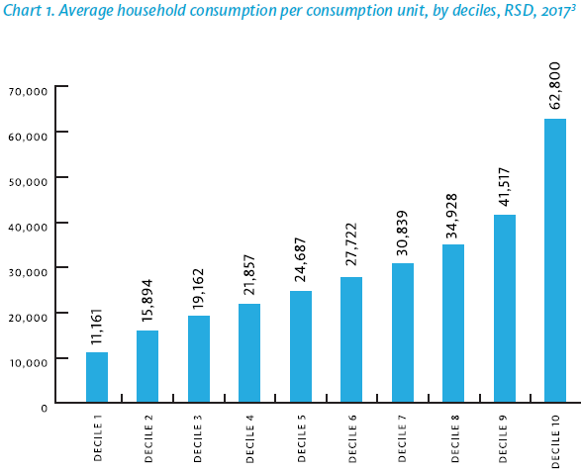

Source: Household Budget Survey, Statistical Office of the Republic of Serbia, 2017 The data was processed specifically for the needs of the Social Inclusion and Poverty Reduction Unit of the Government of the Republic of Serbia. Data in Excel format can be downloaded here.

In the observed period, from 2006 to 2017, the nominal average consumption of the population increased by 2.1 times on average. The biggest increase over time was registered in the first decile, in which average consumption increased from RSD 4,903 to RSD 11,161 per consumption unit, i.e. by 2.3 times, while in the same period, the average consumption of the ninth decile increased by 2.1 times, and of tenth decile by 2.0 times (Chart 2).
Chart 2. Average household consumption per consumption unit, by deciles, RSD, from 2006 to 2017

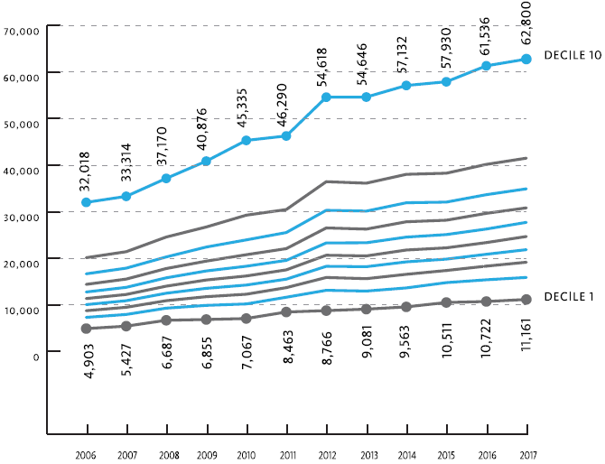

Source: Household Budget Survey, Statistical Office of the Republic of Serbia. The data was processed specifically for the needs of the Social Inclusion and Poverty Reduction Unit of the Government of the Republic of Serbia. Data in Excel format can be downloaded here.

The average consumption in the observed period grew by 11.8% in real terms. The average consumption in the first decile registered a 21% real increase, with the first seven deciles registering an above average growth (Chart 3).

Chart 3. Average consumption real growth rate per consumption unit, by deciles, %, from 2006 to 2017

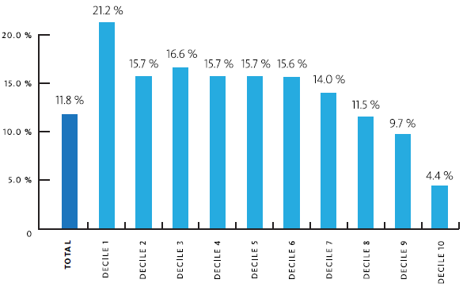

Source: Household Budget Survey, Statistical Office of the Republic of Serbia. The data was processed specifically for the needs of the Social Inclusion and Poverty Reduction Unit of the Government of the Republic of Serbia. Data in Excel format can be downloaded here.

The tenth decile registered the lowest real growth rate in the surveyed period (Chart 3).
The average annual growth rate of average consumption per consumption unit in the observed period stood at 1%. The highest annual real growth rate, amounting to 1.8%, was registered in the first decile.

Structure of Personal Consumption Expenditures

The structure of personal consumption expenditures significantly differs among deciles. The share of expenditures on food and non-alcoholic beverages accounts for almost half of the first decile’s expenditures and is twice higher in the first relative to the tenth decile. The share of expenditures on education is seven times lower among the poorest relative to the richest. The share of expenditures on recreation and culture is four times higher in the tenth relative to the first decile. The expenditures on transport, restaurants and hotels grows significantly in parallel with the consumption expenditures growth rate (Chart 4).

Chart 4. Structure of personal consumption expenditures of the first and tenth decile, 2017

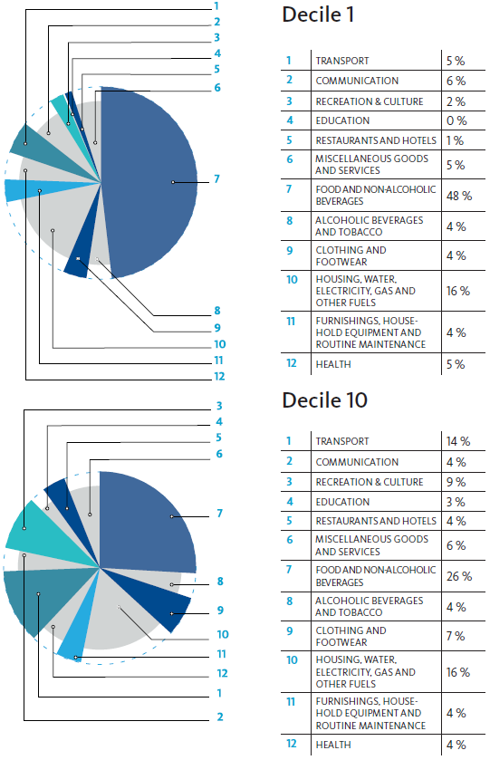

Source: Household Budget Survey, Statistical Office of the Republic of Serbia. The data was processed specifically for the needs of the Social Inclusion and Poverty Reduction Unit of the Government of the Republic of Serbia. Data in Excel format can be downloaded here.
The most pronounced difference in personal consumption expenditures is found in the share of essential expenditures on food and non-alcoholic beverages which accounts for almost half of total consumption in the first decile (48.3% in 2017) and one fourth of expenditures of the tenth decile (26.1% in 2017) (Chart 4).
The share of expenditures on food and non-alcoholic beverages in total consumption in the poorest 20% of the population remains significant despite the fact that it has decreased by approximately five percentage points in the period from 2006 to 2017 (Chart 5).

Chart 5. Share of expenditures on food and non-alcoholic beverages in decile 1, 2 and 10, from 2006 to 2017

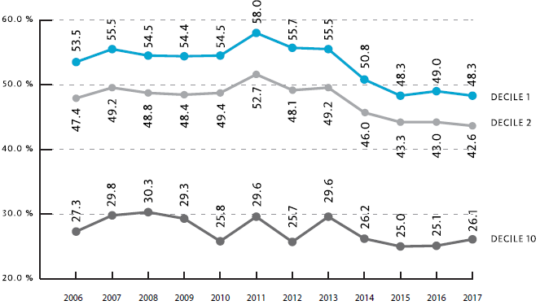

Source: Household Budget Survey, Statistical Office of the Republic of Serbia, 2017. The data was processed specifically for the needs of the Social Inclusion and Poverty Reduction Unit of the Government of the Republic of Serbia. Data in Excel format can be downloaded here.

Median Consumption Decile Analysis

When taking into account the entire population, median consumption has been lower that the average consumption in the entire observed period. This difference is registering a slight decrease. In 2006, the median consumption was by 13.2% lower than the average consumption, while this difference stood at 10% in 2017 (Chart 6).

Chart 6. Average and median household consumption per consumption unit, RSD, from 2006 to 2017
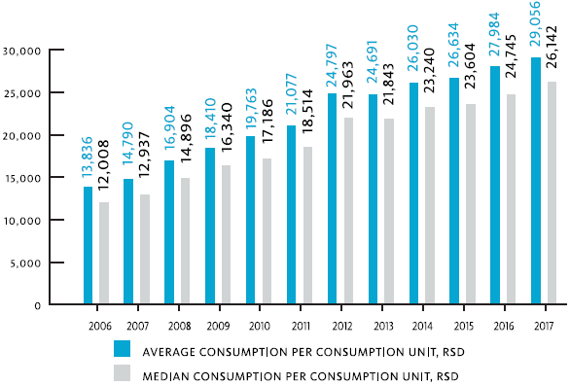

Source: Household Budget Survey, Statistical Office of the Republic of Serbia. The data was processed specifically for the needs of the Social Inclusion and Poverty Reduction Unit of the Government of the Republic of Serbia. Data in Excel format can be downloaded here.

The median and average consumption by deciles are almost uniform. The most important deviation is in the tenth decile in which the median consumption was below the average consumption by about 10% and consequently primarily affected the formation of relations at the level of the entire population. On the other side of distribution, the median consumption is higher than the average consumption, but significantly only in the first decile (approximately 5%) (Chart 7). These differences between the median and average consumption at the distribution extremes result in a significant number of persons with very low consumption in the first decile, and an extremely high consumption rate in the tenth decile.

Chart 7. Average consumption and median consumption per consumption unit, by deciles, RSD, 2017

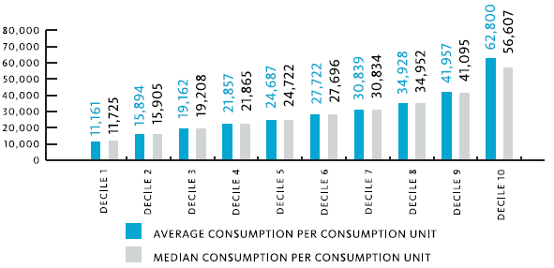

Source: Household Budget Survey, Statistical Office of the Republic of Serbia. The data was processed specifically for the needs of the Social Inclusion and Poverty Reduction Unit of the Government of the Republic of Serbia. Data in Excel format can be downloaded here.

Average Income Decile Analysis

The average consumption in the first decile in 2017 amounted to RSD 9,411 per consumption unit, while the average consumption in the tenth decile was around five and a half times higher, i.e. RSD 72,744 per consumption unit.

Chart 8. Average income per consumption unit, by deciles, RSD, 2017

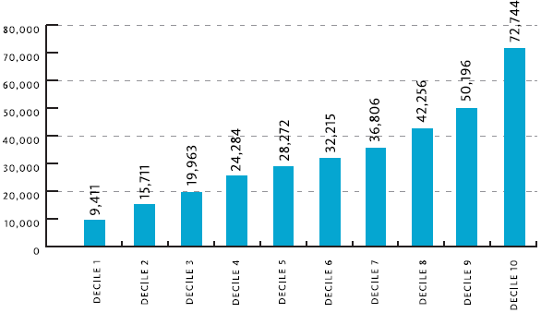

Source: Household Budget Survey, Statistical Office of the Republic of Serbia. The data was processed specifically for the needs of the Social Inclusion and Poverty Reduction Unit of the Government of the Republic of Serbia. Data in Excel format can be downloaded here.

The ratio of the average income of the tenth to the first decile has been in decline throughout the entire observed period. In 2006, this ratio stood at almost 10, and in 2017 at around 8.
Nominally speaking, the income increased on average by two times from 2006 to 2007, with the biggest nominal increase in the first decile (2.4 times). By deciles, the income growth is steadily decreasing, reaching 1.8 in the tenth decile.

Chart 9. Average income per consumption unit, by deciles, RSD, from 2006 to 2017

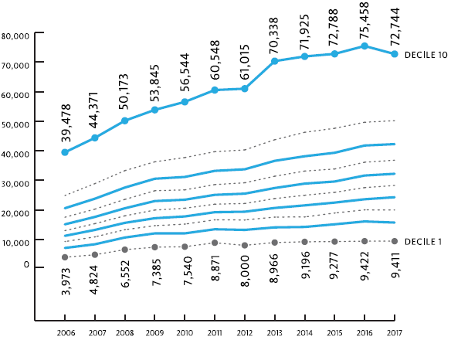

Source: Household Budget Survey, Statistical Office of the Republic of Serbia. The data was processed specifically for the needs of the Social Inclusion and Poverty Reduction Unit of the Government of the Republic of Serbia. Data in Excel format can be downloaded here.

From 2006 to 2017, the average income real growth rate per consumer unit amounted to almost 9%. The highest real growth rate was registered in the first decile, 26.1%. Above-average real growth rates were registered in all deciles except for the ninth and tenth.

Chart 10. Average income real growth per consumption unit, by deciles, %, from 2006 to 2017
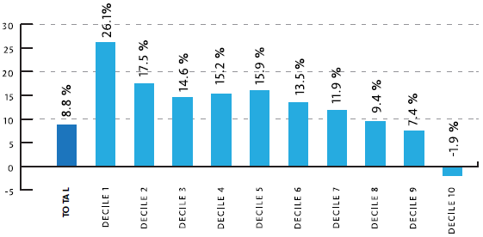
Source: Household Budget Survey, Statistical Office of the Republic of Serbia. The data was processed specifically for the needs of the Social Inclusion and Poverty Reduction Unit of the Government of the Republic of Serbia. Data in Excel format can be downloaded here.

The average annual real growth rate in the observed period amounted to approximately 0.8%, while the first decile had the highest average annual real growth rate at 2.1%.

Median Income Decile Analysis

Median income is lower than the average income in all deciles and no major changes were registered in their ratio in the entire observed period. Only a slight decrease in differences was seen in the period from 2014 to 2017 (Chart 11).
In 2017, the difference between the median and average income registered a 3 percentage points decline relative to 2014, which can be attributed to the effects of fiscal consolidation measures.

Chart 11. Average and median income per consumption unit, by deciles, RSD, from 2006 to 2017
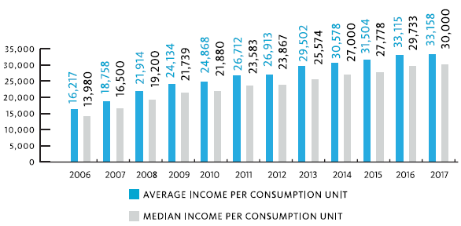

Source: Household Budget Survey, Statistical Office of the Republic of Serbia. The data was processed specifically for the needs of the Social Inclusion and Poverty Reduction Unit of the Government of the Republic of Serbia. Data in Excel format can be downloaded here.

There is no significant difference in the average and median income amounts by deciles, in 2017. This notwithstanding, an exception is the first decile, in which the average income is lower than the median income by about 7 percent, and the tenth decile, in which the average income is higher than the median income by around 8 percent (Chart 12).

Chart 12. Average and median income per consumption unit, by deciles, RSD, 2017

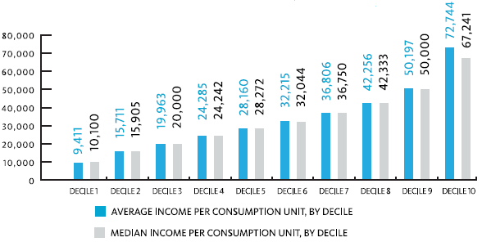
Source: Household Budget Survey, Statistical Office of the Republic of Serbia. The data was processed specifically for the needs of the Social Inclusion and Poverty Reduction Unit of the Government of the Republic of Serbia. Data in Excel format can be downloaded here.

Structure of Income Sources

Wages and pensions are the main source of income of the population of Serbia. In 2017, wages/salaries (53.5%) and pensions (31.0%) accounted for over 85% of sources of income (Table1). However, significant differences are present by deciles (Chart 13).
Table 1: Main sources of income by deciles, 2017

 | Total | Deciles
 |  | 1 | 2 | 3 | 4 | 5 | 6 | 7 | 8 | 9 | 10
Wages and salaries | 53.5 | 32.4 | 41.5 | 48.2 | 54.4 | 55.2 | 58.0 | 59.5 | 60.8 | 62.6 | 69.3
Income from self-employment | 9.2 | 8.4 | 12.6 | 9.8 | 11.7 | 8.5 | 9.2 | 9.2 | 7.7 | 7.7 | 6.8
Property income | 0.5 | 0.1 | 0.9 | 0.1 | 0.4 | 0.6 | 0.5 | - | 0.6 | 1.0 | 0.8
Pensions | 31.9 | 38.7 | 37.8 | 36.7 | 29.7 | 34.4 | 30.2 | 29.5 | 29.6 | 27.4 | 21.5
Unemployment benefit | 0.3 | 1.2 | 0.1 | 0.3 | 0.8 | - | 0.1 | 0.3 | - | - | -
Other | 4.6 | 19.2 | 7.1 | 4.9 | 3.0 | 1.3 | 2.0 | 1.5 | 1.3 | 1.3 | 1.6

Source: Household Budget Survey, Statistical Office of the Republic of Serbia, 2017. The data was processed specifically for the needs of the Social Inclusion and Poverty Reduction Unit of the Government of the Republic of Serbia. Data in Excel format can be downloaded here.
Key sources of income in the first decile are pensions, accounting for 38.7% of total income of the poorest decile, followed by wages with 32.4%, and other receipts with 19.2%. Data from previous years show that the share of pensions has increased since 2006, when it stood at 29.5%, reaching 38.7% in 2017. This situation shows that the poorest decile consists of households with very low work-intensity and high dependency on other transfers, with a dominant role of social transfers (especially means-tested transfers). In the higher deciles, this source of income is significantly lower and becomes negligible (Table 1).

Chart 13. Main sources of income of the first and tenth decile, %, 2017

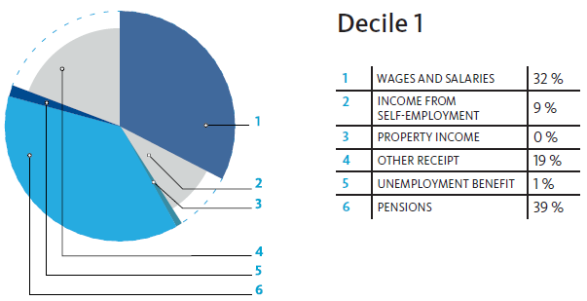
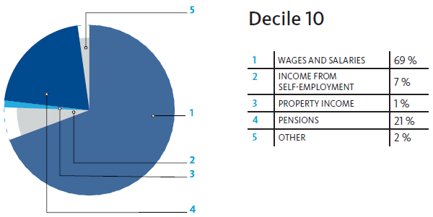

Source: Household Budget Survey, Statistical Office of the Republic of Serbia, 2017. The data was processed specifically for the needs of the Social Inclusion and Poverty Reduction Unit of the Government of the Republic of Serbia. Data in Excel format can be downloaded here.

Income Distribution by Deciles

The equal distribution of income entails the equal participation of each segment of the population in the distribution of income, i.e. that the first 10% of the population should have a 10% share of total income, and so on.
In reality, income distribution by deciles differs from equal distribution, so the poorest deciles participate with a significantly lower share in total income, and the richer deciles with a higher share.
In Serbia, the poorest 10% of the population had a 3.1% of the share of total income, while the richest 10% had a 20% share of total income.

Chart 14. Distribution of total income by deciles

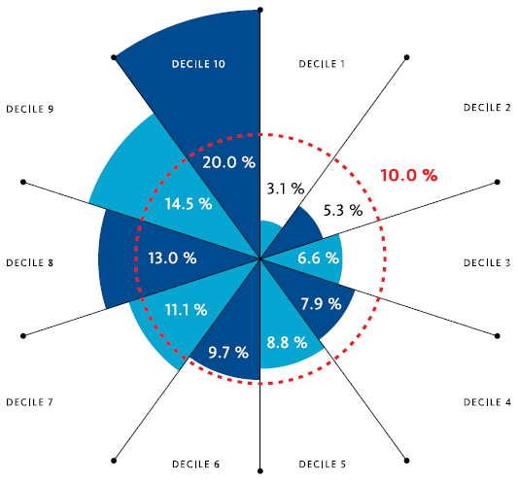
Source: Household Budget Survey, Statistical Office of the Republic of Serbia, 2017. The data was processed specifically for the needs of the Social Inclusion and Poverty Reduction Unit of the Government of the Republic of Serbia. Data in Excel format can be downloaded here.
Throughout the entire observed period, no significant changes occurred in the distribution of income by deciles. On average, the share of the first and tenth decile stood at 3.2% and 21.4%, respectively. A slight decline in the share of the tenth decile in income distribution was noticeable over the years, but the share of the poorest decile in income distribution also declined since 2014.

Average Consumption to Average Income Ratio

When comparing household consumption and income, one should bear in mind the methodological notes, among which, the use of various equivalence scales that reflects on some of the differences.
In 2017, the average expenditure was significantly higher than average income only in the first decile (18.5%), while the average income and expenditure amounts were almost equal in the second decile, and in the subsequent deciles there is a change in this ratio in favour of income.
The difference between income and consumption is most pronounced in decile eight and decile nine, with income exceeding the average monthly consumption by 20% and 16% respectively. In previous years the income-to-consumption ratio was significantly higher in the three richest deciles (specifically, in the period from 2006 to 2016, it stood at around 26% on average).

Chart 15. Average consumption to average income ratio per consumption unit, by deciles, RSD, 2017

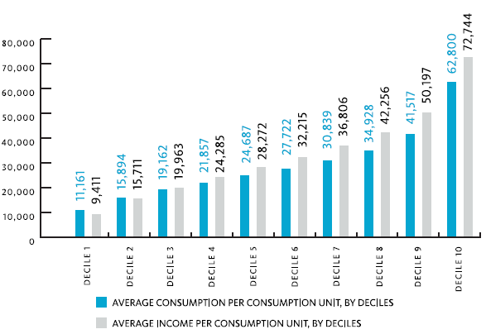

Source: Household Budget Survey, Statistical Office of the Republic of Serbia. The data was processed specifically for the needs of the Social Inclusion and Poverty Reduction Unit of the Government of the Republic of Serbia. Data in Excel format can be downloaded here.

The real growth of consumption and income (both average and median) was positive throughout the observed period. The average consumption in 2017 increased by 11.8 percent in real terms relative to 2006, while the median consumption rate stood at 15.9 percent. In the same period, income registered a somewhat weaker growth. The average income in 2017 increased by 8.8 percent relative to 2006, while the median income increased by 14.2 percent (Table 2). In the observed period, the average consumption annual growth rate stood at 1.02 percent, on average, and was higher than the average income growth rate by 0.25 percentage points.

Table 2 Selected income and consumption trend indicators in the period from 2006 to 2017

 | Total real growth rate  2006-2017 (2006=100) | Total growth rate  2006-2017
Average consumption | 11.8 | 1.02
Median consumption | 15.9 | 1.35
Average income | 8.8 | 0.77
Median income | 14.2 | 1.21

Source: Household Budget Survey, Statistical Office of the Republic of Serbia. The data was processed specifically for the needs of the Social Inclusion and Poverty Reduction Unit of the Government of the Republic of Serbia. Data in Excel format can be downloaded here.

Annexes

Annex 1. Average consumption per consumption unit, by deciles
Average consumption per consumption unit, by deciles
 | Total | 1  Decile | 2  Decile | 3  Decile | 4  Decile | 5  Decile | 6  Decile | 7  Decile | 8  Decile | 9  Decile | 10  Decile
2006 | 13,836 | 4,903 | 7,314 | 8,744 | 10,051 | 11,356 | 12,763 | 14,402 | 16,666 | 20,134 | 32,018
2007 | 14,790 | 5,427 | 7,940 | 9,478 | 10,892 | 12,233 | 13,763 | 15,539 | 17,888 | 21,422 | 33,314
2008 | 16,904 | 6,687 | 9,292 | 10,898 | 12,501 | 14,018 | 15,808 | 17,805 | 20,295 | 24,575 | 37,170
2009 | 18,410 | 6,855 | 9,888 | 11,756 | 13,551 | 15,343 | 17,286 | 19,396 | 22,422 | 26,731 | 40,876
2010 | 19,763 | 7,067 | 10,198 | 12,287 | 14,258 | 16,207 | 18,300 | 20,777 | 23,958 | 29,268 | 45,335
2011 | 21,077 | 8,463 | 11,640 | 13,700 | 15,520 | 17,520 | 19,556 | 22,079 | 25,535 | 30,477 | 46,290
2012 | 24,797 | 8,766 | 13,128 | 15,884 | 18,287 | 20,666 | 23,306 | 26,528 | 30,321 | 36,468 | 54,618
2013 | 24,691 | 9,081 | 12,963 | 15,627 | 18,201 | 20,516 | 23,340 | 26,275 | 30,143 | 36,139 | 54,646
2014 | 26,030 | 9,563 | 13,642 | 16,563 | 19,239 | 21,783 | 24,559 | 27,852 | 31,935 | 38,044 | 57,132
2015 | 26,634 | 10,511 | 14,779 | 17,385 | 19,826 | 22,252 | 25,103 | 28,186 | 32,078 | 38,285 | 57,930
2016 | 27,984 | 10,722 | 15,388 | 18,322 | 20,870 | 23,380 | 26,292 | 29,664 | 33,674 | 40,181 | 61,356
2017 | 29,056 | 11,161 | 15,894 | 19,162 | 21,857 | 24,687 | 27,722 | 30,839 | 34,928 | 41,517 | 62,800

Annex 2. Median consumption per consumption unit, by deciles

Median consumption per consumption unit, by deciles
 | Total | 1  Decile | 2  Decile | 3  Decile | 4  Decile | 5  Decile | 6  Decile | 7  Decile | 8  Decile | 9  Decile | 10  Decile
2006 | 12,008 | 5,211 | 7,342 | 8,768 | 10,037 | 11,379 | 12,755 | 14,389 | 16,616 | 19,990 | 28,502
2007 | 12,937 | 5,717 | 7,909 | 9,501 | 10,902 | 12,199 | 13,749 | 15,511 | 17,849 | 21,181 | 29,541
2008 | 14,896 | 6,995 | 9,227 | 10,922 | 12,565 | 13,985 | 15,859 | 17,812 | 20,193 | 24,424 | 34,468
2009 | 16,340 | 7,356 | 9,887 | 11,753 | 13,537 | 15,301 | 17,268 | 19,368 | 22,464 | 26,423 | 36,436
2010 | 17,186 | 7,448 | 10,190 | 12,274 | 14,285 | 16,197 | 18,317 | 20,790 | 23,904 | 29,140 | 41,434
2011 | 18,514 | 8,773 | 11,701 | 13,713 | 15,502 | 17,548 | 19,504 | 21,992 | 25,348 | 30,271 | 42,312
2012 | 21,963 | 9,280 | 13,268 | 15,973 | 18,282 | 20,607 | 23,319 | 26,582 | 30,357 | 36,315 | 48,457
2013 | 21,843 | 9,485 | 13,008 | 15,611 | 18,159 | 20,475 | 23,268 | 26,247 | 30,031 | 35,768 | 49,013
2014 | 23,240 | 9,970 | 13,712 | 16,525 | 19,262 | 21,733 | 24,535 | 27,884 | 31,859 | 37,825 | 51,339
2015 | 23,604 | 11,121 | 14,784 | 17,386 | 19,786 | 22,258 | 25,164 | 28,205 | 32,002 | 38,016 | 51,396
2016 | 24,745 | 11,355 | 15,486 | 18,324 | 20,941 | 23,343 | 26,253 | 29,740 | 33,421 | 39,899 | 54,321
2017 | 26,142 | 11,725 | 15,905 | 19,208 | 21,865 | 24,722 | 27,696 | 30,844 | 34,952 | 41,095 | 56,607
Annex 3. Structure of personal consumption expenditures, by consumption deciles

Structure of personal consumption expenditures, by consumption deciles
 | Total | 1  Decile | 2  Decile | 3  Decile | 4  Decile | 5  Decile | 6  Decile | 7  Decile | 8  Decile | 9  Decile | 10  Decile
Personal consumption - total | 100.0 | 100.0 | 100.0 | 100.0 | 100.0 | 100.0 | 100.0 | 100.0 | 100.0 | 100.0 | 100.0
2006
Food and non-alcoholic beverages | 38.2 | 53.5 | 47.4 | 43.7 | 43.9 | 41.8 | 42.4 | 39.6 | 37.3 | 36.1 | 27.3
Alcoholic beverages and tobacco | 4.5 | 4.6 | 5.3 | 5.0 | 5.2 | 4.5 | 4.7 | 4.7 | 4.4 | 4.4 | 3.7
Clothing and footwear | 6.9 | 4.3 | 5.6 | 5.2 | 5.7 | 7.1 | 6.8 | 6.7 | 8.0 | 7.4 | 7.9
Housing, water, electricity, gas and other fuels | 15.4 | 14.9 | 15.0 | 16.5 | 17.0 | 15.4 | 16.3 | 16.1 | 15.3 | 15.8 | 13.6
Furnishings, household equipment and routine maintenance | 4.9 | 4.5 | 4.7 | 5.0 | 4.4 | 5.0 | 4.7 | 4.8 | 5.2 | 5.0 | 5.0
Health | 3.7 | 3.4 | 3.0 | 3.9 | 3.3 | 3.8 | 3.1 | 4.1 | 3.8 | 2.9 | 4.4
Transport | 11.4 | 5.3 | 6.9 | 9.2 | 8.5 | 9.5 | 8.8 | 9.5 | 10.9 | 12.5 | 18.3
Communication | 3.3 | 2.6 | 3.3 | 3.1 | 3.1 | 3.4 | 3.4 | 3.4 | 3.5 | 3.4 | 3.1
Recreation and culture | 5.0 | 2.3 | 3.5 | 3.4 | 3.9 | 4.4 | 4.4 | 4.8 | 4.8 | 5.3 | 7.3
Education | 1.2 | 0.4 | 0.3 | 0.6 | 0.5 | 0.5 | 1.0 | 1.2 | 0.9 | 1.6 | 2.2
Restaurants and hotels | 1.4 | 0.9 | 1.0 | 0.8 | 1.2 | 1.2 | 1.2 | 1.2 | 1.7 | 1.7 | 1.7
Miscellaneous goods and services | 4.1 | 3.3 | 4.0 | 3.6 | 3.3 | 3.4 | 3.2 | 3.9 | 4.2 | 3.9 | 5.5
2007
Food and non-alcoholic beverages | 39.8 | 55.5 | 49.2 | 46.1 | 43.6 | 43.4 | 41.3 | 40.4 | 37.5 | 37.2 | 29.8
Alcoholic beverages and tobacco | 5.0 | 5.3 | 6.1 | 5.4 | 5.6 | 5.1 | 5.1 | 4.8 | 4.8 | 5.2 | 4.3
Clothing and footwear | 6.4 | 3.5 | 4.5 | 5.0 | 5.5 | 6.2 | 5.7 | 6.6 | 6.8 | 6.9 | 8.2
Housing, water, electricity, gas and other fuels | 14.1 | 13.8 | 15.1 | 15.3 | 15.0 | 14.4 | 14.9 | 14.3 | 15.1 | 14.1 | 11.8
Furnishings, household equipment and routine maintenance | 4.7 | 4.4 | 4.1 | 4.4 | 5.3 | 5.0 | 4.6 | 4.9 | 4.8 | 4.6 | 4.8
Health | 3.8 | 3.7 | 3.8 | 4.0 | 3.6 | 3.3 | 3.6 | 4.2 | 3.6 | 3.6 | 4.2
Transport | 10.9 | 4.4 | 6.3 | 7.9 | 8.4 | 8.8 | 10.7 | 9.8 | 11.6 | 10.6 | 17.3
Communication | 3.3 | 2.4 | 3.3 | 3.3 | 3.2 | 3.4 | 3.5 | 3.5 | 3.3 | 3.5 | 3.3
Recreation and culture | 4.8 | 2.8 | 2.8 | 3.3 | 3.8 | 4.2 | 4.2 | 4.8 | 5.1 | 5.4 | 6.9
Education | 1.3 | 0.3 | 0.6 | 0.5 | 0.7 | 1.0 | 0.8 | 1.2 | 1.3 | 2.2 | 1.8
Restaurants and hotels | 1.8 | 0.7 | 1.2 | 1.3 | 1.6 | 1.7 | 1.8 | 1.7 | 2.1 | 2.1 | 2.2
Miscellaneous goods and services | 4.1 | 3.2 | 3.0 | 3.5 | 3.7 | 3.5 | 3.8 | 3.8 | 4.0 | 4.6 | 5.4
2008
Food and non-alcoholic beverages | 40.7 | 54.5 | 48.8 | 47.7 | 45.8 | 44.0 | 42.8 | 39.9 | 41.1 | 37.4 | 30.3
Alcoholic beverages and tobacco | 4.6 | 5.1 | 5.0 | 5.1 | 5.0 | 5.0 | 4.6 | 4.6 | 4.8 | 4.5 | 3.8
Clothing and footwear | 6.3 | 4.5 | 5.5 | 5.6 | 5.6 | 6.4 | 6.3 | 6.3 | 6.2 | 6.9 | 7.2
Housing, water, electricity, gas and other fuels | 14.8 | 14.0 | 16.0 | 15.8 | 15.2 | 14.9 | 15.5 | 15.2 | 14.3 | 14.3 | 13.8
Furnishings, household equipment and routine maintenance | 4.5 | 4.0 | 4.2 | 4.0 | 4.6 | 4.4 | 4.5 | 5.0 | 4.6 | 4.7 | 4.4
Health | 3.4 | 4.0 | 3.4 | 3.2 | 3.5 | 3.3 | 3.1 | 3.1 | 3.1 | 3.1 | 4.0
Transport | 10.2 | 4.3 | 6.3 | 7.0 | 7.6 | 7.7 | 8.5 | 9.6 | 10.6 | 11.6 | 16.2
Communication | 3.4 | 3.0 | 3.3 | 3.4 | 3.4 | 3.8 | 3.5 | 4.0 | 3.4 | 3.4 | 3.1
Recreation and culture | 4.8 | 1.9 | 2.8 | 3.0 | 3.3 | 4.6 | 4.2 | 4.5 | 4.5 | 5.7 | 7.3
Education | 1.1 | 0.5 | 0.2 | 0.4 | 0.4 | 0.8 | 0.6 | 1.3 | 1.3 | 1.3 | 2.1
Restaurants and hotels | 2.0 | 0.9 | 1.1 | 1.4 | 2.1 | 1.6 | 2.1 | 2.4 | 2.1 | 2.3 | 2.5
Miscellaneous goods and services | 4.2 | 3.3 | 3.4 | 3.4 | 3.5 | 3.5 | 4.3 | 4.1 | 4.0 | 4.8 | 5.3
2009
Food and non-alcoholic beverages | 39.7 | 54.4 | 48.4 | 46.2 | 45.0 | 45.1 | 41.8 | 40.0 | 39.9 | 35.9 | 29.3
Alcoholic beverages and tobacco | 4.6 | 6.0 | 5.4 | 5.5 | 5.1 | 5.1 | 4.9 | 5.2 | 4.4 | 3.9 | 3.5
Clothing and footwear | 5.9 | 4.4 | 5.1 | 5.4 | 5.5 | 5.5 | 5.9 | 5.9 | 5.8 | 6.5 | 6.5
Housing, water, electricity, gas and other fuels | 15.5 | 12.5 | 15.1 | 16.4 | 15.7 | 16.0 | 15.6 | 16.3 | 16.2 | 16.7 | 13.7
Furnishings, household equipment and routine maintenance | 4.4 | 4.4 | 4.5 | 4.1 | 4.3 | 4.2 | 4.4 | 4.3 | 4.5 | 4.4 | 4.4
Health | 3.3 | 4.3 | 3.0 | 3.0 | 3.4 | 2.4 | 3.0 | 3.1 | 3.1 | 3.1 | 3.9
Transport | 10.0 | 4.0 | 5.7 | 6.2 | 7.5 | 7.2 | 9.0 | 10.1 | 9.3 | 10.6 | 16.6
Communication | 3.8 | 3.0 | 3.7 | 4.2 | 3.5 | 4.1 | 4.1 | 3.8 | 3.9 | 3.9 | 3.3
Recreation and culture | 5.1 | 2.1 | 3.6 | 3.4 | 4.0 | 4.2 | 4.6 | 4.1 | 5.0 | 6.3 | 7.6
Education | 1.1 | 0.3 | 0.2 | 0.2 | 0.3 | 0.6 | 0.6 | 0.9 | 1.3 | 1.3 | 2.6
Restaurants and hotels | 2.1 | 0.9 | 1.3 | 1.6 | 1.7 | 1.8 | 2.0 | 2.3 | 2.1 | 2.8 | 2.6
Miscellaneous goods and services | 4.5 | 3.7 | 4.0 | 3.8 | 4.0 | 3.8 | 4.1 | 4.0 | 4.5 | 4.6 | 6.0
2010
Food and non-alcoholic beverages | 37.4 | 54.5 | 49.4 | 44.6 | 43.0 | 41.9 | 40.5 | 38.3 | 36.5 | 32.5 | 25.8
Alcoholic beverages and tobacco | 4.3 | 4.9 | 5.0 | 4.7 | 5.3 | 4.3 | 4.7 | 4.3 | 4.2 | 4.2 | 3.4
Clothing and footwear | 5.9 | 3.9 | 4.3 | 4.7 | 5.0 | 5.8 | 6.2 | 6.0 | 6.2 | 6.1 | 7.0
Housing, water, electricity, gas and other fuels | 16.1 | 12.8 | 14.9 | 16.7 | 16.1 | 16.6 | 16.9 | 17.0 | 17.5 | 17.3 | 14.1
Furnishings, household equipment and routine maintenance | 4.7 | 4.8 | 5.2 | 4.7 | 4.7 | 4.5 | 4.7 | 4.6 | 4.7 | 5.0 | 4.4
Health | 3.8 | 3.8 | 4.5 | 4.1 | 3.8 | 3.6 | 3.5 | 3.8 | 4.2 | 3.8 | 3.7
Transport | 10.3 | 4.3 | 4.8 | 7.0 | 8.0 | 8.4 | 8.4 | 8.8 | 8.6 | 11.1 | 18.0
Communication | 4.2 | 3.8 | 4.0 | 4.3 | 4.2 | 4.4 | 4.5 | 4.6 | 4.4 | 4.4 | 3.7
Recreation and culture | 5.0 | 2.0 | 2.6 | 2.9 | 3.7 | 3.9 | 3.9 | 4.6 | 5.2 | 5.9 | 8.0
Education | 1.1 | 0.2 | 0.2 | 0.3 | 0.2 | 0.5 | 0.9 | 1.0 | 0.8 | 1.7 | 2.6
Restaurants and hotels | 2.2 | 0.9 | 1.1 | 1.5 | 1.8 | 1.8 | 1.7 | 2.4 | 2.5 | 2.5 | 2.9
Miscellaneous goods and services | 5.0 | 4.1 | 4.0 | 4.5 | 4.2 | 4.3 | 4.1 | 4.6 | 5.2 | 5.5 | 6.4
2011
Food and non-alcoholic beverages | 41.9 | 58.0 | 52.7 | 48.9 | 46.5 | 45.8 | 43.9 | 42.9 | 40.3 | 38.0 | 29.6
Alcoholic beverages and tobacco | 4.7 | 4.8 | 5.0 | 5.5 | 5.1 | 4.9 | 5.3 | 5.0 | 4.6 | 4.1 | 3.8
Clothing and footwear | 5.5 | 3.4 | 4.7 | 5.0 | 5.2 | 4.8 | 5.6 | 5.7 | 5.4 | 6.1 | 6.4
Housing, water, electricity, gas and other fuels | 14.7 | 12.6 | 13.3 | 13.7 | 14.1 | 15.6 | 15.7 | 15.4 | 16.6 | 15.0 | 13.8
Furnishings, household equipment and routine maintenance | 4.2 | 4.8 | 4.4 | 4.2 | 4.5 | 4.6 | 4.4 | 4.3 | 4.0 | 4.0 | 3.9
Health | 3.4 | 3.4 | 3.0 | 2.8 | 3.2 | 3.2 | 2.8 | 3.1 | 3.3 | 3.6 | 4.3
Transport | 9.6 | 3.4 | 5.2 | 6.5 | 8.1 | 7.4 | 8.5 | 8.9 | 10.0 | 10.7 | 15.6
Communication | 4.0 | 3.4 | 3.8 | 4.0 | 3.9 | 4.1 | 4.2 | 4.2 | 4.3 | 4.0 | 3.6
Recreation and culture | 4.4 | 1.8 | 2.4 | 2.6 | 2.8 | 3.1 | 3.2 | 3.9 | 4.3 | 5.6 | 7.8
Education | 0.9 | 0.1 | 0.2 | 0.3 | 0.7 | 0.4 | 0.5 | 0.3 | 0.8 | 1.2 | 2.4
Restaurants and hotels | 2.0 | 0.8 | 1.4 | 1.8 | 1.8 | 1.9 | 1.8 | 2.2 | 1.8 | 2.3 | 2.8
Miscellaneous goods and services | 4.7 | 3.5 | 3.9 | 4.7 | 4.1 | 4.2 | 4.1 | 4.1 | 4.6 | 5.4 | 6.0
2012
Food and non-alcoholic beverages | 37.0 | 55.7 | 48.1 | 45.7 | 42.1 | 39.2 | 37.8 | 37.9 | 34.7 | 34.2 | 25.7
Alcoholic beverages and tobacco | 4.2 | 3.6 | 4.6 | 4.7 | 5.0 | 4.8 | 4.6 | 4.4 | 4.0 | 3.9 | 3.4
Clothing and footwear | 6.2 | 3.2 | 4.8 | 5.2 | 5.8 | 6.9 | 6.0 | 5.9 | 5.8 | 7.3 | 7.0
Housing, water, electricity, gas and other fuels | 16.2 | 14.0 | 14.3 | 14.9 | 16.2 | 16.9 | 17.1 | 16.5 | 17.6 | 16.2 | 15.9
Furnishings, household equipment and routine maintenance | 4.7 | 5.8 | 5.2 | 4.7 | 4.6 | 4.7 | 4.5 | 4.3 | 4.9 | 5.0 | 4.3
Health | 4.2 | 4.0 | 3.9 | 3.6 | 3.4 | 3.1 | 4.1 | 4.1 | 4.1 | 3.9 | 5.8
Transport | 9.8 | 3.5 | 6.1 | 6.7 | 7.7 | 8.1 | 9.1 | 10.4 | 11.0 | 10.9 | 13.7
Communication | 4.5 | 3.8 | 4.6 | 4.6 | 4.7 | 5.1 | 4.9 | 4.7 | 4.8 | 4.5 | 3.8
Recreation and culture | 4.3 | 1.4 | 2.2 | 2.7 | 3.5 | 3.6 | 4.2 | 3.8 | 4.1 | 4.8 | 6.7
Education | 1.1 | 0.1 | 0.2 | 0.5 | 0.2 | 0.5 | 0.8 | 0.6 | 1.1 | 1.2 | 2.8
Restaurants and hotels | 2.4 | 0.9 | 1.6 | 2.0 | 2.2 | 2.3 | 2.1 | 2.5 | 2.6 | 2.6 | 3.2
Miscellaneous goods and services | 5.4 | 4.0 | 4.4 | 4.7 | 4.6 | 4.8 | 4.8 | 4.9 | 5.3 | 5.5 | 7.7
2013
Food and non-alcoholic beverages | 38.8 | 55.5 | 49.2 | 48.1 | 42.9 | 41.3 | 39.7 | 38.1 | 36.3 | 35.3 | 29.6
Alcoholic beverages and tobacco | 4.3 | 3.8 | 4.9 | 4.7 | 5.2 | 4.8 | 4.8 | 4.3 | 4.4 | 3.9 | 3.5
Clothing and footwear | 5.9 | 3.2 | 4.0 | 4.0 | 4.8 | 5.4 | 5.9 | 6.4 | 6.5 | 6.3 | 7.3
Housing, water, electricity, gas and other fuels | 15.9 | 13.8 | 15.4 | 16.0 | 16.0 | 17.8 | 17.4 | 15.2 | 16.9 | 16.6 | 14.2
Furnishings, household equipment and routine maintenance | 4.5 | 5.2 | 5.0 | 4.4 | 4.7 | 4.4 | 4.4 | 4.5 | 4.3 | 4.2 | 4.6
Health | 3.7 | 3.8 | 3.7 | 3.3 | 3.4 | 4.0 | 3.5 | 3.7 | 3.4 | 3.9 | 3.8
Transport | 8.9 | 3.9 | 5.2 | 6.9 | 7.6 | 7.8 | 8.4 | 10.0 | 9.3 | 9.7 | 11.7
Communication | 4.6 | 3.8 | 4.9 | 4.7 | 5.2 | 4.7 | 4.8 | 5.1 | 4.6 | 4.6 | 4.1
Recreation and culture | 4.7 | 1.8 | 2.8 | 2.6 | 3.6 | 3.2 | 3.7 | 4.5 | 4.6 | 4.9 | 8.4
Education | 1.2 | 0.1 | 0.2 | 0.1 | 0.2 | 0.4 | 0.9 | 0.9 | 1.7 | 2.2 | 2.1
Restaurants and hotels | 2.4 | 1.0 | 1.2 | 1.5 | 1.9 | 1.8 | 2.0 | 2.2 | 2.5 | 2.7 | 3.8
Miscellaneous goods and services | 5.1 | 4.1 | 3.5 | 3.7 | 4.5 | 4.4 | 4.5 | 5.1 | 5.5 | 5.7 | 6.9
2014
Food and non-alcoholic beverages | 35.2 | 50.8 | 46.0 | 43.2 | 39.8 | 38.1 | 36.3 | 34.9 | 33.2 | 29.9 | 26.2
Alcoholic beverages and tobacco | 4.5 | 4.7 | 4.7 | 4.0 | 5.2 | 5.0 | 4.4 | 4.8 | 4.6 | 4.7 | 3.5
Clothing and footwear | 6.2 | 3.6 | 4.3 | 4.5 | 5.6 | 5.9 | 6.6 | 6.4 | 6.3 | 7.3 | 7.2
Housing, water, electricity, gas and other fuels | 15.9 | 14.6 | 15.4 | 15.3 | 15.3 | 16.3 | 15.3 | 15.8 | 16.4 | 15.8 | 16.9
Furnishings, household equipment and routine maintenance | 4.7 | 5.1 | 4.9 | 4.7 | 4.5 | 4.6 | 4.9 | 4.4 | 4.5 | 4.3 | 4.9
Health | 3.7 | 4.3 | 3.9 | 3.7 | 3.6 | 3.5 | 3.7 | 3.5 | 3.7 | 3.8 | 3.7
Transport | 10.4 | 4.2 | 5.9 | 7.7 | 8.6 | 8.8 | 10.1 | 10.5 | 11.8 | 12.7 | 13.7
Communication | 5.0 | 4.7 | 5.6 | 5.6 | 5.5 | 5.6 | 5.2 | 5.1 | 5.1 | 4.8 | 4.2
Recreation and culture | 4.9 | 2.2 | 2.6 | 3.8 | 4.2 | 4.0 | 4.5 | 4.6 | 4.8 | 5.7 | 7.5
Education | 1.2 | 0.1 | 0.3 | 0.7 | 0.7 | 0.6 | 1.0 | 1.0 | 1.1 | 1.8 | 2.4
Restaurants and hotels | 2.4 | 0.9 | 1.6 | 1.5 | 1.9 | 2.4 | 2.4 | 2.6 | 2.5 | 2.7 | 3.3
Miscellaneous goods and services | 5.8 | 4.9 | 4.8 | 5.2 | 5.3 | 5.3 | 5.5 | 6.3 | 6.0 | 6.4 | 6.5
2015
Food and non-alcoholic beverages | 35.2 | 48.3 | 43.3 | 41.3 | 39.0 | 39.1 | 36.8 | 35.5 | 34.0 | 31.9 | 25.0
Alcoholic beverages and tobacco | 4.8 | 4.8 | 5.4 | 5.0 | 4.4 | 5.6 | 4.7 | 4.8 | 5.0 | 5.2 | 4.1
Clothing and footwear | 5.6 | 3.5 | 4.7 | 4.7 | 5.2 | 5.3 | 5.9 | 5.9 | 6.3 | 6.1 | 5.9
Housing, water, electricity, gas and other fuels | 15.7 | 14.7 | 15.8 | 16.1 | 16.2 | 16.1 | 15.8 | 16.3 | 15.7 | 15.8 | 14.7
Furnishings, household equipment and routine maintenance | 4.5 | 4.4 | 4.6 | 4.4 | 4.5 | 4.5 | 4.6 | 4.3 | 4.4 | 4.4 | 4.5
Health | 3.7 | 4.1 | 3.8 | 3.8 | 3.7 | 3.3 | 3.6 | 3.5 | 3.8 | 3.5 | 4.1
Transport | 10.0 | 5.0 | 6.0 | 7.4 | 8.3 | 8.3 | 9.3 | 10.1 | 9.9 | 10.5 | 15.3
Communication | 5.4 | 5.7 | 5.9 | 5.9 | 6.3 | 5.8 | 5.7 | 5.5 | 5.4 | 5.1 | 4.2
Recreation and culture | 5.3 | 2.1 | 3.0 | 3.3 | 3.6 | 3.6 | 4.6 | 4.6 | 5.2 | 6.7 | 9.1
Education | 1.4 | 0.6 | 0.6 | 1.0 | 0.9 | 0.7 | 1.1 | 1.3 | 1.5 | 1.8 | 2.7
Restaurants and hotels | 2.7 | 1.6 | 1.7 | 1.9 | 2.6 | 2.2 | 2.5 | 2.5 | 3.0 | 3.0 | 3.9
Miscellaneous goods and services | 5.7 | 5.2 | 5.2 | 5.2 | 5.3 | 5.5 | 5.4 | 5.7 | 5.8 | 6.0 | 6.5
2016
Food and non-alcoholic beverages | 34.3 | 49.0 | 43.0 | 39.6 | 37.9 | 37.5 | 36.5 | 33.4 | 32.7 | 31.4 | 25.1
Alcoholic beverages and tobacco | 4.8 | 4.5 | 4.6 | 5.7 | 5.4 | 5.3 | 5.3 | 4.6 | 4.8 | 4.8 | 3.8
Clothing and footwear | 5.9 | 3.5 | 5.0 | 5.1 | 5.0 | 5.7 | 6.0 | 6.5 | 5.9 | 6.9 | 6.7
Housing, water, electricity, gas and other fuels | 15.6 | 14.0 | 15.4 | 15.1 | 15.4 | 14.9 | 15.0 | 16.8 | 17.1 | 15.8 | 15.1
Furnishings, household equipment and routine maintenance | 4.4 | 4.5 | 4.5 | 4.3 | 4.4 | 4.5 | 4.5 | 4.6 | 4.2 | 4.3 | 4.2
Health | 3.8 | 4.3 | 4.1 | 4.0 | 3.3 | 3.7 | 3.5 | 3.5 | 3.4 | 3.4 | 4.6
Transport | 10.0 | 4.6 | 6.0 | 7.8 | 8.0 | 9.0 | 9.3 | 10.1 | 10.7 | 10.7 | 14.1
Communication | 5.3 | 5.5 | 6.2 | 6.2 | 5.7 | 5.9 | 5.8 | 5.4 | 5.3 | 5.0 | 4.0
Recreation and culture | 5.5 | 2.2 | 2.9 | 3.8 | 5.7 | 4.1 | 4.3 | 4.6 | 5.4 | 6.5 | 9.0
Education | 1.7 | 0.9 | 1.1 | 1.0 | 1.3 | 1.0 | 1.3 | 2.0 | 1.5 | 2.0 | 2.8
Restaurants and hotels | 2.8 | 1.4 | 1.8 | 2.2 | 2.3 | 2.5 | 2.7 | 2.8 | 2.8 | 3.1 | 4.0
Miscellaneous goods and services | 5.9 | 5.6 | 5.4 | 5.2 | 5.6 | 5.9 | 5.8 | 5.7 | 6.2 | 6.1 | 6.6
2017
Food and non-alcoholic beverages | 33.6 | 48.3 | 42.6 | 40.0 | 38.2 | 35.7 | 34.6 | 33.1 | 31.5 | 30.1 | 26.1
Alcoholic beverages and tobacco | 4.9 | 4.3 | 4.7 | 4.9 | 5.8 | 5.4 | 5.1 | 5.0 | 5.2 | 4.7 | 4.1
Clothing and footwear | 5.9 | 3.8 | 4.8 | 5.0 | 5.3 | 5.8 | 6.1 | 5.9 | 6.3 | 6.5 | 6.6
Housing, water, electricity, gas and other fuels | 16.1 | 15.7 | 14.8 | 14.7 | 15.9 | 16.1 | 16.0 | 16.9 | 16.0 | 16.6 | 16.4
Furnishings, household equipment and routine maintenance | 4.3 | 3.6 | 4.5 | 4.6 | 4.1 | 4.3 | 4.2 | 4.5 | 4.4 | 4.1 | 4.2
Health | 3.9 | 4.7 | 4.0 | 4.0 | 3.6 | 3.4 | 3.7 | 3.7 | 3.3 | 4.1 | 4.4
Transport | 9.7 | 5.1 | 6.5 | 7.9 | 8.1 | 9.2 | 9.4 | 9.5 | 10.5 | 10.8 | 12.5
Communication | 5.4 | 5.7 | 6.5 | 6.2 | 6.2 | 5.7 | 5.8 | 5.5 | 5.6 | 5.0 | 4.1
Recreation and culture | 5.4 | 2.2 | 3.2 | 3.2 | 3.5 | 4.1 | 4.8 | 4.5 | 5.9 | 6.4 | 8.9
Education | 1.8 | 0.4 | 1.0 | 1.3 | 1.0 | 1.3 | 1.4 | 1.9 | 2.3 | 1.9 | 2.8
Restaurants and hotels | 3.0 | 1.2 | 2.0 | 2.3 | 2.6 | 2.8 | 3.0 | 3.2 | 3.1 | 3.1 | 3.9
Miscellaneous goods and services | 6.0 | 5.0 | 5.4 | 5.9 | 5.7 | 6.2 | 5.9 | 6.3 | 5.9 | 6.7 | 6.0

Annex 4. Average income per consumption unit, by deciles

Average consumption per consumption unit, by deciles
 | TOTAL | 1  Decile | 2  Decile | 3  Decile | 4  Decile | 5  Decile | 6  Decile | 7  Decile | 8  Decile | 9  Decile | 10  Decile
2006 | 16,217 | 3,973 | 7,115 | 9,274 | 11,216 | 12,985 | 15,109 | 17,512 | 20,560 | 24,881 | 39,478
2007 | 18,758 | 4,824 | 8,364 | 10,864 | 13,222 | 15,346 | 17,662 | 20,262 | 23,785 | 28,890 | 44,371
2008 | 21,914 | 6,552 | 10,649 | 13,291 | 15,613 | 17,984 | 20,549 | 23,544 | 27,555 | 33,285 | 50,173
2009 | 24,134 | 7,385 | 12,053 | 14,654 | 17,184 | 19,952 | 22,990 | 26,485 | 30,542 | 36,271 | 53,845
2010 | 24,868 | 7,540 | 12,053 | 15,184 | 17,784 | 20,558 | 23,443 | 26,776 | 31,148 | 37,705 | 56,544
2011 | 26,712 | 8,871 | 13,447 | 16,636 | 19,216 | 21,927 | 25,087 | 28,561 | 33,205 | 39,696 | 60,548
2012 | 26,913 | 8,000 | 13,228 | 16,587 | 19,383 | 22,161 | 25,495 | 29,168 | 33,736 | 40,295 | 61,015
2013 | 29,502 | 8,966 | 14,079 | 17,565 | 20,653 | 23,831 | 27,401 | 31,384 | 36,595 | 43,737 | 70,338
2014 | 30,578 | 9,196 | 14,228 | 17,604 | 21,527 | 24,945 | 28,890 | 33,136 | 38,145 | 46,248 | 71,925
2015 | 31,504 | 9,277 | 15,121 | 18,938 | 22,467 | 25,936 | 29,597 | 33,847 | 39,328 | 47,607 | 72,789
2016 | 33,115 | 9,422 | 16,088 | 20,011 | 23,597 | 27,533 | 31,630 | 36,132 | 41,783 | 49,645 | 75,459
2017 | 33,158 | 9,411 | 15,711 | 19,963 | 24,285 | 28,272 | 32,215 | 36,806 | 42,256 | 50,197 | 72,744

Annex 5. Median income per consumption unit, by deciles

Median consumption per consumption unit, by deciles
 | TOTAL | 1  Decile | 2  Decile | 3  Decile | 4  Decile | 5  Decile | 6  Decile | 7  Decile | 8  Decile | 9  Decile | 10  Decile
2006 | 13,980 | 4,253 | 7,114 | 9,231 | 11,228 | 13,000 | 15,111 | 17,463 | 20,500 | 24,833 | 34,000
2007 | 16,500 | 5,040 | 8,406 | 10,842 | 13,333 | 15,329 | 17,683 | 20,156 | 23,810 | 28,571 | 39,217
2008 | 19,200 | 6,902 | 10,700 | 13,333 | 15,576 | 18,000 | 20,519 | 23,478 | 27,432 | 33,267 | 44,556
2009 | 21,379 | 7,967 | 12,012 | 14,667 | 17,085 | 20,000 | 22,927 | 26,500 | 30,500 | 36,000 | 49,263
2010 | 21,880 | 8,000 | 12,119 | 15,200 | 17,779 | 20,540 | 23,488 | 26,667 | 31,200 | 37,557 | 50,604
2011 | 23,583 | 9,524 | 13,482 | 16,667 | 19,201 | 21,886 | 25,000 | 28,533 | 33,243 | 39,643 | 52,786
2012 | 23,867 | 8,486 | 13,333 | 16,640 | 19,500 | 22,076 | 25,514 | 29,134 | 33,500 | 40,000 | 54,160
2013 | 25,574 | 9,507 | 14,099 | 17,500 | 20,495 | 23,860 | 27,484 | 31,333 | 36,615 | 43,333 | 58,783
2014 | 27,000 | 8,850 | 13,600 | 16,807 | 20,667 | 24,405 | 28,500 | 32,667 | 37,800 | 46,000 | 63,267
2015 | 27,778 | 9,795 | 15,105 | 18,976 | 22,424 | 25,944 | 29,667 | 33,810 | 39,214 | 47,387 | 66,058
2016 | 29,733 | 10,000 | 16,154 | 20,000 | 23,500 | 27,496 | 31,667 | 36,000 | 41,542 | 49,500 | 66,900
2017 | 30,000 | 10,100 | 15,905 | 20,000 | 24,242 | 28,160 | 32,044 | 36,750 | 42,333 | 50,000 | 67,241

Annex 6. Main source of income of the population, by consumption deciles, by year

Main source of income of the population, by consumption deciles, by year
 | Total | 1  Decile | 2  Decile | 3  Decile | 4  Decile | 5  Decile | 6  Decile | 7  Decile | 8  Decile | 9  Decile | 10  Decile
2006
Wages and salaries in public sector | 28.9 | 17.5 | 25.2 | 27.4 | 27.0 | 30.8 | 29.4 | 33.0 | 32.1 | 33.9 | 34.3
Wages and salaries in  private sector | 27.5 | 21.8 | 29.2 | 21.8 | 23.7 | 31.0 | 28.1 | 28.9 | 27.3 | 29.5 | 33.3
Agriculture | 11.7 | 16.3 | 14.1 | 13.8 | 12.3 | 12.7 | 9.9 | 11.3 | 12.0 | 8.3 | 5.9
Other household business | 1.3 | 1.6 | 0.5 | 0.4 | 0.5 | 0.7 | 1.8 | 1.9 | 1.3 | 1.9 | 1.9
Pensions | 26.2 | 29.5 | 25.8 | 33.5 | 31.4 | 22.1 | 28.2 | 22.7 | 23.7 | 23.5 | 21.3
Transfers (gifts) | 1.0 | 3.3 | 1.1 | 1.3 | 1.0 | 0.3 | 0.7 | - | 0.7 | 0.5 | 0.8
Other | 3.4 | 10.0 | 4.1 | 1.8 | 4.1 | 2.4 | 1.9 | 2.2 | 2.9 | 2.4 | 2.5
2007
Wages and salaries in public sector | 25.9 | 10.7 | 20.1 | 18.5 | 26.4 | 24.4 | 26.5 | 32.1 | 31.8 | 32.5 | 35.9
Wages and salaries in  private sector | 31.0 | 24.8 | 28.0 | 31.3 | 33.0 | 33.5 | 34.1 | 29.6 | 35.7 | 31.0 | 28.1
Agriculture | 10.1 | 16.9 | 14.6 | 12.4 | 7.7 | 11.4 | 9.0 | 10.8 | 5.4 | 6.8 | 6.0
Other household business | 1.9 | 1.2 | 1.9 | 2.5 | 0.9 | 1.6 | 1.0 | 0.3 | 2.5 | 2.3 | 5.0
Pensions | 27.3 | 31.4 | 30.4 | 31.6 | 28.3 | 27.4 | 26.3 | 25.7 | 23.6 | 25.1 | 23.6
Transfers (gifts) | 0.9 | 1.5 | 1.2 | 1.1 | 1.3 | 0.7 | 0.7 | 0.9 | 0.3 | 1.2 | 0.6
Other | 2.9 | 13.5 | 3.8 | 2.6 | 2.4 | 1.0 | 2.4 | 0.6 | 0.7 | 1.1 | 0.8
2008
Wages and salaries in public sector | 25.1 | 9.4 | 16.1 | 23.7 | 24.2 | 26.9 | 25.5 | 28.8 | 29.5 | 31.7 | 35.4
Wages and salaries in  private sector | 33.1 | 35.0 | 31.6 | 32.0 | 33.4 | 34.3 | 33.2 | 35.1 | 30.6 | 33.1 | 32.4
Agriculture | 10.0 | 10.4 | 11.8 | 12.0 | 7.8 | 12.1 | 10.2 | 8.7 | 10.9 | 7.8 | 7.9
Other household business | 1.9 | 2.3 | 1.4 | 1.9 | 2.5 | 1.1 | 2.3 | 2.5 | 1.5 | 2.0 | 1.5
Pensions | 26.1 | 31.7 | 32.9 | 27.4 | 29.2 | 23.1 | 26.7 | 21.9 | 24.9 | 23.3 | 20.4
Transfers (gifts) | 1.2 | 2.5 | 1.2 | 0.7 | 1.0 | 0.8 | 2.0 | 1.0 | 0.9 | 0.6 | 1.0
Other | 2.6 | 8.7 | 5.0 | 2.3 | 1.9 | 1.7 | 0.1 | 2.0 | 1.7 | 1.5 | 1.4
2009
Wages and salaries in public sector | 23.2 | 12.7 | 16.9 | 14.0 | 22.6 | 22.6 | 27.9 | 27.0 | 27.8 | 30.1 | 30.6
Wages and salaries in  private sector | 29.5 | 23.4 | 27.5 | 32.2 | 32.5 | 30.9 | 26.3 | 28.7 | 28.6 | 31.5 | 33.4
Agriculture | 10.6 | 15.3 | 12.9 | 13.8 | 9.8 | 10.7 | 10.7 | 9.3 | 7.7 | 8.1 | 7.2
Other household business | 1.8 | 2.8 | 2.1 | 1.3 | 1.0 | 1.2 | 0.7 | 1.2 | 2.6 | 2.7 | 2.7
Pensions | 30.5 | 29.3 | 34.4 | 35.1 | 28.3 | 32.3 | 32.3 | 31.3 | 30.9 | 26.4 | 24.3
Transfers (gifts) | 1.2 | 3.4 | 1.9 | 0.7 | 1.6 | 0.9 | 0.5 | 1.3 | 1.1 | 0.4 | 0.6
Other | 3.2 | 13.1 | 4.3 | 2.9 | 4.2 | 1.4 | 1.6 | 1.2 | 1.3 | 0.8 | 1.2
2010
Wages and salaries in public sector | 19.5 | 11.0 | 8.8 | 12.5 | 15.8 | 18.4 | 23.9 | 26.7 | 24.4 | 25.5 | 28.1
Wages and salaries in  private sector | 30.6 | 30.3 | 33.5 | 29.9 | 28.9 | 32.1 | 28.0 | 26.7 | 32.2 | 30.8 | 34.2
Agriculture | 9.6 | 12.0 | 13.1 | 11.8 | 11.5 | 9.9 | 8.8 | 7.1 | 7.2 | 7.3 | 7.0
Other household business | 1.8 | 1.9 | - | 1.7 | 1.4 | 2.7 | 1.2 | 1.7 | 0.5 | 2.5 | 4.3
Pensions | 34.0 | 31.3 | 37.8 | 38.5 | 39.0 | 33.6 | 35.1 | 35.2 | 33.8 | 32.2 | 23.1
Transfers (gifts) | 1.5 | 2.8 | 3.0 | 1.8 | 0.1 | 1.3 | 0.8 | 1.5 | 1.4 | 0.9 | 1.7
Other | 3.0 | 10.7 | 3.8 | 3.8 | 3.3 | 2.0 | 2.2 | 1.1 | 0.5 | 0.8 | 1.6
2011
Wages and salaries in public sector | 21.2 | 6.9 | 14.5 | 21.6 | 16.9 | 21.6 | 22.8 | 27.4 | 22.2 | 26.7 | 31.6
Wages and salaries in  private sector | 29.4 | 30.6 | 28.2 | 26.3 | 31.2 | 27.4 | 32.1 | 28.1 | 29.4 | 34.1 | 27.1
Agriculture | 11.5 | 14.9 | 16.5 | 14.0 | 17.2 | 8.8 | 12.2 | 10.0 | 10.6 | 5.0 | 5.7
Other household business | 1.1 | - | 0.9 | 0.7 | 0.4 | 1.3 | 0.6 | 0.9 | 1.7 | 1.5 | 3.0
Pensions | 32.6 | 31.7 | 34.4 | 31.8 | 30.7 | 37.3 | 30.3 | 31.9 | 34.6 | 31.1 | 31.0
Transfers (gifts) | 0.8 | 2.2 | 0.8 | 1.5 | 0.8 | 0.4 | 0.3 | 0.5 | 0.4 | 0.4 | 0.9
Other | 3.4 | 13.7 | 4.7 | 4.1 | 2.8 | 3.2 | 1.7 | 1.2 | 1.1 | 1.2 | 0.7
2012
Wages and salaries in public sector | 19.5 | 9.5 | 15.1 | 12.6 | 15.7 | 23.8 | 16.2 | 22.3 | 25.0 | 28.6 | 26.7
Wages and salaries in  private sector | 27.6 | 28.3 | 25.7 | 27.5 | 26.6 | 29.6 | 32.6 | 27.6 | 23.8 | 28.4 | 25.9
Agriculture | 10.4 | 10.8 | 14.3 | 12.1 | 15.2 | 8.9 | 10.3 | 10.9 | 7.0 | 6.1 | 8.6
Other household business | 1.7 | 1.6 | 0.7 | 1.4 | 2.1 | 1.4 | 1.0 | 1.3 | 2.4 | 1.6 | 3.8
Pensions | 35.4 | 31.3 | 36.0 | 40.8 | 34.4 | 32.7 | 36.0 | 36.3 | 40.0 | 33.4 | 32.5
Transfers (gifts) | 1.4 | 3.3 | 1.6 | 1.7 | 2.0 | 0.8 | 1.1 | 0.7 | 0.5 | 0.9 | 1.2
Other | 4.0 | 15.2 | 6.6 | 3.9 | 4.0 | 2.8 | 2.8 | 0.9 | 1.3 | 1.0 | 1.3
2013
Wages and salaries in public sector | 21.6 | 10.4 | 16.4 | 12.4 | 20.1 | 21.0 | 23.4 | 26.0 | 28.2 | 28.3 | 29.6
Wages and salaries in  private sector | 29.5 | 26.0 | 30.5 | 29.0 | 32.0 | 31.7 | 29.4 | 29.6 | 28.1 | 27.8 | 30.5
Agriculture | 8.0 | 9.0 | 7.7 | 9.6 | 9.0 | 7.4 | 10.1 | 9.3 | 7.8 | 5.1 | 4.9
Other household business | 1.8 | 1.9 | 1.3 | 1.9 | 1.0 | 0.8 | 1.7 | 1.2 | 1.2 | 2.7 | 4.3
Pensions | 33.4 | 35.0 | 37.0 | 39.0 | 32.1 | 35.1 | 32.9 | 30.7 | 31.7 | 33.2 | 28.5
Transfers (gifts) | 1.5 | 4.5 | 0.9 | 2.9 | 2.5 | 1.0 | 0.5 | 0.6 | 0.5 | 1.3 | 0.2
Other | 4.2 | 13.2 | 6.2 | 5.2 | 3.3 | 3.0 | 2.0 | 2.6 | 2.5 | 1.6 | 2.0
2014
Wages and salaries | 51.6 | 28.1 | 42.4 | 45.9 | 53.5 | 54.0 | 55.2 | 55.3 | 57.2 | 57.2 | 66.9
Income from self-employment | 11.1 | 18.3 | 13.7 | 10.9 | 10.1 | 11.6 | 9.6 | 8.5 | 10.9 | 10.2 | 7.1
Property income | 0.3 | 0.7 | 0.1 | 0.6 | 0.6 | 0.1 | 0.4 | 0.2 | 0.1 | 0.2 | 0.5
Pensions | 31.7 | 32.1 | 36.1 | 35.2 | 31.4 | 31.4 | 30.2 | 34.7 | 30.5 | 31.4 | 24.3
Unemployment benefit | 0.3 | 0.6 | 0.3 | 1.3 | 0.3 | 0.1 | 0.4 | - | - | - | 0.2
Other | 5.0 | 20.2 | 7.4 | 6.1 | 4.1 | 2.8 | 4.2 | 1.3 | 1.3 | 1.0 | 1.0
2015
Wages and salaries | 53.4 | 38.6 | 42.2 | 47.9 | 54.7 | 51.9 | 56.9 | 58.2 | 58.9 | 61.1 | 64.1
Income from self-employment | 11.2 | 9.6 | 11.8 | 10.9 | 10.3 | 13.4 | 10.6 | 12.6 | 11.4 | 8.9 | 12.7
Property income | 0.5 | 0.5 | 0.7 | 1.0 | 0.6 | 0.4 | 0.3 | 0.2 | 0.4 | 0.1 | 0.8
Pensions | 30.3 | 30.3 | 40.1 | 34.9 | 31.2 | 32.6 | 29.7 | 27.2 | 27.0 | 28.3 | 21.3
Unemployment benefit | 0.3 | 0.5 | 0.3 | 0.2 | 0.3 | 0.2 | 0.6 | - | 0.5 | 0.2 | -
Other | 4.3 | 20.5 | 4.9 | 5.1 | 2.9 | 1.5 | 1.9 | 1.8 | 1.8 | 1.4 | 1.1
2016
Wages and salaries | 53.4 | 30.2 | 41.0 | 51.6 | 54.0 | 55.7 | 56.3 | 56.9 | 62.8 | 62.1 | 63.5
Income from self-employment | 10.2 | 10.1 | 10.9 | 9.2 | 9.4 | 10.7 | 9.1 | 9.7 | 8.5 | 12.5 | 12.3
Property income | 0.5 | 0.1 | 0.4 | 0.4 | 0.6 | 0.4 | 1.1 | 0.2 | 0.8 | 0.8 | 0.1
Pensions | 31.3 | 37.7 | 42.5 | 33.9 | 32.4 | 31.4 | 31.6 | 30.4 | 26.5 | 23.3 | 22.9
Unemployment benefit | 0.2 | 0.5 | - | 0.3 | 0.4 | - | 0.6 | 0.1 | 0.3 | 0.1 | -
Other | 4.4 | 21.4 | 5.2 | 4.6 | 3.2 | 1.8 | 1.3 | 2.7 | 1.1 | 1.2 | 1.2
2017
Wages and salaries | 53.5 | 32.4 | 41.5 | 48.2 | 54.4 | 55.2 | 58.0 | 59.5 | 60.8 | 62.6 | 69.3
Income from self-employment | 9.2 | 8.4 | 12.6 | 9.8 | 11.7 | 8.5 | 9.2 | 9.2 | 7.7 | 7.7 | 6.8
Property income | 0.5 | 0.1 | 0.9 | 0.1 | 0.4 | 0.6 | 0.5 | - | 0.6 | 1.0 | 0.8
Pensions | 31.9 | 38.7 | 37.8 | 36.7 | 29.7 | 34.4 | 30.2 | 29.5 | 29.6 | 27.4 | 21.5
Unemployment benefit | 0.3 | 1.2 | 0.1 | 0.3 | 0.8 | - | 0.1 | 0.3 | - | - | -
Other | 4.6 | 19.2 | 7.1 | 4.9 | 3.0 | 1.3 | 2.0 | 1.5 | 1.3 | 1.3 | 1.6

Annex 7 Share in the total population income, by deciles

Share in the total population income, by deciles
 | 1  Decile | 2  Decile | 3  Decile | 4  Decile | 5  Decile | 6  Decile | 7  Decile | 8  Decile | 9  Decile | 10  Decile | Total
2006 | 2.6 | 4.8 | 6.0 | 7.3 | 8.3 | 9.3 | 10.7 | 13.0 | 15.0 | 23.0 | 100.0
2007 | 2.8 | 4.7 | 6.0 | 7.4 | 8.5 | 9.7 | 11.2 | 12.6 | 14.9 | 22.2 | 100.0
2008 | 2.9 | 4.8 | 6.2 | 7.4 | 8.2 | 9.6 | 11.4 | 13.0 | 15.4 | 21.1 | 100.0
2009 | 3.2 | 5.2 | 6.2 | 7.4 | 8.3 | 9.8 | 11.2 | 13.1 | 15.0 | 20.6 | 100.0
2010 | 3.3 | 5.0 | 6.5 | 7.4 | 8.3 | 9.5 | 10.8 | 12.5 | 14.9 | 21.8 | 100.0
2011 | 3.5 | 5.4 | 6.6 | 7.6 | 8.4 | 9.7 | 10.9 | 12.6 | 14.4 | 20.9 | 100.0
2012 | 3.2 | 5.0 | 6.9 | 7.5 | 8.6 | 9.6 | 10.6 | 12.3 | 14.6 | 21.7 | 100.0
2013 | 3.3 | 4.8 | 6.6 | 7.4 | 8.2 | 9.6 | 10.5 | 12.5 | 13.9 | 23.2 | 100.0
2014 | 3.8 | 5.2 | 6.2 | 7.3 | 8.4 | 10.4 | 12.4 | 12.5 | 14.3 | 19.5 | 100.0
2015 | 3.2 | 4.9 | 6.1 | 7.7 | 8.8 | 9.4 | 11.3 | 12.5 | 14.7 | 21.4 | 100.0
2016 | 3.0 | 5.0 | 6.2 | 7.4 | 8.5 | 10.0 | 11.5 | 12.9 | 14.4 | 21.1 | 100.0
2017 | 3.1 | 5.3 | 6.6 | 7.9 | 8.8 | 9.7 | 11.1 | 13.0 | 14.5 | 20.0 | 100.0

Annex 8 Consumption and income real growth rates in the period from 2006 to 2017 (2006=100)

Annex 8.1 Average consumption real growth rate, by deciles, 2006=100

Average consumption real growth rate per consumption unit, by deciles, from 2006=100
 | Total | 1  Decile | 2  Decile | 3  Decile | 4  Decile | 5  Decile | 6  Decile | 7  Decile | 8  Decile | 9  Decile | 10  Decile
2006 | 0.0 | 0.0 | 0.0 | 0.0 | 0.0 | 0.0 | 0.0 | 0.0 | 0.0 | 0.0 | 0.0
2007 | -3.7 | -0.3 | -2.2 | -2.3 | -2.4 | -2.9 | -2.9 | -2.8 | -3.3 | -4.1 | -6.3
2008 | 1.4 | 13.2 | 5.4 | 3.4 | 3.2 | 2.4 | 2.8 | 2.6 | 1.1 | 1.3 | -3.7
2009 | 3.5 | 8.8 | 5.2 | 4.6 | 4.9 | 5.1 | 5.4 | 4.8 | 4.7 | 3.3 | -0.6
2010 | 0.8 | 1.7 | -1.6 | -0.8 | 0.1 | 0.7 | 1.2 | 1.8 | 1.5 | 2.6 | -0.1
2011 | 0.5 | 13.8 | 5.0 | 3.4 | 1.9 | 1.8 | 1.1 | 1.1 | 1.1 | -0.1 | -4.6
2012 | 5.4 | 5.1 | 5.5 | 6.8 | 7.0 | 7.0 | 7.3 | 8.3 | 7.0 | 6.5 | 0.3
2013 | 2.7 | 6.6 | 2.0 | 2.8 | 4.2 | 3.9 | 5.2 | 5.0 | 4.1 | 3.3 | -1.8
2014 | 6.4 | 10.3 | 5.5 | 7.1 | 8.3 | 8.5 | 8.8 | 9.4 | 8.4 | 6.9 | 0.9
2015 | 7.2 | 19.4 | 12.6 | 10.8 | 9.9 | 9.2 | 9.6 | 9.0 | 7.2 | 5.9 | 0.8
2016 | 10.9 | 19.9 | 15.3 | 14.9 | 13.8 | 12.9 | 12.9 | 12.9 | 10.8 | 9.4 | 5.1
2017 | 11.8 | 21.2 | 15.7 | 16.6 | 15.7 | 15.7 | 15.6 | 14.0 | 11.5 | 9.7 | 4.4

Annex 8.2 Median consumption real growth rate per consumption unit, by deciles, 2006=100

Median consumption real growth rate per consumption unit, by deciles, 2006=100
 | Total | 1  Decile | 2  Decile | 3  Decile | 4  Decile | 5  Decile | 6  Decile | 7  Decile | 8  Decile | 9  Decile | 10  Decile
2006 | 0 | 0 | 0 | 0 | 0 | 0 | 0 | 0 | 0 | 0 | 0
2007 | -2.9 | -1.2 | -3.0 | -2.4 | -2.1 | -3.4 | -2.9 | -2.9 | -3.2 | -4.5 | -6.6
2008 | 2.9 | 11.4 | 4.3 | 3.4 | 3.9 | 2.0 | 3.2 | 2.7 | 0.9 | 1.4 | 0.4
2009 | 5.9 | 9.9 | 4.8 | 4.3 | 5.0 | 4.6 | 5.4 | 4.7 | 5.2 | 2.9 | -0.5
2010 | 1.0 | 0.9 | -2.1 | -1.2 | 0.4 | 0.4 | 1.3 | 2.0 | 1.5 | 2.9 | 2.6
2011 | 1.7 | 11.1 | 5.1 | 3.2 | 1.9 | 1.7 | 0.9 | 0.8 | 0.6 | -0.1 | -2.1
2012 | 7.5 | 4.7 | 6.2 | 7.1 | 7.1 | 6.5 | 7.5 | 8.6 | 7.4 | 6.8 | -0.1
2013 | 4.7 | 4.7 | 1.9 | 2.4 | 4.1 | 3.5 | 5.0 | 5.0 | 4.0 | 3.0 | -1.1
2014 | 9.5 | 8.2 | 5.6 | 6.6 | 8.5 | 8.0 | 8.8 | 9.6 | 8.4 | 7.0 | 1.9
2015 | 9.5 | 18.9 | 12.2 | 10.5 | 9.8 | 9.0 | 9.9 | 9.2 | 7.3 | 5.9 | 0.5
2016 | 13.0 | 19.5 | 15.6 | 14.6 | 14.4 | 12.5 | 12.8 | 13.3 | 10.3 | 9.4 | 4.5
2017 | 15.9 | 19.7 | 15.3 | 16.6 | 15.9 | 15.6 | 15.6 | 14.1 | 11.9 | 9.4 | 5.7

Annex 8.3 Average income real growth rate per consumption unit, by deciles, 2006=100
Average income real growth rate per consumption unit, by deciles, 2006=100
 | Total | 1  Decile | 2  Decile | 3  Decile | 4  Decile | 5  Decile | 6  Decile | 7  Decile | 8  Decile | 9  Decile | 10  Decile
2006 | 0 | 0 | 0 | 0 | 0 | 0 | 0 | 0 | 0 | 0 | 0
2007 | 4.2 | 9.4 | 5.9 | 5.5 | 6.2 | 6.5 | 5.3 | 4.2 | 4.2 | 4.6 | 1.3
2008 | 12.1 | 36.8 | 24.2 | 18.9 | 15.5 | 14.9 | 12.9 | 11.6 | 11.2 | 11.0 | 5.5
2009 | 15.8 | 44.7 | 31.8 | 23.0 | 19.2 | 19.6 | 18.4 | 17.7 | 15.6 | 13.4 | 6.1
2010 | 8.2 | 33.9 | 19.6 | 15.5 | 11.9 | 11.7 | 9.5 | 7.9 | 6.9 | 6.9 | 1.1
2011 | 8.7 | 47.3 | 24.7 | 18.3 | 13.0 | 11.4 | 9.5 | 7.6 | 6.5 | 5.2 | 1.2
2012 | -2.4 | 18.4 | 9.3 | 5.1 | 1.6 | 0.3 | -0.8 | -2.1 | -3.5 | -4.8 | -9.1
2013 | 4.7 | 29.9 | 13.8 | 9.0 | 5.9 | 5.6 | 4.3 | 3.1 | 2.4 | 1.1 | 2.5
2014 | 6.6 | 30.9 | 13.1 | 7.4 | 8.6 | 8.7 | 8.1 | 7.0 | 4.9 | 5.1 | 3.0
2015 | 8.2 | 30.1 | 18.4 | 13.8 | 11.6 | 11.3 | 9.1 | 7.7 | 6.6 | 6.6 | 2.7
2016 | 12.0 | 30.0 | 24.0 | 18.3 | 15.3 | 16.2 | 14.8 | 13.1 | 11.4 | 9.4 | 4.8
2017 | 8.8 | 26.1 | 17.5 | 14.6 | 15.2 | 15.9 | 13.5 | 11.9 | 9.4 | 7.4 | -1.9
Annex 8.4 Median income real growth rate per consumption unit, by deciles, 2006=100

Median income real growth rate per consumption unit, by deciles, 2006=100
 | Total | 1  Decile | 2  Decile | 3  Decile | 4  Decile | 5  Decile | 6  Decile | 7  Decile | 8  Decile | 9  Decile | 10  Decile
2006 | 0.0 | 0.0 | 0.0 | 0.0 | 0.0 | 0.0 | 0.0 | 0.0 | 0.0 | 0.0 | 0.0
2007 | 6.3 | 6.8 | 6.5 | 5.8 | 7.0 | 6.2 | 5.4 | 4.0 | 4.6 | 3.7 | 3.9
2008 | 14.0 | 34.7 | 24.8 | 19.9 | 15.1 | 14.9 | 12.7 | 11.6 | 11.0 | 11.2 | 8.8
2009 | 19.0 | 45.8 | 31.4 | 23.6 | 18.4 | 19.7 | 18.1 | 18.1 | 15.8 | 12.8 | 12.8
2010 | 10.5 | 32.8 | 20.2 | 16.2 | 11.7 | 11.5 | 9.7 | 7.8 | 7.4 | 6.7 | 5.0
2011 | 11.3 | 47.7 | 25.0 | 19.1 | 12.8 | 11.1 | 9.1 | 7.8 | 7.0 | 5.3 | 2.4
2012 | 0.4 | 17.3 | 10.2 | 6.0 | 2.1 | -0.2 | -0.7 | -1.9 | -3.9 | -5.3 | -6.4
2013 | 5.3 | 28.6 | 14.0 | 9.1 | 5.0 | 5.6 | 4.7 | 3.2 | 2.8 | 0.4 | -0.5
2014 | 9.2 | 17.7 | 8.1 | 3.0 | 4.1 | 6.2 | 6.7 | 5.8 | 4.3 | 4.8 | 5.2
2015 | 10.7 | 28.3 | 18.3 | 14.5 | 11.3 | 11.2 | 9.4 | 7.9 | 6.6 | 6.3 | 8.2
2016 | 16.6 | 28.9 | 24.5 | 18.8 | 14.7 | 16.0 | 14.9 | 13.0 | 11.1 | 9.3 | 7.9
2017 | 14.2 | 26.4 | 19.0 | 15.3 | 14.9 | 15.3 | 12.9 | 12.0 | 9.9 | 7.2 | 5.3

Annex 9 Income and consumption average annual real growth rate, by deciles, 2006-2017

Annexe 9.1 Average consumption real growth rate per consumption unit, by deciles, from 2006=100

Average consumption real growth rate per consumption unit, by deciles, from 2006=100
 | Total | 1  Decile | 2  Decile | 3  Decile | 4  Decile | 5  Decile | 6  Decile | 7  Decile | 8  Decile | 9  Decile | 10  Decile
2017/2006 | 1.02 | 1.76 | 1.33 | 1.41 | 1.34 | 1.33 | 1.33 | 1.19 | 1 | 0.85 | 0.39

Annex 9.2 Median consumption real growth rate per consumption unit, by deciles, from 2006=100

Median consumption real growth rate per consumption unit, by deciles, from 2006=100
 | Total | 1  Decile | 2  Decile | 3  Decile | 4  Decile | 5  Decile | 6  Decile | 7  Decile | 8  Decile | 9  Decile | 10  Decile
2017/2006 | 1.35 | 1.65 | 1.30 | 1.40 | 1.35 | 1.33 | 1.32 | 1.20 | 1.03 | 0.82 | 0.51

Annex 9.3 Average income real growth rate per consumption unit, by deciles, 2006=100

Average income real growth rate per consumption unit, by deciles, 2006=100
 | Total | 1  Decile | 2  Decile | 3  Decile | 4  Decile | 5  Decile | 6  Decile | 7  Decile | 8  Decile | 9  Decile | 10  Decile
2017/2006 | 0.77 | 2.13 | 1.48 | 1.24 | 1.3 | 1.35 | 1.16 | 1.02 | 0.82 | 0.65 | -0.18

Annex 9.3 Median income real growth rate per consumption unit, by deciles, 2006=100

Median income real growth rate per consumption unit, by deciles, 2006=100
 | Total | 1  Decile | 2  Decile | 3  Decile | 4  Decile | 5  Decile | 6  Decile | 7  Decile | 8  Decile | 9  Decile | 10  Decile
2017/2006 | 2.15 | 1.59 | 1.3 | 1.27 | 1.3 | 1.11 | 1.04 | 0.86 | 0.63 | 0.47 | 1.21

WWW.SOCIJALNOUKLJUCIVANJE.GOV.RS

Note: Depending on the choice, it is possible to form deciles by dividing the total number of households into ten equal units. This approach was applied in developing the Household Budget Survey of the Statistical Office of the Republic of Serbia. For further information, please see, for instance http://publikacije.stat.gov.rs/G2018/Pdf/G20185639.pdf, p. 12.
Further information on the Household Budget Survey methodology is available at: http://www.stat.gov.rs/sr-latn/istrazivanja/methodology-and-documents/?a=01&s=0101
Data are available in Annex 1.
Data are available in Annex 1.
Data are available in Annex 8.1.
Data are available in Annex 3.
Data are available in Annex 3.
Median consumption refers to the consumption of an average (median) person. When an individual’s consumption per consumption unit is ranked from lowest to highest, the median consumption divides the consumption distribution into two parts, so that both contain approximately the same number of individuals.
Data are available in Annex 1 and Annex 2.
Data are available in Annex 1 and Annex 2.
Data are available in Annex 4 and Annex 5.
Data are available in Annex 4.
Data are available in Annex 8.3.
Data are available in Annex 4 and Annex 5.
Data are available in Annex 4 and Annex 5.
Data are available in Annex 6.
Data are available in Annex 6.
Data are available in Annex 6.
Data are available in Annex 1 and Annex 4.
Note: Since 2014, as a result of the alignment of the Household Budget Survey with international recommendations and the economic activity status of household members, the structure of the main household sources of income changed. In the income structure, since 2014, we differentiate between income from employment (income from wages), from self-employment (which includes income from agriculture), unemployment benefits, while the inactive population may have, as their main source of income, income from pensions, property and other sources of income not specifically mentioned. It is evident that, in the structure of the main sources of income of households, income from wages (after 2014) is the sum of income from public sector and private sector wages (according to data from 2006 to 2013).

