# Poverty Map of Serbia

# Method and Key Findings

[cid:image001.gif@01D217EF.ECE66370](http://webrzs.stat.gov.rs/WebSite/Default.aspx)

**Statistical Office of the Republic of Serbia**

# ACKNOWLEDGEMENTS

This report is a joint product of the Statistical Office of the Republic of Serbia (SORS) and the World Bank, with valuable support from the Social Inclusion and Poverty Reduction Unit (SIPRU) of the Government of the Republic of Serbia. The World Bank team was led by Trang Van Nguyen (Senior Economist). Modeling and data analysis for deriving the poverty map was conducted by William Seitz (Economist) and Roy Van der Weide (Economist). Kadeem Khan (Junior Professional Associate) provided expert cartographic assistance.

Using this modeling analysis and with close support from the World Bank team, final poverty estimates based on the full Census data were derived by Melinda Tokai of the Statistical Office of the Republic of Serbia with the support of Tijana Comic, Slavica Vukojicic-Sevo, Mirjana Ogrizovic-Brasanac and Nada Delic, under the direction of Snezana Lakcevic.

The team gratefully acknowledges helpful comments from Minh Nguyen and Sandu Cojocaru (Poverty and Equity Global Practice, World Bank), and support and guidance from Tony Verheijen, Lazar Sestovic, and Vesna Kostic (World Bank office, Belgrade). This task received early guidance from Ken Simler, and was completed under the overall guidance of Carolina Sanchez-Paramo (Poverty and Equity Global Practice, World Bank). The team is also thankful for support from Ivan Sekulovic, Irena Radinovic, and Biljana Mladenovic at the Social Inclusion and Poverty Reduction Unit (SIPRU) of the Government of the Republic of Serbia.

# Abstract

This report describes the method and key findings of small-area at-risk-of-poverty estimation for Serbia. The poverty map provides at-risk-of-poverty rates and related indicators at the national, regional, area, and municipal levels. The results are derived from the micro-data in the Population Census (2011) and the Survey of Income and Living Conditions (SILC) for 2013, which collects income for the reference year of 2012.

Poverty maps present poverty estimates for smaller territories, such as municipalities. Survey-based poverty figures are usually not available for small geographic units because collecting consumption or income data requires comprehensive questionnaires that are difficult and expensive to administer on a very large sample. Therefore, consumption or income surveys tend to include only a representative sample of the whole population. Sampling leads to errors that increase as the results are disaggregated.

Poverty mapping gets around this problem by leveraging the strengths of multiple data sources to estimate poverty and related indicators at a lower level of disaggregation than would be possible otherwise. The small-area estimates of poverty in this report were calculated by combining the details of a household income survey and the coverage of the national census. Poverty maps are useful to build awareness about poverty, to strengthen accountability, to help identify leading and lagging areas of the country, to better geographically target resources, and to inform policy more broadly.

Contents

Abstract 3

I – Introduction 5

II – Data 6

III – Approach and Method 8

IV – Results 11

V – Validation 17

VI – Concluding remarks 18

VII – References 19

Annex A – Area and Municipal-level At-Risk-Of-Poverty Estimates 20

Annex B – Additional Validation 28

Annex C – SILC Census Comparisons 29

Annex D – Alpha and Beta Models 33

Annex E – Maps of Additional Indicators Derived from Poverty Mapping 35

Annex F – Examples of linking poverty maps to other thematic maps 38

Annex G – Variable Overlap 41

# I – Introduction

The Government of the Republic of Serbia is committed to monitoring and promoting poverty reduction and social inclusion. With the prospect of joining the European Union (EU), Serbia began in 2013 to implement the Survey of Income and Living Conditions (SILC), one of the main sources of data used in the EU to monitor poverty and social inclusion. On this basis, the official at-risk-of-poverty rate (AROP, or the share of population living under 60 percent of median income) was estimated to be 24.5 percent. This rate implies just under 1.8 million people in Serbia.

While survey data are traditionally used to measure national poverty rates, by themselves, they are often not designed to enable calculation of poverty at the local level. To allow for frequent monitoring and to contain the costs of gathering detailed information, such surveys usually visit only a small sample of the population. When this sample of the population is representative, welfare surveys provide reliable estimates of poverty incidence for the entire population, at a small fraction of the cost that would be required to survey each person in the country. This approach necessarily leads to sampling errors. As a consequence, a typical household income or expenditure survey cannot produce statistically reliable poverty estimates for small geographic units. In Serbia, the SILC is representative at the national level and at the level of four regions (Belgrade, Vojvodina, Šumadija and Western Serbia, and Southern and Eastern Serbia). Official poverty rates based on the SILC are not produced below the regional level for this reason.

Poverty mapping, or small area estimation of poverty, is a powerful approach to measuring welfare for highly disaggregated geographic units. Using multiple imputation techniques, poverty mapping analysts can estimate poverty for small areas, which would be impossible to reliably derive with survey data alone. Poverty maps are typically used to highlight geographic variation, identify leading and lagging areas of a country, simultaneously display different dimensions of poverty, and understand poverty determinants. They help build awareness, strengthen accountability (including at smaller administrative units), achieve better geographic targeting of resources, and enhance poverty and inclusion impacts through both the design and selection of policy interventions. Given the geographical disparities in Serbia, poverty maps are expected to strengthen the evidence base for policy making toward inclusive growth, poverty reduction, and shared prosperity.

A variety of poverty mapping methods have been devised to overcome the increased imprecision of poverty estimates based on survey data when they are disaggregated. The standard approach to small area estimation (SAE) is described in Elbers, Lanjouw, and Lanjouw (2003) and is often referred to as the “ELL” poverty mapping method. This method is used in most cases when sufficient data are available. The assumptions and data employed for ELL maps are further elaborated in Bedi, Coudouel, and Simler (2007).

This report summarizes the main findings of SAE of poverty in Serbia using the ELL approach, which leverages the strengths of two data sources available in Serbia. First, the method makes use of the SILC survey data that include detailed information on income and other individual and household characteristics. Second, the method employs individual and household-level information from the full micro-data of the national census. In Serbia, as in most countries, the census provides less detail than the survey for any individual or household. Instead, the main advantage of using the census is that it provides complete coverage of the entire population and therefore is free of sampling error. Sections II and III describe in more detail the data sources and the approach used for the maps in this report. Section IV presents the results, and the last section concludes.

# II – Data

Data from two sources collected at around the same time are generally required to conduct poverty mapping. The first source is a welfare survey, preferably the data with which poverty is monitored. The second source must be disaggregated to the level for which poverty will be imputed and, preferably, include the entire population rather than a sample. Any sampling for the second source leads to additional errors and should be avoided if possible. SAE of poverty in this report uses the SILC survey and the population census data, which include the entire population (except for two municipalities, for reasons described in greater detail below).

These data allow for three levels of spatial disaggregation: macro region, district/area, and municipality. The most disaggregated is the municipality, a territorial unit at which local government is divided. In some instances, “cities” are defined as territorial units representing the economic, administrative, geographic, and cultural center of a wider area. These units are included in maps disaggregated to the municipal level. Of the 197 local areas officially listed by the Serbia statistical agency, 29 are in Kosovo* and are not present in the census or the SILC data. Based on the last available census data, poverty rates were estimated for 168 municipalities/cities/urban municipalities. The SILC data contain 139 municipalities, all of which can be exactly matched to the census areas.

The 168 municipalities are grouped into 25 districts/areas and 4 macro regions. This report presents poverty estimates at the municipality level and the area level. The final results aggregated to the regional level are compared to the SILC estimates for validation in section V.

**II.I** – **EU-SILC 2013 data**

Serbia uses standard SILC surveys to monitor relative poverty in the country. The data are collected by the Statistical Office of the Republic of Serbia and are comparable with data from other countries that use SILC-style surveys (primarily EU countries). SILC surveys provide i) cross-sectional data pertaining to a certain time period with variables on income, poverty, social exclusion and other living conditions, and ii) longitudinal data, pertaining to individual-level changes over time, observed periodically over a four-year period. For the purposes of the poverty map, only the cross-sectional dimension is used.

For Serbia, the 2013 SILC data include 20,069 individuals in 6,501 households (out of 8,008 initially sampled). The data are weighted for national representativeness, with about 19.5 percent of the unweighted sample located in Belgrade, about 27.1 percent of the unweighted sample in Vojvodina, about 30.1 percent in Šumadija and Western Serbia, and about 23.3 percent in Southern and Eastern Serbia. Reported statistics are representative at the regional level, and no official estimates for poverty at lower levels are available.

Official poverty estimates for Serbia are defined using a relative poverty line set at 60 percent of median income per adult equivalent. In 2013, the official poverty rate – referred to as the “at risk of poverty” rate in Serbia – was 24.5 percent at the 13,680 RSD poverty line per month, by equivalent adult. The relative at-risk-of-poverty gap stood at 36.6 percent.[1]

II.II – Population Census Data

The most recent census in Serbia took place in 2011, in the period from 1 to 15 October 2011. The design of the 2011 Census was harmonized with international standards, and in particular, with the UN Recommendations for the 2010 Census of Population and Housing. Responses were tabulated according to the individual or household status on the day of 30 September 2011. At that time, the population was estimated to be 7,186,862 and a total of 2,487,886 households.

**Table 1:** *Population, by region, 2002 and 2011*

|  |  |  |  |  |
| --- | --- | --- | --- | --- |
|  | 2002 | 2011 | Increase or Decrease | Change |
| Republic of Serbia | 7,498,001 | 7,186,862 | -311,139 | -4.15% |
| Belgrade Region | 1,576,124 | 1,659,440 | 83,316 | 5.29% |
| Vojvodina Region | 2,031,992 | 1,931,809 | -100,183 | -4.93% |
| Šumadija and Western Serbia | 2,136,881 | 2,031,697 | -105,184 | -4.92% |
| Southern and Eastern Serbia | 1,753,004 | 1,563,916 | -189,088 | -10.79% |

A boycott by the majority of members of the Albanian ethnic community in the municipalities of Preševo and Bujanovac reduced census coverage in these areas. The poverty results that follow are therefore only representative for the enumerated population in these municipalities.

# III – Approach and Method

The estimates described in this report followed the SAE method developed by Elbers et al. (2003) (henceforth referred to as ELL). While numerous mapping methods are available, as documented by Bigman and Deichmann (2000), the ELL method has gained wide popularity among development practitioners. This is considered the preferred approach when both survey and census are available at the unit-record level.

The ELL model relies on detailed income information from a household survey such as the SILC to estimate a model for household income per adult equivalent, given a set of observable household characteristics. The estimated model is then applied to the same set of characteristics in the population census to impute household incomes, and then estimate expected levels of poverty across localities in the census. While these poverty rates are estimated and thus subject to error, experience to date suggests that they are sufficiently precise for purposes of informing policy choices (Bedi, Coudouel, and Simler, 2007; World Bank, 2012b). The ELL approach also provides estimates of the standard errors.

Formally, ELL assumes that (log) adult equivalent household income satisfies:

$$y_{ch}={X'}_{ch}β+u_{ch}$$

where $y_{ch}$ is the adult-equivalent income of household *h* residing in area *c*, $X_{ch}$ are household and area/location characteristics, and $u_{ch}=μ_{c}+ε_{ch}$, representing the residual, which is composed of the area component $μ_{c}$ and the household component $ε_{ch}$. These two residual components have expected values of zero, and are independent of each other, with $E\left(u_{c}^{2}\right)=σ_{μ}^{2}+σ_{ε}^{2}$. These unconditional variance parameters are estimated using Henderson's method III, a commonly used estimator for the variance parameters of a nested error model (see Henderson, 1953; and Searle et al., 1992).

ELL also allows for heteroscedasticity. The conditional variance of the remaining residual $ε_{ch}$ is modeled via a logistic transformation as a function of household and area characteristics ${ln\left[\frac{e_{ch}^{2}}{A-e_{ch}^{2}}\right]={Z'}_{ch}α+r}_{ch}$ in order to obtain an estimate of the variance ${\hat{ σ}}_{ε,ch}^{2}$. Once all variance parameters have been estimated (and hence, and estimate of the full variance-covariance matrix is available), $β$ is re-estimated using feasible Generalized Least Squares (GLS).

The small area estimates and their standard errors are obtained by means of simulation, which is ideally suited for estimating quantities that are non-linear functions of *y* (and thus non-linear function of the errors and the model parameters), which applies to measures of poverty and inequality. Let *R* denote the number of simulations. The estimator then takes the form:

$$\hat{H}=\frac{1}{R}\sum_{r=1}^{R}{h({\tilde{y}}^{r})}$$

where $h(y)$ is a function that converts the vector *y* with (log) incomes for all households into a poverty measure (such as the head-count rate), and where ${\tilde{y}}^{r}$ denotes the *r*-th simulated vector with elements:

$${\tilde{y}}^{r}=X^{'}{\tilde{β}}^{r}+{\tilde{μ}}_{c}^{r}+{\tilde{ε}}_{ch}^{r}$$

With each simulation, both the model parameters ${\tilde{β}}^{r}$ and the errors ${\tilde{μ}}_{c}^{r}$ and ${\tilde{ε}}_{ch}^{r}$ are drawn from their estimated distributions. The parameter ${\tilde{β}}^{r}$ is drawn by re-estimating the model parameters using the *r*-th bootstrap version of the survey sample. Alternatively, ${\tilde{β}}^{r}$ may be drawn from its estimated asymptotic distribution (which is referred to as “parametric drawing”).

The advantage of parametric drawing is that it is computationally fast. A potential disadvantage is that the true distribution of the estimator for the model parameter vector does not necessarily coincide with the asymptotic distribution.

The use of bootstrapping, albeit more computationally intensive, is expected to provide more accurate results when the sample size is small. The sample size of the SILC is large enough that there should be little to no difference between estimates obtained with parametric drawing and bootstrapping. The point estimates and their corresponding standard errors are obtained by computing respectively the average and the standard deviation over these simulated values. Box 1 below provides greater detail on this method.

The difference between the true poverty rate *W* in a given area and the estimator $\tilde{μ}$ of its expectation, given the above model, has three components: $W-\tilde{μ}=\left(W-μ\right)+\left(μ-\hat{μ}\right)+\left(\hat{μ}-\tilde{μ}\right).$ The first component $\left(W-μ\right)$ is *idiosyncratic error*, due to the presence of the error term in the first stage regression; this error is higher for smaller target populations. The second component $\left(μ-\hat{μ}\right)$ is the *model error*, determined by the variance of model parameters; this error depends on the precision of the welfare model and on the distance between the *X* variables across the survey and the census. The model error does not change systematically with the size of the target population. The fact that it depends on the distance between the X variables across the survey and the census highlights the importance of getting a set of variables from both the survey and the census that match well. Finally, the third component $\left(\hat{μ}-\tilde{μ}\right)$ is the *computation error,* based on the method of computation and is generated by the fact that $\tilde{μ}$ is based on a finite number of simulations. This component of the error can be made as small as desired with sufficient computational resources.[2]

Box 1: Step-by-step summary of the modelling approach

1. Bootstrap the survey (unless parametric drawing of the model parameters is used).

2. Estimate $β$ by means of Ordinary Least Squares (OLS), and extract the residuals.

3. Estimate the unconditional variance parameters of the nested error model ( $σ_{μ}^{2}$ and ${ σ}_{ε}^{2}$) by applying Henderson-method-III (see Henderson, 1953).

4. If heteroskedastic household errors are assumed, then: (a) derive estimates of the household errors by subtracting the area averages from the residuals (i.e. deviations from the area mean residual), (b) apply a logistic transformation to the errors derived under (a) to obtain the left-hand side (LFS) of the regression (also referred to as the “alpha-model”) that will be used to predict the conditional variance of household component $ε_{ch}$, denoted by $σ_{ε,ch}^{2}$, (c) ensure that the unconditional variance is still equal to , i.e.

5. Given estimates of the unconditional variance $σ_{ε}^{2}$ and conditional variance $σ_{ε,ch}^{2}$, the covariance matrix $Ω=E\left[ηη^{T}+εε^{T} | x\right]= σ_{η }^{2}I_{η}+diag(σ_{ε,ch }^{2})$ can be constructed, which is used to obtain the GLS estimator for.

6. At this stage, estimates for all the model parameters ${ \tilde{β}}^{r}, {\tilde{ σ}}_{η}^{2, r} and {\tilde{ σ}}_{ε, ch}^{2, r}$ are available. The next step is to draw the area errors and the household idiosyncratic errors: ${\tilde{ η}}_{c}^{r} and {\tilde{ η}}_{ch}^{r}$ from their respective normal distributions with variances.

7. From this basis, all that is needed to compute the round *r* simulated (log) household expenditure values for all households in the population census is available:

8. With the simulated household income data, the poverty and inequality measures can now be computed as if the population census came with household income data from the start.

9. This yields a simulated poverty and inequality measure for each of the *R* simulation rounds. The average and standard deviation give the poverty point estimate and the corresponding standard error respectively.

# IV – Results

Since the ELL setup relies on estimating a model of income on the SILC data and applying it to the full census data, one of the key issues in the model building stage is assessing the similarity between the variables in the SILC and the census. As part of building a welfare model, a two-stage process was undertaken:

**Step 1**: comparison of the SILC and census questionnaires to identify “candidate variables” that exist both in the survey and the census and that are generated from identical or similar questions;

**Step 2**: comparison of the distributions of the “candidate variables” identified in step 1 in order to examine whether they appear to capture the same underlying phenomena or whether, despite similar questions, their empirical distributions differ in any important ways between the survey and the census.

While the goal of model construction is to build a statistical model that performs well in explaining the variation in adult equivalent household income, the final choice of candidate variables is based on a heuristic model of income. The adult equivalent household income is often assumed to be a function of the demographic characteristics of the household (e.g. small children, working-age adults, or elderly), as well as the individual education and occupation characteristics of the household and its members (e.g. maximum level of education in the household, education level and employment status of household members, the type of employment for those who are employed).

In addition, the literature often shows that the type of dwelling a household resides in or the types of assets the household possesses (e.g. whether or not there is a bath or toilet in the dwelling) commonly proxy for variation in other welfare measurements. Access to basic services such as water and electricity is also assumed to be able to describe or “reflect” the income level of the household. Furthermore, household income may also vary, given a set of household characteristics, based on the location of the household (e.g. rural vs. urban; proximity to big cities; area with low or high employment rates etc.). These potential dimensions are not unique (or exhaustive), but the choice of characteristics is typically constrained by the overlap between the survey and census questionnaires.

Based on the common information available in the survey and the census in Serbia, the pool of variables common to the two questionnaires includes the following:

**Demographic characteristics**: gender, age, marital status, household size, number of children, adults, elderly in the household, and dependency ratio,

**Education**: education level of each member of the household, the highest level of education by any household member, the average educational attainment among for household members,

**Occupation and Employment**: employment status, occupation, sector of employment,

**Housing characteristics**: type of housing unit, main construction material of wall, total area of land and dwelling, ownership and occupancy status of dwelling, source of drinking water and electricity, type of sewage and toilet.

Assignment of candidate variables for matching proceeded by comparing nationally-representative means in the two data sources. Those variables deemed acceptable were included in the model selection process. For those that were deemed to differ too greatly from one another – due, for instance, to slight differences in the wording of the question – the variable was excluded and not used in the model development process. Each candidate variable was evaluated at the household level, including for questions that were gathered at the individual level in the questionnaire.

Comparisons of the indicators in both data sources show that the SILC survey is indeed quite comparable to the census data. Tables 2 and 3 highlight the similarities in a few key indicators. For a full list of the variable overlap and comparisons, please see Annex G.

**Table 2:** *Comparison of Household Level Indicators between the Census and the SILC*

|  |  |  |
| --- | --- | --- |
|  | Survey | Census |
| Household Size | 2.87 | 2.88 |
| Household Size Squared | 10.81 | 10.87 |
| Log Household Size | 0.89 | 0.89 |
| Number of Dependent Members | 0.94 | 0.91 |
| Dependency Ratio | 0.34 | 0.34 |

**Table 3:** *Comparison of Individual-Level Indicators between the Census and the SILC, summarized as the Sum, Mean, and Max by Household*

|  |  |  |  |  |  |  |  |
| --- | --- | --- | --- | --- | --- | --- | --- |
|  | Survey | | |  | Census | | |
| Indicator for: | Mean of Sum | Mean of Mean | Mean of Max |  | Mean of Sum | Mean of Mean | Mean of Max |
| Out of Labor Force | 0.91 | 0.41 | 0.65 | 1.27 | 0.54 | 0.77 |
| Employed | 1.13 | 0.43 | 0.66 | 1.10 | 0.43 | 0.66 |
| Tertiary Education | 0.41 | 0.18 | 0.29 | 0.40 | 0.18 | 0.29 |
| Male | 1.40 | 0.47 | 0.82 | 1.40 | 0.47 | 0.83 |
| Female | 1.48 | 0.53 | 0.90 | 1.48 | 0.53 | 0.90 |
| Age 0 to 6 | 0.17 | 0.04 | 0.13 | 0.16 | 0.04 | 0.13 |
| Age 1 to 14 | 0.39 | 0.09 | 0.25 | 0.41 | 0.09 | 0.26 |
| Age 15 to 24 | 0.35 | 0.09 | 0.25 | 0.34 | 0.09 | 0.24 |
| Age 25 to 64 | 1.64 | 0.56 | 0.80 | 1.63 | 0.56 | 0.81 |
| Age 65 and Above | 0.58 | 0.29 | 0.44 | 0.50 | 0.25 | 0.39 |

From the pool of variables not excluded due to comparability concerns, a variety of model selection techniques were employed to arrive at the best performing model in explaining variation in income and to evaluate performance on the basis of several criteria. Automated model selection techniques (lasso, forward stepwise, backward stepwise, etc.) were complimented by manually designed models and assessed in terms of out of sample performance.

In the process of model development, thorough checks on the variance composition were also conducted. The final model was partially selected on the basis of the combination of a good adjusted R-squared and the small ratio of location variance over total variance. For the model used in this exercise, the ratio is indistinguishable from 0, much below the recommended 5% level.

The error structure observed in the survey was also decomposed into several layers to ensure that the location effect accounts for a small share of the overall error. In this case, the large majority of the error is associated with the household level effect, and a relatively small share is associated with the municipal-level location effect. The municipality variance (var(municipality) = .0025) is less than one percent of the overall residual (var(epsilon) = .339).

The approach described in Section III leads to two separate models that are used to estimate income. The first, called the “beta” model, is developed to explain variation in income among households. The second, called the “alpha” model, is developed to explain the residual ${ ε}_{ch}$. The results of both models are presented in Annex D. The beta model uses a larger set of variables, largely related to household, dwelling, employment and municipal characteristics. The adjusted R-squared of the final model is 45 percent, once municipal-level variables are included.

The inclusion of municipality-level variables into the beta model aims at capturing the spatial correlation within the target areas. The conditional correlations in the income model correspond to common priors. For instance, income is positively associated with maximum levels of education in the household, with tertiary education, and with the share of professionals in the household. Income is also negatively correlated with the share of household members looking for work, or working in agriculture.

Municipality-level poverty estimates and associated measures of standard errors were estimated using the approach described above with several variations in the specification. Estimates from slight changes to the beta model suggest that poverty predictions are not particularly sensitive to marginal changes in the underlying model used to explain variation in income across households.

At the same time, the estimates were sensitive to whether heteroscedasticity is allowed for via the inclusion of the alpha model – poverty predictions were higher throughout if the alpha model was not specified. Non-normality in the error term was a known issue in this case, even before working with the census micro-data. From preliminary model development in the SILC data, it was apparent that the normality assumption was violated (Figure 1).

**Figure 1:** *Non-Normality in the Error Term, density distribution of the residuals*

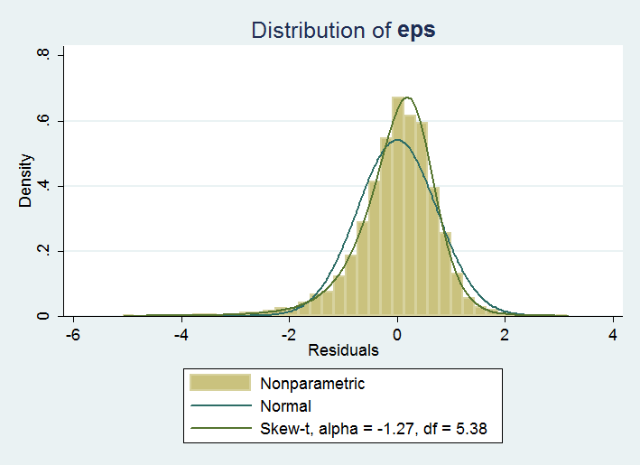

The results from the preferred specification are presented in map form in Figure 2. The same estimates are presented in detail in Annex A along with their standard errors, suggesting a confidence interval around each point estimate. The predicted poverty rates reveal considerable heterogeneity across municipalities. While the national poverty rate is estimated at 24.5 percent in 2012 (based on data collected in 2013), the municipality level poverty estimates range from 4.8 percent in parts of Belgrade to 66.1 percent in parts of Šumadija and Western Serbia. Table 4 shows the regional level estimates using poverty mapping.

**Table 4**: *Region-Level Estimates of At-Risk-Of-Poverty in 2011, poverty mapping method*

|  |  |  |  |  |  |  |  |  |
| --- | --- | --- | --- | --- | --- | --- | --- | --- |
| Region | Poverty Rate | SE Poverty | Poverty Gap | SE Poverty Gap | Squared Poverty Gap | SE Squared Poverty Gap | Gini Index | SE Gini |
| National | 25.7% | 0.0077 | 0.088 | 0.0035 | 0.044 | 0.0021 | 0.368 | 0.0053 |
| Belgrade Region | 10.5% | 0.0085 | 0.032 | 0.0028 | 0.014 | 0.0014 | 0.332 | 0.0061 |
| Southern and Eastern Serbia | 33.0% | 0.0141 | 0.117 | 0.0065 | 0.059 | 0.0038 | 0.364 | 0.0059 |
| Vojvodina Region | 25.8% | 0.0124 | 0.087 | 0.0049 | 0.043 | 0.0027 | 0.349 | 0.0054 |
| Šumadija and Western Serbia | 32.3% | 0.0131 | 0.112 | 0.0056 | 0.056 | 0.0032 | 0.359 | 0.0051 |

Note: SE = standard errors

**Figure 2:** *Poverty Map of Serbia, 2011: at-risk-of-poverty rates (percent)*

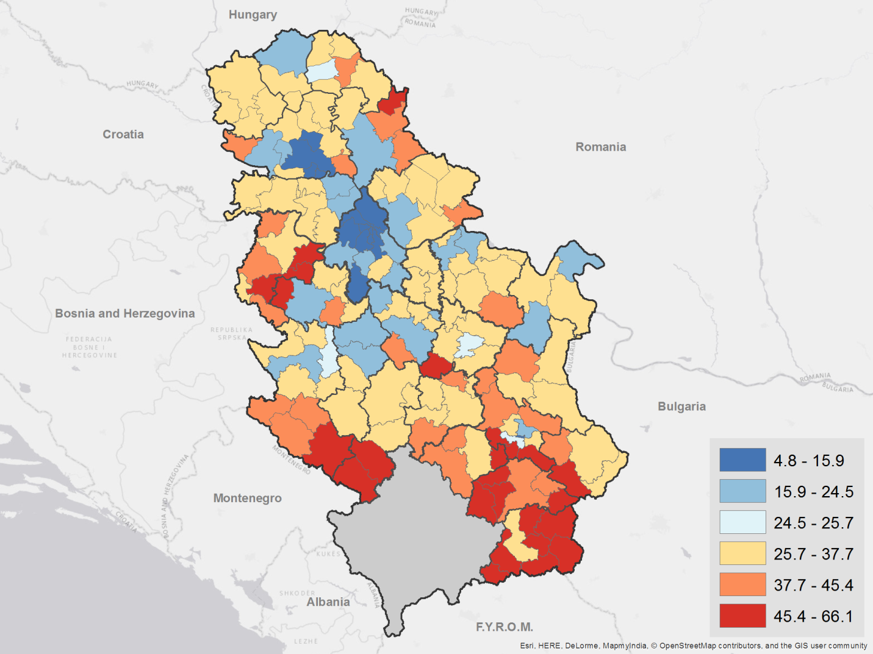

**Figure 3:** *Poverty Map of Serbia, 2011: District-Level at-risk-of-poverty rates (percent)*

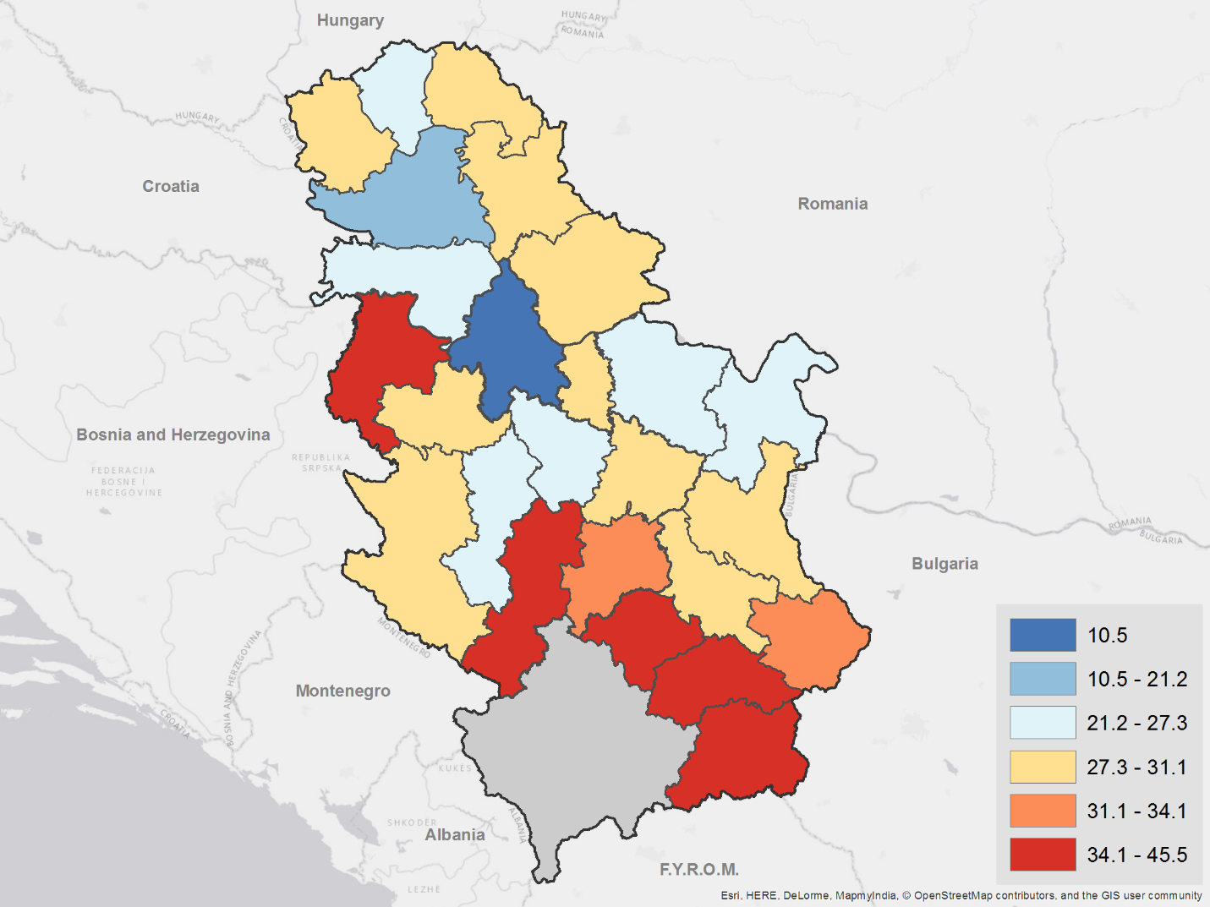

Predictions at the municipality level suggest that within regions, there are municipalities with significantly different incidence of poverty, highlighting important spatial heterogeneity that may not be apparent in the regional rates available from the SILC survey. For instance, predicted poverty estimates range from more than 13 percent in Medijana to more than 63 percent in Bojnik in the region of Southern and Eastern Serbia, which comes out to a 33 percent average for the region. Similarly, the regional poverty estimate for Belgrade is 10.5 percent, but this can obscure the fact that within the Belgrade region, relative poverty rates vary between 4.8 percent and nearly 27 percent.

The density of the population below the relative poverty threshold (i.e. the absolute number of individuals at risk of poverty, obtained as the product of the predicted relative poverty rate and population of the municipality) is concentrated in the more densely populated areas, which do not necessarily coincide with the areas with the highest AROP rates. In particular, a band of higher population density running down the center of the country has much higher concentration of people at risk of poverty, even as the overall rates of at risk of poverty in those municipalities is lower on average that other parts of the country. Figure 4 and Figure 5 highlight these spatial dimensions of poverty density in map form.

**Figure 4:** *Poverty Density Map of Serbia, 2011: number of individuals at risk of poverty*

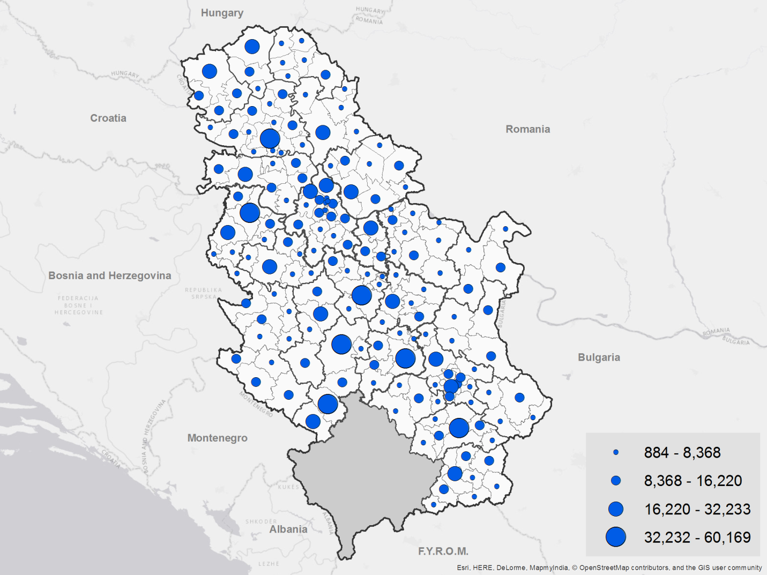

**Figure 5:** *Poverty Density Map of Serbia, 2011: number of individuals at risk of poverty (District)*

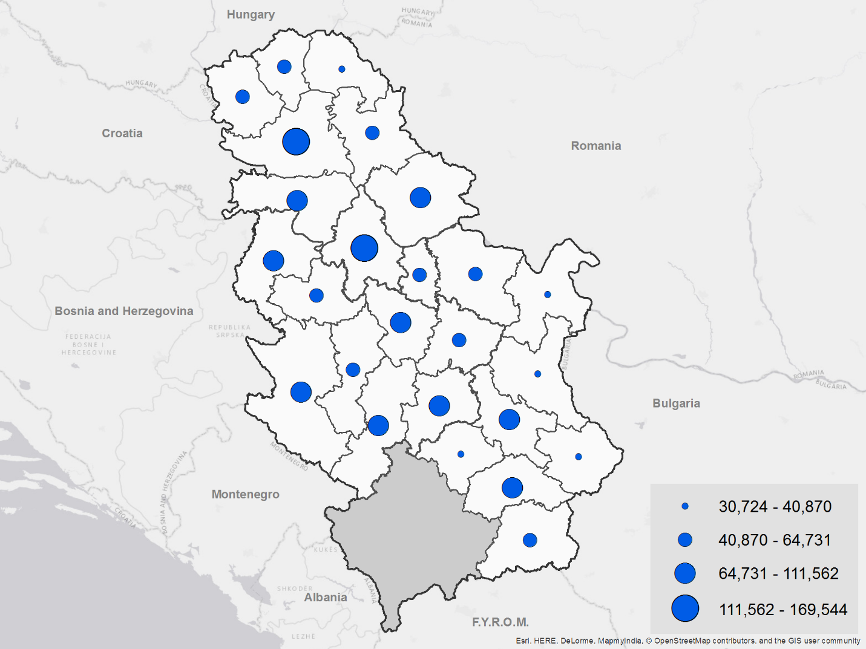

# V – Validation

To ensure that the map faithfully represents the underlying poverty dynamics of the country, it is important to ensure that the results are internally consistent. The model underwent validation within the SILC data by visually assessing the similarity between predicted and empirical income distributions. This process included the following steps: withholding a subset of the data, using the remainder as the “training” data, and subsequently imputing income into the withheld data using the preferred model to ensure the robustness of the approach. The resulting distributions in Figure 6 closely track each other. Annex B presents additional comparison of the ELL results to the poverty estimates derived from aggregated municipality-level data, following an alternative area-based approach.

**Figure 6:**Validation of Imputed and Observed Income within the SILC data

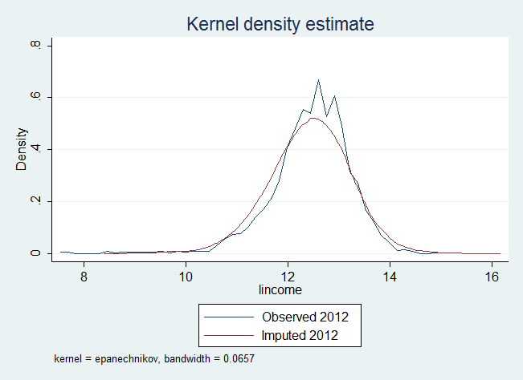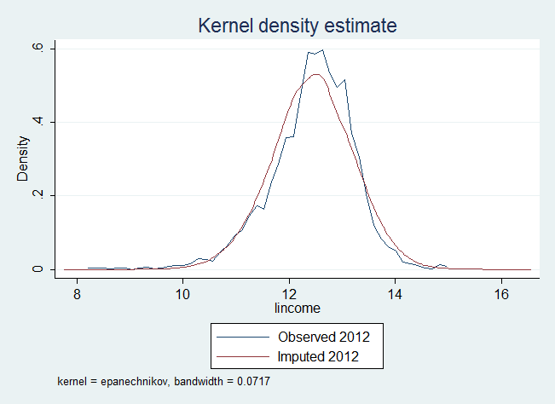

Comparing the aggregated poverty rates from the mapping exercise to the SILC estimates at the level for which they are representative is another way to confirm that the results conform to expectations. Table 5 reports these rates for comparison, noting that both the ELL and SILC results are estimated with standard errors around them. The estimates are comparable and within confidence intervals of each other. The differences between sampled and imputed poverty rates at the regional level are small. While estimates for the region of Šumadija and Western Serbia differ more than elsewhere, their confidence intervals still barely overlap, and the true rate might have changed from the year of the census to the year of the survey. At the national level, the estimated poverty rate was 25.7 percent, similar to the official 2013 SILC-based poverty rate of 24.5 percent for income year 2012.

***Table 5:*** *Comparison of Poverty Rate Estimates*

|  |  |  |
| --- | --- | --- |
| At risk of poverty (%) | ELL- full 2011 Census | SILC 2013 |
| National | 25.7 | 24.5 |
| Belgrade | 10.5 | 11.6 |
| Vojvodina | 25.8 | 26.8 |
| Šumadija and Western Serbia | 32.3 | 28.2 |
| Southern and Eastern Serbia | 33.0 | 31.0 |

# VI – Concluding remarks

This report presents the method and results of small area poverty estimation for Serbia. Given that the SILC survey in Serbia is not representative at the municipality-level, the data only allow for statistically representative poverty estimates at the regional level. Using the full micro-data from the 2011 Population Census and applying small area estimation techniques, this report describes the estimation of poverty at the municipality-level. According to the estimates, relative poverty ranges from 4.8 percent in Novi Beograd in the Belgrade Region, to 66.1 percent in Tutin in the region of Šumadija and Western Serbia. When aggregated, these estimates are largely consistent with the regional estimates derived from the SILC.

These first poverty maps for Serbia based on the full 2011 Population Census provide valuable information about living standards at the local level and can be a useful tool for policy making. Annex F presents a few examples of linking poverty maps to maps of other dimensions of well-being and potential policy indicators.

# VII – References

Bedi, T., A. Coudouel and K. Simler, (2007) *More than a pretty picture: using poverty maps to design better policies and interventions.* Washington DC: The World Bank Group.

Elbers C., J. O. Lanjouw and P. Lanjouw (2003) “Micro-Level Estimation of Poverty and Inequality”. *Econometrica* 71(1): 355–364.

Fay, R. and R. Herriot. (1979) “Estimates of income for small places: an application of James-Stein procedures to census data.” *Journal of the American Statistical Association* 74 (1979): 269–277.

Molina I. and Rao J. (2010) “Small area estimation of poverty indicators.” *Canadian Journal of Statistics*, 38(3), 369-385.

Rao, J. N. K. (2003) *Small Area Estimation.* 1st ed. Wiley-Interscience.

Statistical Office of the Republic of Serbia (2015) “Income and Living conditions in the Republic of Serbia – 2013”. Final Report. Belgrade, Republic of Serbia: Statistical Office

World Bank (2012) “Pilot Study of Small Area Poverty Estimation Methods for the New Member States of the European Union,” Report prepared for the Scientific Steering Committee of the World Bank and European Commission Project on Small Area Poverty Estimation, Washington, DC: The World Bank Group.

# Annex A – Area and Municipal-level At-Risk-Of-Poverty Estimates

|  |  |  |  |  |  |  |  |  |
| --- | --- | --- | --- | --- | --- | --- | --- | --- |
| Area | Poverty Rate | SE Poverty | Poverty Gap | SE Poverty Gap | Sq. Poverty Gap | SE Sq. Poverty Gap | Gini Index | SE Gini |
| Beogradska | 10.5% | 0.0085 | 0.032 | 0.0028 | 0.014 | 0.0014 | 0.332 | 0.0061 |
| Borska | 26.3% | 0.0250 | 0.089 | 0.0099 | 0.044 | 0.0053 | 0.353 | 0.0067 |
| Braničevska | 25.6% | 0.0210 | 0.086 | 0.0082 | 0.042 | 0.0044 | 0.351 | 0.0076 |
| Jablanička | 45.5% | 0.0308 | 0.174 | 0.0154 | 0.091 | 0.0093 | 0.372 | 0.0059 |
| Južnobačka | 21.2% | 0.0160 | 0.069 | 0.0056 | 0.033 | 0.0029 | 0.345 | 0.0062 |
| Južnobanatska | 28.1% | 0.0223 | 0.097 | 0.0087 | 0.049 | 0.0047 | 0.352 | 0.0060 |
| Kolubarska | 30.6% | 0.0254 | 0.108 | 0.0106 | 0.055 | 0.0059 | 0.364 | 0.0062 |
| Mačvanska | 38.2% | 0.0223 | 0.138 | 0.0101 | 0.071 | 0.0058 | 0.366 | 0.0060 |
| Moravička | 27.0% | 0.0285 | 0.090 | 0.0108 | 0.044 | 0.0056 | 0.345 | 0.0053 |
| Nišavska | 29.3% | 0.0195 | 0.099 | 0.0078 | 0.049 | 0.0042 | 0.359 | 0.0087 |
| Pčinjska | 42.0% | 0.0290 | 0.160 | 0.0136 | 0.085 | 0.0081 | 0.370 | 0.0082 |
| Pirotska | 34.1% | 0.0334 | 0.118 | 0.0137 | 0.059 | 0.0074 | 0.351 | 0.0065 |
| Podunavska | 28.3% | 0.0287 | 0.094 | 0.0110 | 0.046 | 0.0057 | 0.346 | 0.0054 |
| Pomoravska | 29.9% | 0.0222 | 0.100 | 0.0088 | 0.049 | 0.0047 | 0.348 | 0.0055 |
| Rasinska | 31.9% | 0.0289 | 0.109 | 0.0119 | 0.054 | 0.0065 | 0.354 | 0.0060 |
| Raška | 39.5% | 0.0249 | 0.145 | 0.0115 | 0.074 | 0.0067 | 0.367 | 0.0078 |
| Severnobačka | 25.5% | 0.0302 | 0.085 | 0.0113 | 0.042 | 0.0059 | 0.340 | 0.0056 |
| Severnobanatska | 28.6% | 0.0238 | 0.099 | 0.0091 | 0.050 | 0.0049 | 0.347 | 0.0057 |
| Srednjobanatska | 29.0% | 0.0243 | 0.102 | 0.0099 | 0.052 | 0.0055 | 0.355 | 0.0066 |
| Sremska | 27.3% | 0.0172 | 0.091 | 0.0067 | 0.045 | 0.0036 | 0.346 | 0.0070 |
| Šumadijska | 26.6% | 0.0307 | 0.086 | 0.0114 | 0.041 | 0.0057 | 0.345 | 0.0053 |
| Toplička | 40.3% | 0.0379 | 0.146 | 0.0176 | 0.075 | 0.0102 | 0.356 | 0.0059 |
| Zaječarska | 29.6% | 0.0288 | 0.101 | 0.0116 | 0.050 | 0.0063 | 0.353 | 0.0060 |
| Zapadnobačka | 29.6% | 0.0312 | 0.100 | 0.0119 | 0.049 | 0.0062 | 0.343 | 0.0058 |
| Zlatiborska | 31.1% | 0.0185 | 0.109 | 0.0076 | 0.055 | 0.0042 | 0.361 | 0.0073 |

|  |  |  |  |  |  |  |  |  |
| --- | --- | --- | --- | --- | --- | --- | --- | --- |
| **Belgrade Region (Beogradski Region)** | | | | | | | | |
| Municipality | Poverty Rate | SE Poverty | Poverty Gap | SE Poverty Gap | Sq. Poverty Gap | SE Sq. Poverty Gap | Gini Index | SE Gini |
| Barajevo | 21.9% | 0.044 | 0.068 | 0.015 | 0.032 | 0.0075 | 0.330 | 0.0075 |
| Voždovac | 8.6% | 0.020 | 0.025 | 0.006 | 0.011 | 0.0026 | 0.319 | 0.0051 |
| Vračar | 5.3% | 0.012 | 0.015 | 0.004 | 0.007 | 0.0016 | 0.307 | 0.0053 |
| Grocka | 18.2% | 0.038 | 0.056 | 0.013 | 0.027 | 0.0064 | 0.331 | 0.0063 |
| Zvezdara | 8.3% | 0.027 | 0.023 | 0.008 | 0.010 | 0.0038 | 0.315 | 0.0052 |
| Zemun | 11.0% | 0.020 | 0.032 | 0.006 | 0.015 | 0.0028 | 0.320 | 0.0050 |
| Lazarevac | 13.4% | 0.028 | 0.040 | 0.009 | 0.018 | 0.0042 | 0.326 | 0.0055 |
| Mladenovac | 24.0% | 0.052 | 0.078 | 0.020 | 0.037 | 0.0102 | 0.341 | 0.0051 |
| Novi Beograd | 4.8% | 0.011 | 0.014 | 0.003 | 0.006 | 0.0014 | 0.304 | 0.0051 |
| Obrenovac | 20.1% | 0.041 | 0.065 | 0.015 | 0.031 | 0.0076 | 0.343 | 0.0057 |
| Palilula | 11.9% | 0.022 | 0.036 | 0.007 | 0.016 | 0.0033 | 0.325 | 0.0052 |
| Rakovica | 6.9% | 0.027 | 0.019 | 0.008 | 0.008 | 0.0034 | 0.307 | 0.0051 |
| Savski venac | 5.7% | 0.015 | 0.016 | 0.004 | 0.007 | 0.0020 | 0.308 | 0.0055 |
| Sopot | 26.9% | 0.044 | 0.089 | 0.017 | 0.043 | 0.0094 | 0.337 | 0.0071 |
| Stari grad | 5.4% | 0.014 | 0.015 | 0.004 | 0.006 | 0.0017 | 0.306 | 0.0053 |
| Čukarica | 8.3% | 0.017 | 0.024 | 0.005 | 0.011 | 0.0023 | 0.318 | 0.0048 |
| Surčin | 15.9% | 0.035 | 0.048 | 0.011 | 0.022 | 0.0053 | 0.318 | 0.0051 |

| **Southern and Eastern Serbia (Region Južne i Istočne Srbije)** | | | | | | | | |
| --- | --- | --- | --- | --- | --- | --- | --- | --- |
| Municipality | Poverty Rate | SE Poverty | Poverty Gap | SE Poverty Gap | Sq. Poverty Gap | SE Sq. Poverty Gap | Gini Index | SE Gini |
| Aleksinac | 40.9% | 0.051 | 0.147 | 0.023 | 0.075 | 0.0125 | 0.354 | 0.0057 |
| Babušnica | 50.4% | 0.055 | 0.193 | 0.029 | 0.101 | 0.0174 | 0.360 | 0.0082 |
| Bela Palanka | 44.5% | 0.047 | 0.164 | 0.022 | 0.084 | 0.0130 | 0.347 | 0.0073 |
| Blace | 38.9% | 0.055 | 0.134 | 0.025 | 0.066 | 0.0138 | 0.340 | 0.0069 |
| Bojnik | 63.4% | 0.054 | 0.277 | 0.035 | 0.158 | 0.0240 | 0.383 | 0.0107 |
| Boljevac | 38.2% | 0.057 | 0.137 | 0.028 | 0.070 | 0.0161 | 0.363 | 0.0072 |
| Bor | 23.1% | 0.040 | 0.079 | 0.016 | 0.039 | 0.0083 | 0.348 | 0.0052 |
| Bosilegrad | 51.6% | 0.048 | 0.210 | 0.028 | 0.114 | 0.0181 | 0.384 | 0.0101 |
| Bujanovac | 54.6% | 0.045 | 0.231 | 0.025 | 0.129 | 0.0165 | 0.385 | 0.0078 |
| Velika Plana | 31.5% | 0.043 | 0.105 | 0.017 | 0.051 | 0.0088 | 0.339 | 0.0059 |
| Veliko Gradište | 22.0% | 0.035 | 0.072 | 0.013 | 0.035 | 0.0065 | 0.342 | 0.0071 |
| Vladičin Han | 52.4% | 0.061 | 0.208 | 0.033 | 0.111 | 0.0205 | 0.369 | 0.0074 |
| Vlasotince | 43.8% | 0.052 | 0.162 | 0.025 | 0.083 | 0.0141 | 0.361 | 0.0071 |
| Vranje | 31.1% | 0.049 | 0.107 | 0.020 | 0.053 | 0.0108 | 0.344 | 0.0054 |
| Gadžin Han | 51.0% | 0.066 | 0.191 | 0.034 | 0.099 | 0.0203 | 0.350 | 0.0104 |
| Golubac | 28.5% | 0.040 | 0.094 | 0.016 | 0.046 | 0.0082 | 0.342 | 0.0086 |
| Dimitrovgrad | 33.8% | 0.046 | 0.114 | 0.019 | 0.056 | 0.0098 | 0.341 | 0.0066 |
| Doljevac | 51.7% | 0.056 | 0.194 | 0.028 | 0.100 | 0.0167 | 0.344 | 0.0083 |
| Žabari | 36.2% | 0.058 | 0.127 | 0.025 | 0.064 | 0.0136 | 0.348 | 0.0084 |
| Žagubica | 40.3% | 0.055 | 0.144 | 0.025 | 0.073 | 0.0144 | 0.348 | 0.0090 |
| Žitorađa | 50.2% | 0.062 | 0.195 | 0.031 | 0.104 | 0.0190 | 0.357 | 0.0082 |
| Zaječar | 26.5% | 0.043 | 0.087 | 0.017 | 0.042 | 0.0087 | 0.347 | 0.0050 |
| Kladovo | 19.8% | 0.034 | 0.062 | 0.011 | 0.029 | 0.0055 | 0.333 | 0.0061 |
| Knjaževac | 33.1% | 0.050 | 0.115 | 0.021 | 0.057 | 0.0115 | 0.350 | 0.0063 |
| Kuršumlija | 40.8% | 0.055 | 0.144 | 0.025 | 0.072 | 0.0138 | 0.343 | 0.0060 |
| Kučevo | 33.5% | 0.045 | 0.113 | 0.018 | 0.055 | 0.0096 | 0.341 | 0.0070 |
| Lebane | 54.6% | 0.059 | 0.219 | 0.035 | 0.118 | 0.0223 | 0.371 | 0.0066 |
| Leskovac | 42.7% | 0.043 | 0.159 | 0.021 | 0.083 | 0.0125 | 0.368 | 0.0056 |
| Majdanpek | 37.2% | 0.054 | 0.133 | 0.025 | 0.067 | 0.0144 | 0.349 | 0.0067 |
| Malo Crniće | 29.6% | 0.055 | 0.100 | 0.022 | 0.050 | 0.0120 | 0.347 | 0.0079 |
| Medveđa | 52.4% | 0.053 | 0.209 | 0.029 | 0.112 | 0.0179 | 0.374 | 0.0079 |
| Merošina | 47.7% | 0.052 | 0.179 | 0.025 | 0.093 | 0.0144 | 0.349 | 0.0084 |
| Negotin | 28.5% | 0.049 | 0.097 | 0.019 | 0.048 | 0.0098 | 0.351 | 0.0057 |
| Petrovac na Mlavi | 27.8% | 0.046 | 0.094 | 0.018 | 0.046 | 0.0094 | 0.350 | 0.0065 |
| Pirot | 28.5% | 0.047 | 0.094 | 0.018 | 0.045 | 0.0096 | 0.339 | 0.0050 |
| Požarevac | 16.9% | 0.036 | 0.052 | 0.012 | 0.024 | 0.0057 | 0.330 | 0.0054 |
| Preševo | 63.6% | 0.050 | 0.279 | 0.034 | 0.158 | 0.0235 | 0.377 | 0.0147 |
| Prokuplje | 36.8% | 0.056 | 0.132 | 0.025 | 0.067 | 0.0142 | 0.355 | 0.0053 |
| Ražanj | 38.2% | 0.060 | 0.134 | 0.026 | 0.068 | 0.0145 | 0.350 | 0.0094 |
| Svrljig | 40.2% | 0.052 | 0.140 | 0.023 | 0.069 | 0.0127 | 0.343 | 0.0073 |
| Smederevo | 26.8% | 0.041 | 0.088 | 0.015 | 0.042 | 0.0077 | 0.344 | 0.0052 |
| Smederevska Palanka | 29.0% | 0.040 | 0.097 | 0.016 | 0.048 | 0.0084 | 0.347 | 0.0052 |
| Sokobanja | 27.4% | 0.040 | 0.091 | 0.015 | 0.045 | 0.0079 | 0.345 | 0.0070 |
| Surdulica | 46.7% | 0.053 | 0.182 | 0.027 | 0.097 | 0.0158 | 0.368 | 0.0063 |
| Trgovište | 56.5% | 0.055 | 0.234 | 0.033 | 0.129 | 0.0211 | 0.382 | 0.0123 |
| Crna Trava | 53.6% | 0.057 | 0.212 | 0.031 | 0.113 | 0.0199 | 0.371 | 0.0165 |
| Niška Banja | 32.8% | 0.061 | 0.108 | 0.024 | 0.052 | 0.0125 | 0.333 | 0.0072 |
| Pantelej | 23.4% | 0.045 | 0.072 | 0.016 | 0.033 | 0.0078 | 0.333 | 0.0056 |
| Crveni krst | 37.3% | 0.051 | 0.128 | 0.021 | 0.063 | 0.0115 | 0.344 | 0.0066 |
| Palilula | 25.4% | 0.045 | 0.081 | 0.017 | 0.039 | 0.0084 | 0.337 | 0.0055 |
| Medijana | 13.4% | 0.033 | 0.038 | 0.010 | 0.017 | 0.0047 | 0.322 | 0.0052 |
| Kostolac | 27.6% | 0.056 | 0.100 | 0.025 | 0.052 | 0.0146 | 0.347 | 0.0068 |
| Vranjska Banja | 49.3% | 0.048 | 0.189 | 0.026 | 0.098 | 0.0163 | 0.363 | 0.0082 |

| **Šumadija and Western Serbia (Region Šumadije i Zapadne Srbije)** | | | | | | | | |
| --- | --- | --- | --- | --- | --- | --- | --- | --- |
| Municipality | Poverty Rate | SE Poverty | Poverty Gap | SE Poverty Gap | Sq. Poverty Gap | SE Sq. Poverty Gap | Gini Index | SE Gini |
| Aleksandrovac | 35.3% | 0.047 | 0.123 | 0.0196 | 0.062 | 0.0106 | 0.354 | 0.0070 |
| Aranđelovac | 23.3% | 0.043 | 0.073 | 0.0149 | 0.034 | 0.0073 | 0.329 | 0.0051 |
| Arilje | 29.4% | 0.055 | 0.101 | 0.0214 | 0.051 | 0.0113 | 0.346 | 0.0070 |
| Bajina Bašta | 34.7% | 0.059 | 0.120 | 0.0255 | 0.060 | 0.0141 | 0.348 | 0.0062 |
| Batočina | 36.1% | 0.060 | 0.125 | 0.0255 | 0.062 | 0.0138 | 0.348 | 0.0068 |
| Bogatić | 42.3% | 0.046 | 0.156 | 0.0208 | 0.081 | 0.0120 | 0.366 | 0.0081 |
| Brus | 39.2% | 0.051 | 0.142 | 0.0227 | 0.073 | 0.0129 | 0.356 | 0.0069 |
| Valjevo | 24.5% | 0.035 | 0.082 | 0.0135 | 0.040 | 0.0071 | 0.348 | 0.0049 |
| Varvarin | 38.3% | 0.044 | 0.136 | 0.0194 | 0.069 | 0.0111 | 0.357 | 0.0095 |
| Vladimirci | 49.6% | 0.059 | 0.196 | 0.0308 | 0.105 | 0.0188 | 0.373 | 0.0087 |
| Vrnjačka Banja | 26.8% | 0.047 | 0.087 | 0.0179 | 0.042 | 0.0092 | 0.338 | 0.0056 |
| Gornji Milanovac | 24.0% | 0.039 | 0.078 | 0.0141 | 0.038 | 0.0071 | 0.336 | 0.0050 |
| Despotovac | 27.7% | 0.047 | 0.091 | 0.0181 | 0.044 | 0.0095 | 0.335 | 0.0069 |
| Ivanjica | 35.9% | 0.052 | 0.126 | 0.0212 | 0.063 | 0.0114 | 0.349 | 0.0064 |
| Knić | 40.1% | 0.057 | 0.142 | 0.0256 | 0.071 | 0.0144 | 0.347 | 0.0085 |
| Kosjerić | 32.8% | 0.052 | 0.110 | 0.0213 | 0.054 | 0.0113 | 0.336 | 0.0076 |
| Koceljeva | 47.5% | 0.061 | 0.183 | 0.0311 | 0.097 | 0.0189 | 0.371 | 0.0101 |
| Kragujevac | 23.8% | 0.046 | 0.075 | 0.0167 | 0.035 | 0.0083 | 0.339 | 0.0049 |
| Kraljevo | 28.3% | 0.042 | 0.093 | 0.0161 | 0.045 | 0.0083 | 0.343 | 0.0051 |
| Krupanj | 49.4% | 0.049 | 0.186 | 0.0246 | 0.097 | 0.0147 | 0.360 | 0.0069 |
| Kruševac | 29.0% | 0.043 | 0.097 | 0.0171 | 0.047 | 0.0091 | 0.350 | 0.0051 |
| Lajkovac | 28.1% | 0.055 | 0.099 | 0.0222 | 0.051 | 0.0122 | 0.356 | 0.0073 |
| Loznica | 38.2% | 0.052 | 0.135 | 0.0228 | 0.067 | 0.0127 | 0.355 | 0.0060 |
| Lučani | 34.6% | 0.048 | 0.121 | 0.0202 | 0.061 | 0.0111 | 0.352 | 0.0065 |
| Ljig | 32.4% | 0.047 | 0.111 | 0.0187 | 0.055 | 0.0101 | 0.351 | 0.0083 |
| Ljubovija | 42.7% | 0.051 | 0.156 | 0.0241 | 0.080 | 0.0139 | 0.362 | 0.0087 |
| Mali Zvornik | 37.3% | 0.051 | 0.129 | 0.0219 | 0.064 | 0.0122 | 0.354 | 0.0073 |
| Mionica | 39.7% | 0.051 | 0.144 | 0.0218 | 0.074 | 0.0122 | 0.363 | 0.0085 |
| Nova Varoš | 40.0% | 0.047 | 0.142 | 0.0205 | 0.071 | 0.0114 | 0.350 | 0.0063 |
| Novi Pazar | 49.4% | 0.057 | 0.185 | 0.0291 | 0.096 | 0.0173 | 0.357 | 0.0054 |
| Osečina | 48.3% | 0.055 | 0.185 | 0.0284 | 0.098 | 0.0172 | 0.368 | 0.0094 |
| Paraćin | 29.2% | 0.033 | 0.096 | 0.0125 | 0.046 | 0.0064 | 0.341 | 0.0055 |
| Požega | 25.2% | 0.034 | 0.083 | 0.0125 | 0.040 | 0.0064 | 0.340 | 0.0057 |
| Priboj | 38.7% | 0.052 | 0.140 | 0.0234 | 0.071 | 0.0131 | 0.360 | 0.0059 |
| Prijepolje | 42.9% | 0.044 | 0.161 | 0.0203 | 0.084 | 0.0117 | 0.366 | 0.0062 |
| Rača | 34.9% | 0.040 | 0.121 | 0.0168 | 0.061 | 0.0092 | 0.349 | 0.0084 |
| Raška | 37.7% | 0.053 | 0.129 | 0.0224 | 0.063 | 0.0120 | 0.344 | 0.0064 |
| Rekovac | 47.4% | 0.063 | 0.176 | 0.0304 | 0.091 | 0.0180 | 0.350 | 0.0089 |
| Jagodina | 31.7% | 0.046 | 0.107 | 0.0184 | 0.053 | 0.0097 | 0.349 | 0.0054 |
| Svilajnac | 26.7% | 0.050 | 0.089 | 0.0195 | 0.043 | 0.0102 | 0.343 | 0.0066 |
| Sjenica | 46.6% | 0.054 | 0.182 | 0.0274 | 0.097 | 0.0165 | 0.372 | 0.0064 |
| Užice | 17.9% | 0.034 | 0.054 | 0.0112 | 0.025 | 0.0053 | 0.330 | 0.0050 |
| Topola | 37.6% | 0.060 | 0.134 | 0.0255 | 0.068 | 0.0140 | 0.357 | 0.0063 |
| Trstenik | 33.6% | 0.058 | 0.117 | 0.0247 | 0.058 | 0.0135 | 0.353 | 0.0060 |
| Tutin | 66.1% | 0.050 | 0.290 | 0.034 | 0.164 | 0.0233 | 0.380 | 0.0073 |
| Ćićevac | 30.3% | 0.049 | 0.098 | 0.0187 | 0.047 | 0.0096 | 0.328 | 0.0075 |
| Ćuprija | 24.9% | 0.037 | 0.080 | 0.0137 | 0.038 | 0.0070 | 0.340 | 0.0052 |
| Ub | 37.7% | 0.046 | 0.140 | 0.0204 | 0.073 | 0.0116 | 0.374 | 0.0077 |
| Čajetina | 26.5% | 0.047 | 0.088 | 0.0172 | 0.043 | 0.0087 | 0.343 | 0.0073 |
| Čačak | 24.3% | 0.043 | 0.079 | 0.0161 | 0.038 | 0.0082 | 0.339 | 0.0049 |
| Šabac | 32.3% | 0.043 | 0.114 | 0.0176 | 0.057 | 0.0096 | 0.360 | 0.0053 |
| Lapovo | 23.9% | 0.037 | 0.072 | 0.0134 | 0.033 | 0.0067 | 0.320 | 0.0074 |

| **Vojvodina Region (Region Vojvodine)** | | | | | | | | |
| --- | --- | --- | --- | --- | --- | --- | --- | --- |
| Municipality | Poverty Rate | SE Poverty | Poverty Gap | SE Poverty Gap | Sq. Poverty Gap | SE Sq. Poverty Gap | Gini Index | SE Gini |
| Ada | 26.2% | 0.0368 | 0.086 | 0.0137 | 0.042 | 0.0071 | 0.33053 | 0.0059 |
| Alibunar | 35.9% | 0.0434 | 0.129 | 0.0182 | 0.066 | 0.0101 | 0.35663 | 0.0062 |
| Apatin | 33.5% | 0.0488 | 0.116 | 0.0195 | 0.058 | 0.0104 | 0.33659 | 0.0053 |
| Bač | 38.6% | 0.0558 | 0.139 | 0.0251 | 0.071 | 0.0144 | 0.34879 | 0.0078 |
| Bačka Palanka | 23.4% | 0.0455 | 0.076 | 0.0165 | 0.037 | 0.0083 | 0.33455 | 0.0054 |
| Bačka Topola | 30.9% | 0.0462 | 0.107 | 0.0183 | 0.053 | 0.0098 | 0.34966 | 0.0059 |
| Bački Petrovac | 19.7% | 0.0409 | 0.063 | 0.0138 | 0.030 | 0.0068 | 0.32886 | 0.0063 |
| Bela Crkva | 45.4% | 0.0651 | 0.173 | 0.0313 | 0.092 | 0.0185 | 0.35776 | 0.0067 |
| Beočin | 33.7% | 0.0448 | 0.116 | 0.0191 | 0.058 | 0.0104 | 0.34094 | 0.0063 |
| Bečej | 36.8% | 0.0514 | 0.135 | 0.0227 | 0.070 | 0.0129 | 0.35420 | 0.0060 |
| Vršac | 26.1% | 0.0462 | 0.091 | 0.0184 | 0.046 | 0.0100 | 0.34537 | 0.0053 |
| Žabalj | 34.3% | 0.055 | 0.120 | 0.0222 | 0.060 | 0.0119 | 0.34639 | 0.0062 |
| Žitište | 40.9% | 0.0571 | 0.154 | 0.0256 | 0.082 | 0.0148 | 0.36416 | 0.0093 |
| Zrenjanin | 23.0% | 0.0314 | 0.076 | 0.0118 | 0.037 | 0.0062 | 0.33890 | 0.0047 |
| Inđija | 23.1% | 0.0379 | 0.073 | 0.0131 | 0.035 | 0.0065 | 0.33199 | 0.0052 |
| Irig | 36.0% | 0.0518 | 0.126 | 0.0215 | 0.063 | 0.0117 | 0.34347 | 0.0066 |
| Kanjiža | 30.3% | 0.0387 | 0.106 | 0.0150 | 0.054 | 0.0080 | 0.35012 | 0.0065 |
| Kikinda | 26.0% | 0.049 | 0.088 | 0.0183 | 0.043 | 0.0094 | 0.33888 | 0.0053 |
| Kovačica | 35.6% | 0.0449 | 0.127 | 0.0183 | 0.065 | 0.0101 | 0.35381 | 0.0071 |
| Kovin | 31.6% | 0.0457 | 0.112 | 0.0188 | 0.057 | 0.0103 | 0.36096 | 0.0056 |
| Kula | 26.1% | 0.0443 | 0.084 | 0.0161 | 0.040 | 0.0081 | 0.33304 | 0.0051 |
| Mali Iđoš | 35.1% | 0.0478 | 0.125 | 0.0205 | 0.064 | 0.0115 | 0.35782 | 0.0075 |
| Nova Crnja | 49.1% | 0.0733 | 0.198 | 0.0371 | 0.109 | 0.0228 | 0.37301 | 0.0095 |
| Novi Bečej | 36.0% | 0.0496 | 0.129 | 0.0211 | 0.066 | 0.0118 | 0.35009 | 0.0065 |
| Novi Kneževac | 36.2% | 0.0544 | 0.133 | 0.0236 | 0.070 | 0.0133 | 0.35156 | 0.0068 |
| Novi Sad | 15.7% | 0.024 | 0.048 | 0.0079 | 0.022 | 0.0038 | 0.32930 | 0.0051 |
| Opovo | 35.4% | 0.0597 | 0.126 | 0.0256 | 0.064 | 0.0144 | 0.34750 | 0.0065 |
| Odžaci | 37.1% | 0.0569 | 0.130 | 0.0241 | 0.066 | 0.0132 | 0.34674 | 0.0062 |
| Pančevo | 21.4% | 0.0396 | 0.067 | 0.0141 | 0.032 | 0.0070 | 0.33264 | 0.0049 |
| Pećinci | 32.2% | 0.0499 | 0.113 | 0.0212 | 0.058 | 0.0118 | 0.34807 | 0.0083 |
| Plandište | 36.8% | 0.0533 | 0.133 | 0.0228 | 0.068 | 0.0127 | 0.36120 | 0.0093 |
| Ruma | 27.9% | 0.0493 | 0.093 | 0.0191 | 0.045 | 0.0099 | 0.33983 | 0.0049 |
| Senta | 25.6% | 0.0406 | 0.089 | 0.0157 | 0.045 | 0.0084 | 0.34167 | 0.0058 |
| Sečanj | 42.5% | 0.0486 | 0.160 | 0.0232 | 0.085 | 0.0137 | 0.36275 | 0.0079 |
| Sombor | 27.5% | 0.0496 | 0.092 | 0.0187 | 0.045 | 0.0096 | 0.34024 | 0.0050 |
| Srbobran | 35.0% | 0.0499 | 0.119 | 0.0206 | 0.059 | 0.0111 | 0.33676 | 0.0059 |
| Sremska Mitrovica | 29.4% | 0.0393 | 0.099 | 0.0153 | 0.049 | 0.0080 | 0.34624 | 0.0056 |
| Sremski Karlovci | 15.8% | 0.0345 | 0.047 | 0.0110 | 0.021 | 0.0053 | 0.31364 | 0.0073 |
| Stara Pazova | 19.6% | 0.0452 | 0.061 | 0.0156 | 0.029 | 0.0077 | 0.32906 | 0.0058 |
| Subotica | 23.5% | 0.0389 | 0.076 | 0.0144 | 0.037 | 0.0074 | 0.33306 | 0.0051 |
| Temerin | 15.1% | 0.0364 | 0.044 | 0.0115 | 0.020 | 0.0053 | 0.31261 | 0.0054 |
| Titel | 40.4% | 0.0543 | 0.147 | 0.0238 | 0.076 | 0.0136 | 0.34734 | 0.0078 |
| Vrbas | 26.1% | 0.0405 | 0.084 | 0.0145 | 0.040 | 0.0072 | 0.33579 | 0.0052 |
| Čoka | 39.8% | 0.044 | 0.147 | 0.0203 | 0.076 | 0.0118 | 0.35645 | 0.0069 |
| Šid | 36.8% | 0.052 | 0.129 | 0.0222 | 0.065 | 0.0123 | 0.34595 | 0.0061 |
| Petrovaradin | 12.8% | 0.0269 | 0.037 | 0.0081 | 0.016 | 0.0037 | 0.31910 | 0.0049 |

# Annex B – Additional Validation

As part of the validation of the results, an area-based poverty mapping exercise was conducted, using municipality-level aggregates from the census that are publically available, combined with direct survey estimates. To compare these visually, the area-based estimates are plotted along the x-axis, and ELL-model estimates along the y-axis. Perfect correlation would lie along the 45˚ line. The size of the circle represents the population size. As Figure 7 shows, there is indeed a strong relationship between the model predictions and those of the adjusted values in the SILC data.

**Figure 7:** *Comparison of Area-Based and ELL-based Estimates*



# Annex C – SILC Census Comparisons

|  |  |  |  |  |  |  |  |
| --- | --- | --- | --- | --- | --- | --- | --- |
| **Individual-Level Summarized by Household: Employment** | | | | | | | |
|  | Survey | | |  | Census | | |
|  | Survey Mean of Household Sum | Survey Mean of Household Mean | Survey Mean of Household Max |  | Survey Mean of Household Sum | Survey Mean of Household Mean | Survey Mean of Household Max |
| Inactive: On pension | 0.65 | 0.33 | 0.52 | 0.65 | 0.32 | 0.51 |
| Inactive: Incapacitated | 0.02 | 0.01 | 0.02 | 0.04 | 0.02 | 0.03 |
| Actively Looking for a Job | 0.31 | 0.10 | 0.25 | 0.27 | 0.09 | 0.21 |
| Receive a Salary | 1.09 | 0.36 | 0.67 | 0.97 | 0.32 | 0.61 |
| Receive Pension | 0.88 | 0.33 | 0.58 | 0.67 | 0.33 | 0.52 |
| Receive Social Benefits | 0.29 | 0.15 | 0.26 | 0.07 | 0.02 | 0.05 |
| Receive Scholarship | 0.01 | 0.00 | 0.01 | 0.01 | 0.00 | 0.01 |
| Receive Unemployment | 0.02 | 0.01 | 0.02 | 0.02 | 0.01 | 0.02 |
| Unemployed | 0.30 | 0.11 | 0.24 | 0.10 | 0.03 | 0.08 |
| Out of Labor Force | 0.91 | 0.41 | 0.65 | 1.27 | 0.54 | 0.77 |
| Working | 1.13 | 0.43 | 0.66 | 1.10 | 0.43 | 0.66 |

|  |  |  |  |  |  |  |  |
| --- | --- | --- | --- | --- | --- | --- | --- |
| **Individual-Level Summarized by Household: Demographic** | | | | | | | |
|  | Survey | | |  | Census | | |
|  | Survey Mean of Household Sum | Survey Mean of Household Mean | Survey Mean of Household Max |  | Survey Mean of Household Sum | Survey Mean of Household Mean | Survey Mean of Household Max |
| Married and Live Together | 1.30 | 0.46 | 0.59 |  | 1.33 | 0.47 | 0.60 |
| Married and Live Separately | 0.02 | 0.01 | 0.01 | 0.04 | 0.02 | 0.04 |
| Widow/er | 0.32 | 0.20 | 0.31 | 0.29 | 0.17 | 0.28 |
| Divorced | 0.13 | 0.08 | 0.12 | 0.12 | 0.07 | 0.11 |
| Consensual Union | 0.11 | 0.04 | 0.06 | 0.09 | 0.03 | 0.05 |
| Serbian Nationality | 2.87 | 1.00 | 1.00 | 2.86 | 0.99 | 1.00 |
| Foreign Nationality | 0.01 | 0.01 | 0.01 | 0.02 | 0.01 | 0.01 |
| No Citizenship | 0.00 | 0.00 | 0.00 | 0.00 | 0.00 | 0.00 |
| Not Married/Union | 0.70 | 0.26 | 0.48 | 0.69 | 0.26 | 0.48 |
| Male | 1.40 | 0.47 | 0.82 | 1.40 | 0.47 | 0.83 |
| Female | 1.48 | 0.53 | 0.90 | 1.48 | 0.53 | 0.90 |
| Age 0-6 | 0.17 | 0.04 | 0.13 | 0.16 | 0.04 | 0.13 |
| Age 1-14 | 0.39 | 0.09 | 0.25 | 0.41 | 0.09 | 0.26 |
| Age 15-24 | 0.35 | 0.09 | 0.25 | 0.34 | 0.09 | 0.24 |
| Age 25-64 | 1.64 | 0.56 | 0.80 | 1.63 | 0.56 | 0.81 |
| Age 65+ | 0.58 | 0.29 | 0.44 | 0.50 | 0.25 | 0.39 |

|  |  |  |  |  |  |  |  |
| --- | --- | --- | --- | --- | --- | --- | --- |
| **Individual-Level Summarized by Household: Employment Sector** | | | | | | | |
|  | Survey | | |  | Census | | |
|  | Survey Mean of HH Sum | Survey Mean of HH Mean | Survey Mean of HH Max |  | Survey Mean of HH Sum | Survey Mean of HH Mean | Survey Mean of HH Max |
| Working in Agric. Sector | 0.16 | 0.09 | 0.11 |  | 0.14 | 0.08 | 0.10 |
| Mining And Quarrying | 0.01 | 0.01 | 0.01 | 0.01 | 0.01 | 0.01 |
| Manufacturing | 0.15 | 0.10 | 0.13 | 0.21 | 0.12 | 0.17 |
| Electricity, Gas, Steam And Air Conditioning Supply | 0.02 | 0.01 | 0.02 | 0.01 | 0.01 | 0.01 |
| Water Supply; Sewerage, Waste Activities | 0.01 | 0.01 | 0.01 | 0.02 | 0.01 | 0.02 |
| Construction | 0.05 | 0.03 | 0.04 | 0.06 | 0.04 | 0.06 |
| Wholesale And Retail Trade | 0.13 | 0.08 | 0.11 | 0.17 | 0.10 | 0.14 |
| Transportation And Storage | 0.06 | 0.04 | 0.05 | 0.06 | 0.03 | 0.05 |
| Accommodation And Food Service Activities | 0.03 | 0.02 | 0.03 | 0.04 | 0.02 | 0.03 |
| Information And Communication | 0.02 | 0.01 | 0.02 | 0.02 | 0.01 | 0.02 |
| Financial And Insurance Activities | 0.02 | 0.01 | 0.02 | 0.02 | 0.01 | 0.02 |
| Real Estate Activities | 0.00 | 0.00 | 0.00 | 0.00 | 0.00 | 0.00 |
| Professional, Scientific And Technical Activities | 0.02 | 0.02 | 0.02 | 0.04 | 0.02 | 0.03 |
| Administrative And Support Service Activities | 0.02 | 0.01 | 0.02 | 0.02 | 0.01 | 0.02 |
| Public Admin., Defense; Compulsory Social Security | 0.06 | 0.04 | 0.06 | 0.08 | 0.05 | 0.07 |
| Education | 0.06 | 0.04 | 0.06 | 0.06 | 0.04 | 0.06 |
| Human Health And Social Work Activities | 0.06 | 0.04 | 0.06 | 0.07 | 0.04 | 0.06 |
| Arts, Entertainment And Recreation | 0.01 | 0.01 | 0.01 | 0.02 | 0.01 | 0.02 |
| Other Service Activities | 0.02 | 0.01 | 0.02 | 0.02 | 0.01 | 0.02 |
| Activities Of Households As Employers | 0.00 | 0.00 | 0.00 | 0.00 | 0.00 | 0.00 |

|  |  |  |
| --- | --- | --- |
| **Household Level** | | |
|  | Survey | Census |
| Household Size | 2.874 | 2.879 |
| Household Size^2 | 10.813 | 10.874 |
| Log of Household size | 0.894 | 0.894 |
| Dependent Members | 0.939 | 0.910 |
| Dependency Ratio | 0.344 | 0.339 |
| Detached Home | 0.576 | 0.611 |
| Semi-detached Home | 0.102 | 0.033 |
| Residential building With Fewer Than 10 Units | 0.059 | 0.071 |
| Residential building With 10 Units or more | 0.262 | 0.265 |
| Other Building Type | 0.001 | 0.004 |
| Own Computer | 0.558 | 0.489 |
| Own Home | 0.796 | 0.877 |
| Number of Rooms | 2.696 | 2.721 |
| Urban Location | 0.654 | 0.617 |
| Bath or Shower in Home | 0.945 | 0.902 |
| Flush Toilet in Home | 0.940 | 0.899 |
| Rooms = 2 | 0.897 | 0.844 |
| Rooms = 3 | 0.504 | 0.503 |
| Rooms = 4 | 0.194 | 0.220 |
| Rooms = 5 | 0.069 | 0.092 |
| Rooms Per Capita | 1.176 | 1.219 |
| Log of Rooms | 0.901 | 0.905 |

# Annex D – Alpha and Beta Models

|  |  |  |  |
| --- | --- | --- | --- |
| **Alpha Model** | | | |
|  | Coeff. | Std. Err. | P>|t| |
| At least one HH member on pension | -0.421 | 0.0733 | 0.00 |
| At least one HH member employed in salaried position | -0.337 | 0.0881 | 0.00 |
| More than one HH member employed in salaried position | -0.414 | 0.0784 | 0.00 |
| At least one HH member employed in agricultural sector | 0.669 | 0.1090 | 0.00 |
| Urban Location | -0.303 | 0.0752 | 0.00 |
| MSE=5.441 ; R2=0.0316 ; Adjusted R2=0.0309 | | | |

|  |  |  |  |  |  |  |  |  |  |  |
| --- | --- | --- | --- | --- | --- | --- | --- | --- | --- | --- |
| Beta Model | | | | | | | | | | |
| **Demographics and Relationships** | | Coeff. | Std. Err. | P>|t| |  | **Dwelling** | | Coeff. | Std. Err. | P>|t| |
|  | Presence of HH member age 15-24 | -0.188 | 0.0203 | 0.00 |  |  | Share of HHs in municipality using coal for heating | 0.105 | 0.0530 | 0.05 |
|  | Presence of HH member age 1-14 | -0.091 | 0.0246 | 0.00 |  |  | Flush toilet in the household | 0.336 | 0.0387 | 0.00 |
|  | Presence of multiple HH members, age 1-14 | -0.120 | 0.0306 | 0.00 |  |  | Share of HHs in municipality using natural gas for heating | 0.246 | 0.0763 | 0.00 |
|  | More than one married couple cohabiting | -0.109 | 0.0216 | 0.00 |  |  | Share of HHs in municipality with central heating | 0.351 | 0.1154 | 0.00 |
|  | At least one married couple cohabiting | -0.146 | 0.0339 | 0.00 |  |  | Residential building with 10 and more dwellings | 0.244 | 0.0253 | 0.00 |
| **Income and employment** | |  |  |  |  |  | Residential building with less than 10 dwellings | 0.112 | 0.0386 | 0.00 |
|  | At least one HH member on pension | 0.214 | 0.0210 | 0.00 |  |  | Number of room in dwelling = 3 | 0.063 | 0.0203 | 0.00 |
|  | More than one HH member on pension | 0.295 | 0.0275 | 0.00 |  |  | Number of room in dwelling = 4 | 0.054 | 0.0236 | 0.02 |
|  | At least two HH member employed in salaried position | 0.323 | 0.0221 | 0.00 |  |  |  |  |  |  |
|  | At least three HH member employed in salaried position | 0.142 | 0.0313 | 0.00 |  | **Assets** | |  |  |  |
|  | At least one HH member looking for employment | -0.324 | 0.0197 | 0.00 |  |  | Owner-occupied dwelling | 0.033 | 0.0229 | 0.14 |
|  | Share in muni with member looking for employment | -0.635 | 0.4314 | 0.14 |  |  | Household owns a computer | 0.116 | 0.0222 | 0.00 |
|  | Share in municipality that receive social welfare assistance | -2.351 | 0.7763 | 0.00 |  |  |  |  |  |  |
|  | At least one HH member employed | 0.228 | 0.0248 | 0.00 |  |  |  |  |  |  |
| **Location** | |  |  |  |  | **Sectors** | |  |  |  |
|  | Belgrade region | 0.070 | 0.0330 | 0.03 |  |  | At least one HH member employed in agricultural sector | -0.201 | 0.0330 | 0.00 |
|  | Vojvodina | 0.002 | 0.0245 | 0.93 |  |  | More than one HH member employed in agriculture | -0.166 | 0.0495 | 0.00 |
|  | Šumadija and Western Serbia | -0.020 | 0.0292 | 0.48 |  |  | Total of HH members working in manufacturing sector | 0.070 | 0.0250 | 0.01 |
|  | Urban Location | 0.080 | 0.0216 | 0.00 |  |  | Total of HH members working in transportation sector | 0.077 | 0.0362 | 0.03 |
| **Education** | |  |  |  |  |  | Total of HH members working in finance/insurance | 0.081 | 0.0602 | 0.18 |
|  | At least one HH member with tertiary education | 0.237 | 0.0232 | 0.00 |  |  | Total of HH members working in professional sector | 0.088 | 0.0554 | 0.11 |
|  | More than one HH member with tertiary education | 0.208 | 0.0319 | 0.00 |  |  | Total of HH members working in education sector | 0.064 | 0.0368 | 0.08 |
|  | Adult member with less than secondary school | -0.156 | 0.0236 | 0.00 |  |  | Total of HH members working in health and social work | 0.197 | 0.0356 | 0.00 |
| MSE=0.3329; R2=0.4578; Adjusted R2=0.4546 | |  |  |  |  |  |  |  |  |  |

# Annex E – Maps of Additional Indicators Derived from Poverty Mapping

**Figure 8:** Average Imputed Income Per Adult Equivalent (annual, in RSD)

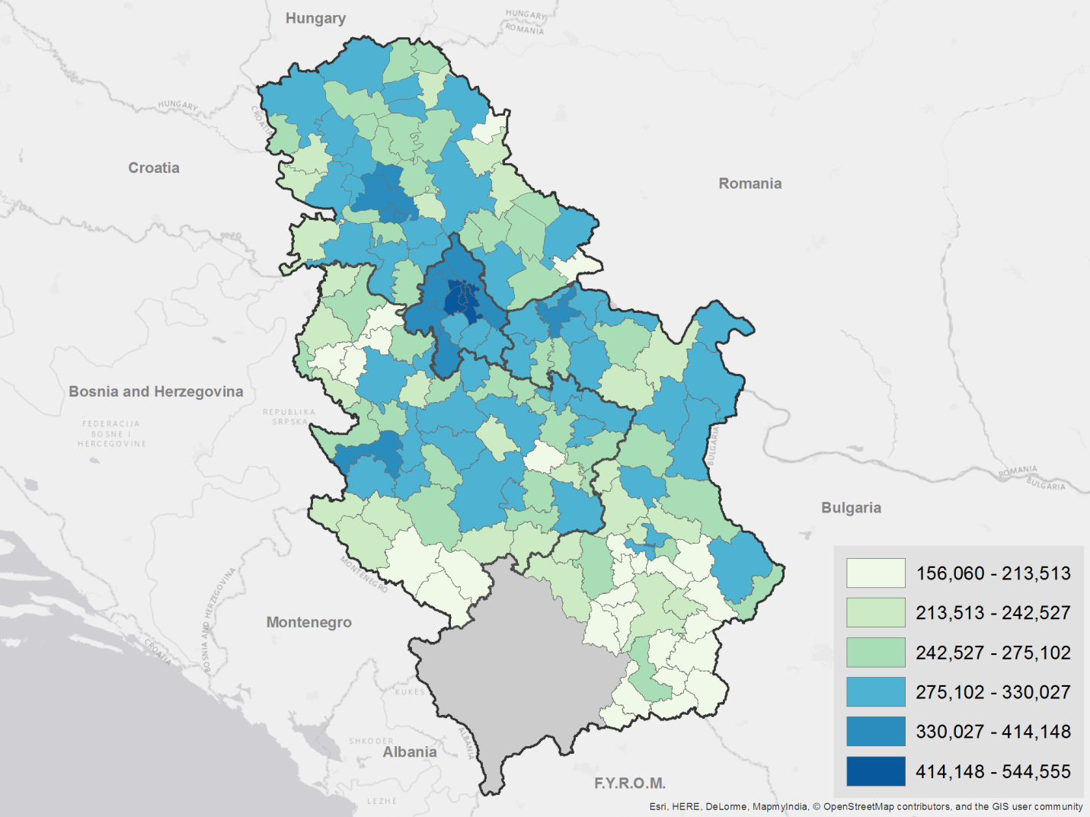

**Figure 9:** *Gini Coefficient of Imputed Per Adult Equivalent Income (percent)*

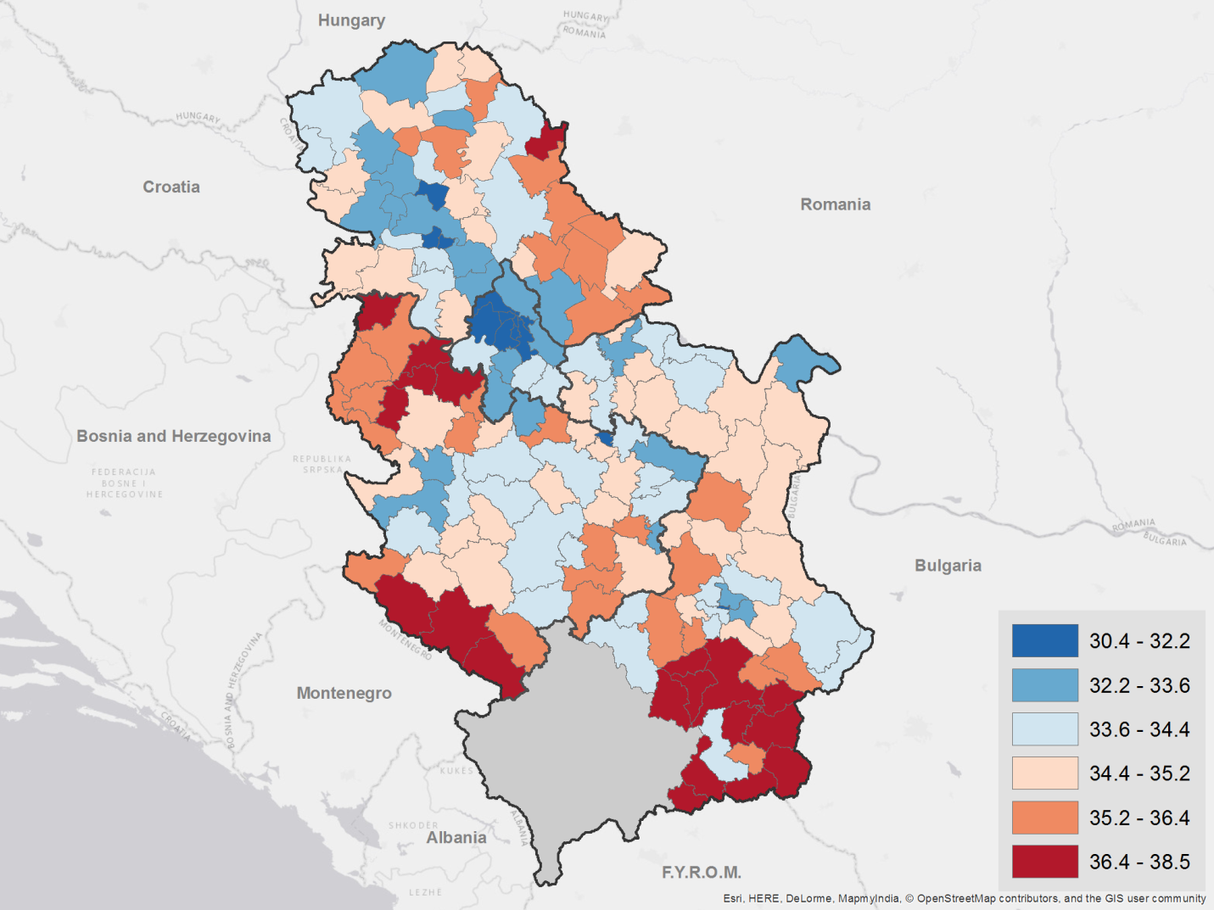

**Figure 10:** *Average Imputed Relative Poverty Gap (percent)*

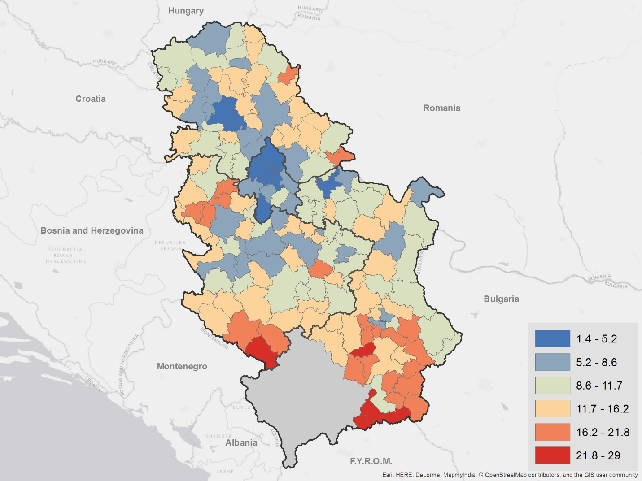

# Annex F – Examples of linking poverty maps to other thematic maps

Poverty maps can be overlaid with other thematic maps such as those on basic services, infrastructure, public expenditure, market accessibility, for example; to inform policy and interventions. To illustrate this potential use, below are a few examples of linking poverty maps to thematic maps where aggregated census data or administrative data are readily available.

Overall, there are distinctive spatial clusters along several important welfare dimensions. The south is poorer, has less access to services, and is more dependent on social welfare transfers. The southeast is on average more dependent on pension income, and the poverty rate is lower than average, but not as low as in the north and around Belgrade. The most prosperous area in the country clearly centers on Belgrade, and many indicators of welfare including labor income, education, water, and sanitation services are better in this part of the country. Specifically, the share of the population without schooling is concentrated in the poorest areas in the country (particularly in the south, and to a lesser extent, west of Belgrade). There are pockets of concentration of tertiary-educated people throughout the country, but there is a clear concentration around Belgrade where poverty rates are comparatively lower. Water supplied directly to the household is much more common in the northern part of the country, where poverty is less common. The presence of flush toilets also strongly correlates with urban dwellings and areas with lower poverty.

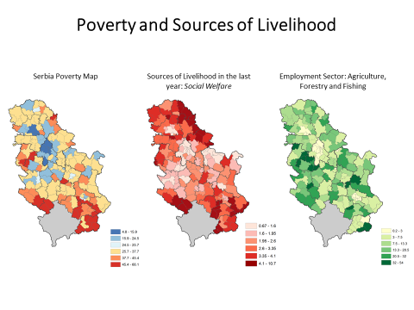

Note: “Social Welfare” = Percentage of people, in each municipality, that selected social welfare (child benefit, materially provision, etc.) as a source of livelihood in the individual census questionnaire.

”Agriculture, Forestry and Fishing” = Percentage of working age adults who specified Agriculture, Forestry, and Fishing as their sector of employment during the Census.

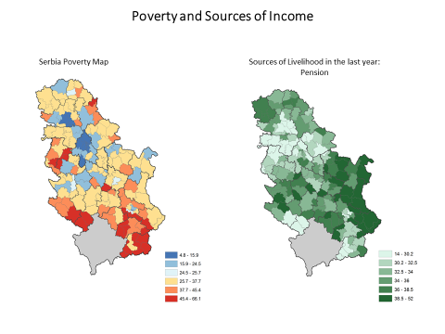

Note: “Pension” = Percentage of individuals who indicated during the Census that they receive pension income.

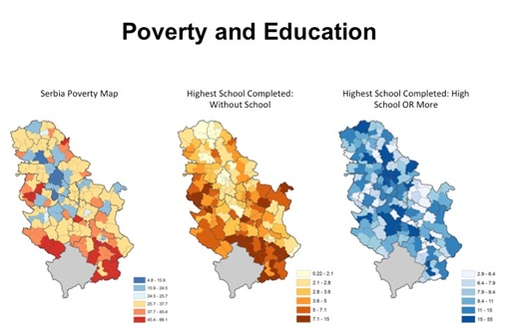

Note: “Without School” = Percentage of adults, in each municipality, who selected without school as highest school competed during the Census.

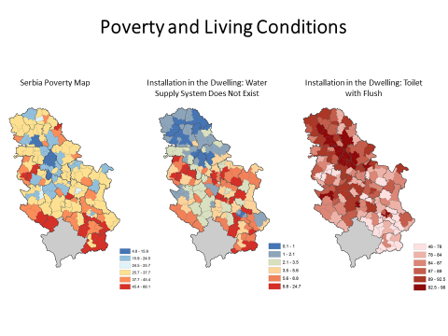“High school or More”= Percentage of people, in each municipality, that selected high school or higher school/faculty/academy as highest school competed during the Census.

Note: “Water Supply System Does Not Exist” = *Percentage of households in each municipality that selected “water supply: dos not exist” in the installation in the dwelling question during the Census.

“Toilet with Flush” = Percentage of households in each municipality that selected “toilet with flush” in the toilet in the dwelling question during the Census.

# Annex G – Variable Overlap

|  |  |  |
| --- | --- | --- |
| **Variable Description** | **Census** | **SILC** |
| HH size | List of persons (4, 10) | HL3 – HL7, HL12 – HL13, IA1, IA2 |
| Dependency Ratio | Pg1 – V3 (Ind) | ID12, HL3 – HL7 |
| Share male/Female | Pg1 – V2 (Ind) | HL3, ID12 |
| Enrollment by age | Pg1 – V3, Pg2 – V26 (Ind) | OP4, OP5, D14.3 |
| Educational attainment | Pg2 – V24, Pg2 – V25 (Ind) | OP7 |
| Consensual union | Pg2 – V18 (Ind) | OP9 |
| Marital status | Pg2 – V 17 (Ind) | OP8 |
| Citizenship | Pg2 – V 16 (Ind) | OP11 |
| Employed | Pg3 – 30–35 (Ind) | L1.1 – L1.11, OP12 |
| Occupation (may differ) | Pg3 – 36 (Ind) | L2.1 |
| Industry | Pg3 – 38 (Ind) | L2.2 |
| Absence (may differ) | Pg3 – 31 (Ind) | L1.6, L1.7, L1.9, L1.11 |
| Job search | Pg3 – 32 (Ind) | L3.2 |
| Ever worked (ref. per. Different) | Pg3 – 34 (Ind) | L3.6 |
| Inactivity type | Pg3 – 35 (Ind) | L3.14 |
| Employment category | Pg3 – 37 (Ind) | L1.1 – L1.11, OP12, L2.4, L3.13 |
| Sources of livelihood | Pg4– 40 (Ind) | L5.1, L6.1, L6.11, L6.13, L6.17, L7.1, L7.2, L9.1, D7.1, D8.1, D9.2 |
| Number of rooms (may not match) | Pg4 – 5 (Ind) | D1.2 |
| Utilities (may not match) | Pg4 – 9 (Ind) | D6.1 |
| Agricultural goods | Pg1 – V5, Pg1 – V6 (HH) | D12–D13 |
| Type of housing unit | Pg2 – V15 (HH) | D1.1 |
| Computer | Pg1 – V3 (HH) | D1.6 |
| Dwelling ownership | Pg1 – V2 (HH) | D1.9, PD10 |
| Agricultural production | Pg1 – V5, Pg1 – V10 (HH) | D12.1 |
| Bathroom | Pg2 – V7 (HH) | D1.5 |
| Toilet | Pg2 – V8 (HH) | D1.5 |

1. For more information, please see: Statistical Office of the Republic of Serbia (2015)
2. For more details, see Elbers et al. (2003) and World Bank (2013).