Mapping
Social Care Services
within the Mandate of Local Governments
in the Republic of Serbia

December 2016

Mapping Social Care Services within the Mandate of Local Governments in the Republic of Serbia

Publisher:
Social Inclusion and Poverty Reduction Unit
Government of the Republic of Serbia

Authors:
Gordana Matković, Milica Stranjaković

Editor:
Ivan Sekulović

Copy editing and reviewing:
Social Inclusion and Poverty Reduction Unit

Design and prepress:
Dalibor Jovanović

Government
of the Republic
of Serbia

SUPPORT: The development of this publication was financially supported by the Swiss Agency for Development and Cooperation
as part of the Support to Social Inclusion Policy in Serbia project.

This analysis does not represent official views of the Government of the Republic of Serbia. All terms used in the text in the masculine gender denote both males and females.

Table of Contents

1. Introduction 4
2. Mapping Process and Methodology 5
3. Mapping Findings 10
4. Service Prevalence 12
4.1 Prevalence of day care community-based services 12
4.2 Prevalence of services for independent living 14
4.3 Prevalence of emergency and temporary accommodation services 14
4.4 Prevalence of counselling/therapy and social/educational services 15
5. Clients 16
5.1 Clients of day care community-based services 17
5.2 Clients of services for independent living 19
5.3 Clients of emergency and temporary accommodation services 19
5.4 Clients of counselling/therapy and social/educational services 20
5.5 Clients referred to services in other municipalities or cities 20
6. Service Providers 22
6.1 Day care community-based service providers 22
6.2 Providers of services for independent living 23
6.3 Emergency and temporary accommodation service providers 24
6.4 Counselling/therapy and social/educational service providers 24
7. Service Funding 26
7.1 Expenditures on social care services within the mandate of local governments 26
7.2 Expenditures on social care services by service groups 27
7.3 Funding sources 31
8. Assessment of Social Care Services Development Level 33
9. Characteristics of the Two Most Prevalent Social Care Services 35
9.1 Adult and elderly home care 35
9.2 Day care for children with developmental and other disabilities 46
10. Findings and Recommendations 55
Annex 1 – Maps 62

Introduction

The research Mapping Social Care Services within the Mandate of Local Governments in the Republic of Serbia was conducted between October 2015 and March 2016. The initiative to conduct this comprehensive research again after three years was launched by the Social Inclusion and Poverty Reduction Unit of the Government of the Republic of Serbia, with support from the Republic Institute for Social Protection and in cooperation with the Standing Conference of Towns and Municipalities. The research was carried out by the Centre for Social Policy.

The mapping of social care services was conducted in 145 local governments. All local governments and/or local service providers provided the data on social care services for 2015. Following the same methodology applied in 2012, data were collected on the social care services provided in each local government, their prevalence, availability, efficiency and quality.

The data collected through this research also facilitate a comparative analysis against the data collected in 2012, during the previous mapping exercise. The analysis of the data on social care services from 2012, including the database, is available on the official website of the Social Inclusion and Poverty Reduction Unit of the Government of the Republic of Serbia, www.socijalnoukljucivanje.gov.rs

Making the data on social care services within the mandate of local governments in 2015 available for viewing and use, as well as the analysis of the available services with findings and recommendations, are aimed at contributing to the further development of non-institutional forms of care, development of the plurality of service providers and integrated social care services, formulation and development of sector-specific and local policies, more efficient use of earmarked transfers and implementation of a monitoring and reporting system. The database on social care services within the mandate of local governments in 2015 is available on the websites of the Social Inclusion and Poverty Reduction Unit of the Government of the Republic of Serbia, www.socijalnoukljucivanje.gov.rs and the Republic Institute for Social Protection, www.zavodsz.gov.rs.

For the purposes of this analysis, in addition to the data obtained by mapping social care services, data from other sources were used as well, e.g. data of the 2011 Census of Population, Households and Dwellings, documentation tables of the Statistical Office of the Republic of Serbia (estimated data on population by municipalities and by age groups for 2014), relevant quotes from literature and research in this area and other available official data.

For readers’ convenience, some official terms or notions are used in the abbreviated form. The concept of social care service and/or (local) service refers to social care services within the mandate of local governments. (Service) providers are the organisations/institutions providing social care services within the mandate of local governments. Emergency and temporary accommodation institutions or emergency and temporary accommodation means social care institutions providing accommodation to clients. Civil society organisations or civic associations providing social care services within the mandate of local governments are referred to in the text as non-state (non-governmental) (service) providers, or the non-state (non-governmental) sector, while public-sector institutions providing social care services within the mandate of local governments are referred to as state-sector service providers, the state sector, or state (service) providers. Counselling/therapy and social/educational services are denoted by the abbreviated term “counselling services”. Mapping social care services within the mandate of local governments is usually referred to as mapping.

2. Mapping Process and Methodology

Mapping social care services consisted of four phases:

I The first or preparatory phase was characterised by the preparation of the data collection questionnaire, a consultation process and the consolidation of the questionnaire contents with representatives of the Republic Institute for Social Protection and the Social Inclusion and Poverty Reduction Unit of the Government of the Republic of Serbia. During this period, the questionnaire was also piloted, i.e. tested in nine local governments. The preparatory phase lasted from mid-September to the second half of October 2015.

The questionnaire for mapping social care services within the mandate of local governments was set up so that one questionnaire represented one municipality/city and contained the data on the services present in the community. The database thus enables data overview by services provided in 2015 for each individual local government (see: Annex 3 – Questionnaire).

II In the second phase, all local governments and social work centres were notified of the forthcoming research. An introduction letter, containing details of the process of mapping social care services within the mandate of local governments, and instructions for completing the questionnaire were prepared. The introduction letter about the mapping was disseminated to all municipal and city mayors by the Standing Conference of Towns and Municipalities. The introduction letter for social work centres, in many cases the only community-based service providers, was forwarded by the Republic Institute for Social Protection to all social work centre directors.

In this phase, an intensive support plan was prepared for about 30 local governments deemed to need assistance in data collection and entry in the questionnaire. At the same time, a short training course was delivered to four mentors – survey interviewers tasked with assisting service providers in collecting data and entering them in the questionnaire.

The second phase lasted about two weeks and was concluded, in parallel with the first phase, towards the end of October 2015.

III The mapping exercise itself represented the third phase of the process. It lasted from the end of October 2015 to February 2016. During this period, data were collected and questionnaires completed in about 85% of the local governments. For 15% of the local governments, the questionnaire completion deadline was extended by mid-March 2016. During this period, each received questionnaire was checked for accuracy of data entry.

Communication with local representatives

Special attention was dedicated to the consultation process through direct contacts and meetings with representatives of local governments, social work centres and service providers from both state and non-state sectors. The initial joint meeting was organised with heads of social affairs services/departments (in some cases municipal/city council members or deputy mayors), directors of social work centres and/or managers/coordinators of civic associations whose activity included the provision of social care services. The meeting was, at the same time, aimed at providing information about the process, the role of local representatives and service providers in the process, the importance of providing as accurate data as possible, any concerns about questionnaire completion etc. During these consultations, a time limit for questionnaire completion and submission – usually between two and three weeks – was set.

In most municipalities and cities, representatives of local governments or social work centres single-handedly coordinated data collection from all service providers and their consolidation in one questionnaire. Some local governments forwarded the individual questionnaires completed by each service provider to the Centre for Social Policy, and the responses were subsequently consolidated into one questionnaire.

For 23 local governments, it was necessary for the time limit for data collection and submission to be extended and for survey interviewers to intensify their active involvement to ensure the questionnaires were completed with all pertinent data.

IV The fourth, closing phase lasted during March and April 2016. In this phase, the received questionnaires were checked and additional consultations were held with local service providers. The database format was agreed as well.

The preliminary mapping results were presented to the relevant stakeholders at the national level in the first half of April 2016.

Key challenges in the mapping process

Mapping entailed collecting information and data not covered by the regular records kept either by social work centres or by service providers: clients by gender and age, area of residence, specific presentation of service provision frequency and intensity (service provision model), declaration of the total expenditures on services and expenditures disaggregated by funding sources.

The greatest challenge was certainly the collection of data on service funding, i.e. total expenditures on services at the annual level, their classification by funding sources, and specific presentation of the model and intensity of service provision.

In such an extensive research, some service providers may have been omitted; it is estimated that their number is small.

The methodology used for mapping social care services within the mandate of local governments in 2015 was almost the same as in 2012, with a new data set. The data were collected using an Excel questionnaire, and the database is available in the Excel format.
In this document, the data on the number of clients are expressed as the average monthly number of clients at the annual level in 2015.

Data collected through the questionnaire

Availability
- Services present in the local government in 2015, providers of those services and the sector providing them (state and/or non-state);
- Number of clients, clients by gender, by age groups (0-5, 6-14, 15-25, 26-64, 65-79, 80+), by area of residence/origin, clients referred to a service from their home local government to another municipality/city where a specific service exists;
Efficiency
- Staff engaged in service provision;
- Intensity of service provision to client;
- Total local budget (expenditures) for 2015, total allocations for one-off assistance and number of beneficiaries, existence of a work engagement programme for cash assistance beneficiaries;
- Total annual expenditures by services, expenditures by funding sources (local budget, national-level funds, donations, client co-payment, other – reimbursement of service costs by home local governments for clients referred to services in other local governments), period/number of months of service provision during the year.
Quality
- Information on the presence of cross-sectoral cooperation;
- Information on whether the staff directly engaged in service provision were certified (i.e. completed an accredited training programme);
- Information on whether service providers in the social protection sector had obtained an operating permit (licence), or whether they were in the licensing process (application filed), whether they had filed an application at all (for a licence) or whether their application had been denied;
- Information on whether funding had been provided, by local governments or from other funding sources, for service provision in the following year and the sources concerned (to the best of the service providers’ knowledge at the time);
- Information on whether client satisfaction assessments/surveys were conducted and by whom;
- Assessment of service development level in the local government.

Compared to 2012, some new features were introduced in the mapping questionnaire in 2015, namely:

- Recording all service providers, including organisation names, managers/contact persons, their telephone numbers and e-mail addresses, which enabled setting up a list of service providers, whether from the state or the non-state sector.

- Declaration of the total local budget (expenditures), expenditures on one-off cash assistance and information on work engagement of cash assistance beneficiaries.

- Emergence of new services during the past three years, such as (a) child personal attendant (from the day care services group) and (b) family outreach worker. It should be noted that, at the time when mapping was being planned, the family outreach worker service was being piloted and funded under a donor project. It targeted families with children facing numerous and complex challenges and difficulties, at risk of children being separated from the family. The service had not been standardised or the competent authority defined; nevertheless, it was included in the mapping as an innovative service and one that might possibly be funded from local government (hereinafter: LG) budgets. In 2015, through this service, support was provided to somewhat over 1,000 clients and, judging by the Analysis of Initial Results of the Family Outreach Worker Service, this form of support achieved satisfactory effects from all aspects of family strengthening.

- Data on service providers that had obtained a licence or were in the licensing process for the provision of social care services. The organisations licensing process was under way at the time of the mapping exercise, thus providing an opportunity to assess the situation from this aspect as well.

Compared to the 2012 report, a somewhat different approach was used in the presentation of some data. The changes primarily pertain to the following:

- How services are broken down by sector providing them. The 2012 report presented the share of state or non-state service providers in the total number of service providers. This time, a more adequate indicator is used – the share of clients served by state or non-state service providers in the total number of clients.

- More adequate approach to assessing service availability. To facilitate comparisons among local governments by service availability (and efficiency), the number of clients declared in the mapping questionnaires collected was converted into the number of equivalent clients.

The number of clients is expressed as equivalent clients not only owing to different service provision models (intensity, schedule and/or duration of service provision to the client), but also owing to the observed phenomenon of service interruptions during the year. This is especially pronounced with regard to the elderly home care service, as discussed in more detail below. Converting the number of client declared in questionnaires into equivalent clients should eliminate the differences due to service provision models and service interruptions during the year.

- To enable a comparative analysis of data from 2012 and 2015, some adjustments were made; for instance, in 2012, the home care service was disaggregated by clients from three target groups: the elderly, adults and children, and in 2015, by clients from two target groups: the elderly/adults and children. The key reason for considering adults and the elderly as a single target group of the home care service is the fact that the clients over the age of 65 are, in fact, the primary client group, with a 91% share in the total number of clients. This service is, therefore, referred to in the text as the elderly home care service. Owing to this adjustment, the combined data (for adult and elderly clients) on this service are somewhat different compared to the 2012 report.

On the other hand, in 2012, the adult day care service was available in only one local government and was not considered separately, while in 2015 a substantial presence was recorded in as many as 21 municipalities and cities. Therefore, in this document, day care services comprise adult day care (for persons with disabilities) and elderly day care.

Some data collected by mapping are not analysed in depth in this document. This is primarily the case with support provided through clubs and support programmes, available mainly in major cities. Support received via helplines for women with experience of violence was not specifically addressed in this analysis.

- Clubs are not recognised by the Law on Social Protection and accompanying bylaws as a social care service and are not subject to standardisation and licensing. Given that they are not designed in a uniform way in terms of activities, opening hours or organisational models, the comparability of this form of support among local governments would be questionable. According to the data collected, clubs indeed covered a large number of clients in 2015 – about 20 thousand people. They were present in 31 municipalities and cities and available to the population on an open basis, with diversified activities, which is the very reason why it is difficult to classify clubs as a form that would allow more precise interpretation.

- Support programmes, specific programmes provided at the local level, cannot be considered as services as they are not standardised or specified. Some of these programmes, e.g. early childhood development support or distance learning for children in home/hospital care, could develop into integrated services if the contents, duration and sustainability of such forms of support were specified in more detail. Some programmes, e.g. mobile teams for protection against violence, are, in fact, cross-sectoral bodies. Some support programmes or programme activities could also be identified as innovative services. In the process of mapping social care services, a proposed typology of these support programmes was developed.

In 2015, support programmes of different types covered somewhat under 3,000 clients in 20 local governments. About 55 million dinars were allocated by local governments for these purposes.

- Helpline for women with experience of violence is a new service, standardised in November 2015. Owing to its specific contents, it is not encompassed by this analysis.

3. Mapping Findings

The data on social care services for 2015 are disaggregated by service types, as defined by the Law on Social Protection and the Rulebook on Detailed Conditions and Standards of Provision of Social Care Services.

Social care services within the mandate of local governments are classified into four groups:

- Day care community-based services, including the following services: day care, home care, child personal attendant and drop-in centre. Within this group, local governments may provide other services also aimed at supporting clients to remain with their families and in their natural immediate environment.

- Services for independent living are the type of services, i.e. the type of support, needed for clients’ active and independent participation in society, such as: personal assistance for adult persons with disabilities, supportive housing for youth who start living independently and supportive housing for persons with disabilities. This group of services also includes training/education programmes to facilitate clients' transition to independence and enhancement of independent living skills.

- Emergency and temporary accommodation services include: placement in a shelter (for various target groups), respite care and other similar types of accommodation.

- Counselling/therapy and social/educational services comprise: intensive support services for families in crises through counselling and support to parents, foster parents and adoptive parents, families caring for their children or adult members with developmental disabilities; fostering family relations and family reunification; counselling and support in cases of violence; family therapy and mediation; helplines; activation and other counselling and education activities.

Through the mapping exercise, data were collected on 18 social care services within the mandate of local governments. The services were pre-defined in terms of target groups, as the experience of the 2012 mapping exercise had shown that this yielded more credible data.

Table 1. Social care services within the mandate of local governments by service groups on which data were collected in 2015

Social care services by service groups
Day care community-based services | Adult and elderly home care
 | Child home care
 | Day care for children/youth with developmental and other disabilities
 | Day care for children in conflict with the law
 | Day care for adults with developmental and other disabilities
 | Elderly day care
 | Personal attendant
 | Drop-in centre
Services for independent living | Personal assistance
 | Supportive housing for youth leaving the social protection system
 | Supportive housing for persons with disabilities
Emergency and temporary accommodation services | Shelter for children
 | Shelter for adults/the elderly
 | Shelter for violence victims
 | Respite care
Counselling/therapy and social/educational services | Counselling centre
 | Family outreach worker

The findings on social care services are presented below by service groups, and comprise service prevalence, clients, providers and funding in 2015, as well as a comparison to the situation in 2012. Elderly home care and day care for children with developmental and other disabilities, the most prevalent social care services, are presented in more detail in a separate section. Where appropriate, a comparison to the 2012 data is also shown. Finally, conclusions and recommendations on further development of social care services within the mandate of local governments are given.

4. Service Prevalence

The prevalence of social care services is expressed as the number of local governments where specific services/service groups were provided. As regards general findings on the prevalence of social care services, the data show the following:

- In 2015, social care services were provided in 133 out of the total of 145 local governments.
- In 12 local governments, no social care services were provided in 2015.
- In three municipalities – Lajkovac, Ljig and Lučani – no social care services were provided either in 2012 or in 2015.
- The most prevalent services were elderly home care (provided in 122 LGs) and day care for children with developmental and other disabilities (provided in 68 LGs).
- In a number of local governments, services were not provided continuously throughout the year; this was especially the case with elderly home care. This indicates that the data on services not provided continuously during all 12 months should be interpreted with caution.

Some social care services, such as drop-in centre, day care for children in conflict with the law, shelter for children and respite care, had low prevalence – they were provided in about 10 local governments.

4.1 Prevalence of day care community-based services

Day care community-based services were the most prevalent group of social care services. In 2015, services from this group were provided in 132 cities and municipalities. Home care was provided in a total of 123 local governments (for the elderly – in 122 LGs, and for children – in 20 LGs).

Although it was the most prevalent service, provided in 122 local governments, in 2015 elderly home care was provided on a smaller scale or on a discontinuous basis in about 30 municipalities/cities. The observed phenomenon changes the picture of its availability and efficiency.

Day care services were provided in a total of 77 municipalities and cities, and day care for children with developmental and other disabilities – in 68 local governments. The child personal attendant service was provided in 30, and the drop-in centre service – in 3 local governments.

Table 2. Prevalence of day care community-based services: number of LGs where they were provided and their share in the total number of LGs, 2012 and 2015

Social care service | Number of LGs where day care community-based services were provided |  | Share in the total number of LGs, %
 | 2012 | 2015 | 2012 | 2015
Elderly (and adult) home care* | 124* | 122 | 85 | 84
Child home care | 37 | 20 | 26 | 14
Day care for children/youth with developmental and other disabilities | 71 | 68 | 49 | 47
Day care for children in conflict with the law | 10 | 6 | 7 | 4
Day care for adults with developmental and other disabilities | 1 | 21 | 0.7 | 14
Elderly day care | 12 | 10 | 8 | 7
Child personal attendant | / | 30 | / | 21
Drop-in centre | 4 | 3 | 3 | 2
*Note: In the interest of comparability, the data on the elderly home care and adult home care services, which were provided in 124 local governments in 2012, are combined.

The child personal attendant service featured more prominently in the previous 2-3 years; in 2015, it was provided in as many as 30 local governments, but not in all cases continuously throughout the (school) year. The emergence of this service resulted from the development of inclusive education, as well as the work of inter-sectoral committees, established in almost all local governments in Serbia between 2010 and 2012. Higher inclusion of children with developmental and other disabilities in the education process resulted in growing needs for support, prompting the social protection system to respond and define standards for this service. The personal attendant service is primarily aimed at enabling children's inclusion in mainstream education, as well as achieving a higher level of independence. The standards for this service were adopted in 2013.

A significant change in prevalence was registered in respect of the service home care for children with developmental and other disabilities. In 2015, it was provided in 20, and in 2012 – in as many as 37 local governments. This is probably attributable to the conclusion of the donor programme Developing Community-based Services for Children with Disabilities and their Families, which supported the development of services for children in 41 municipalities and cities between 2011 and 2013. Although local governments were required to continue funding the services established and developed under the programme, it is clear that the expiry of donor funding led to the termination of this service in almost half of the municipalities in which it was present in 2012.

On the other hand, in 2015, the prevalence of the service adult day care recorded a significant increase; it was provided in 21 local governments, probably as a result of the EU-funded programme Open Arms, implemented in 2014 and 2015. The key programme goal was deinstitutionalisation and development of relevant community-based services for persons with intellectual and mental health difficulties. In 2012, this service was present in only one municipality and, consequently, was not considered separately.

The drop-in centre service, targeting children living and working in the street, still had a low prevalence. In 2015, it was present in only three, and in 2012 – in only four municipalities/cities.

4.2 Prevalence of services for independent living

In 2015, services for independent living were provided in a total of 36 cities and municipalities. In general, the prevalence of these services was very low, whether they are considered as a group or individually.

Table 3. Prevalence of services for independent living number of LGs where they were provided and their share in the total number of LGs, 2012 and 2015

Social care service | Number of LGs where services for independent living were provided |  | Share in the total number of LGs, %
 | 2012 | 2015 | 2012 | 2015
Personal assistance | 16 | 17 | 11 | 12
Supportive housing for youth leaving the social protection system | 15 | 18 | 10 | 12
Supportive housing for persons with disabilities | 5 | 13 | 3 | 9

A significant increase in the number of local governments in 2015 compared to 2012, almost threefold, was recorded in the prevalence of the service “supportive housing for persons with disabilities” as a result of the legal changes creating the possibility for its funding from the national level in all except the highest-developed municipalities and cities. The increased prevalence may have been affected by the presence of the EU-funded programme Open Arms as well.

4.3 Prevalence of emergency and temporary accommodation services

Emergency and temporary accommodation services were provided in a total of 29 local governments in 2015. Shelters for children, adults and the elderly, and violence victims were mainly present in major cities.

Emergency and temporary accommodation services were still insufficiently prevalent in 2015, being present in 6-10% of all local governments. A similar situation was recorded in 2012 as well.

Table 4. Prevalence of emergency and temporary accommodation services: number of LGs where they were provided and their share in the total number of LGs, 2012 and 2015

Social care service | Number of LGs where emergency and temporary accommodation services were provided |  | Share in the total number of LGs, %
 | 2012 | 2015 | 2012 | 2015
Shelter for adults/the elderly | 18 | 13 | 12 | 9
Shelter for children | 9 | 8 | 6 | 6
Shelter for violence victims | 15 | 15 | 10 | 10
Respite care | 11 | 9 | 8 | 6

4.4 Prevalence of counselling/therapy and social/educational services

In 2015, the services in this group were provided in a total of 33 local governments. They included a new service – family outreach worker, delivered in 7 local governments.

Table 5. Prevalence of counselling/therapy and social/educational services: number of LGs where they were provided and their share in the total number of LGs, 2012 and 2015

Social care service | Number of LGs where emergency and temporary accommodation services were provided |  | Share in the total number of LGs, %
 | 2012 | 2015 | 2012 | 2015
Counselling centre | 21 | 29 | 14 | 20
Family outreach worker | / | 7 | / | 5

Although the number of local governments providing counselling centre services grew by almost one third relative to 2012, the prevalence of these services was still insufficient. According to the 2014 Synthetic Report on the Operation of Centres for Social Work in Serbia, it was estimated that few local governments were able to fund most adequately the provision of counselling services on a scale commensurate with population needs.

5. Clients

According to the mapping data, the number of clients covered by all four service groups totalled somewhat over 25 thousand in 2015.

An increase in the number of clients in 2015 relative to 2012, albeit small, was only recorded in services for independent living, while the number of clients in other service groups recorded an insignificant decline.

The number of clients of counselling services (counselling centre and family outreach worker) cannot be added up, owing to the specific nature of the counselling centre service. In 2015, counselling centres were used by an average of 798 clients per month, while the pilot service of family outreach worker covered 1,152 clients.

Table 6. Total number of clients by service groups, 2012 and 2015

Social care service groups | Number of clients in 2012 | Number of clients in 2015
Day care community-based services | 21,116 | 20,474
Services for independent living | 299 | 372
Emergency and temporary accommodation services | 2,888 | 2,452

The overview of the total number of clients by service groups is provided as an illustration of the number of people covered by community-based services at the annual level. It is important to note that clients of different services should not be added up, as the services differ in contents, target groups, service provision models (schedule and intensity), prevalence and availability.

---------------------------------------------------------------------------------------------------------------------------------
The number of clients can be considered from another aspect, as the number of equivalent clients, to eliminate differences in service provision models and service duration throughout the year. Introducing the number of equivalent clients enables a more realistic comparison of municipalities and cities by service availability. Thus, the number of clients declared in the questionnaires is expressed as the number of equivalent clients in line with:

Service provision models, which differ in the intensity of service provision to the client. Service provision models may differ by the sector providing the service – state or non-state, and by different providers’ approaches within one sector. In particular, home care services are characterised by wide differences in service provision models or intensities.

The number of equivalent clients according to the service provision model is calculated on the basis of the hypothesis of uniform intensity of service provision to all clients in all local governments.

For the adult and elderly home care service, the “two hours per day, five days per week” model is used. The average monthly number of clients at the annual level is taken as the number of clients.
---------------------------------------------------------------------------------------------------------------------------------

Home care service – examples of two models different in terms of service provision intensity

Local governments chose different service provision models. In some local governments, services were provided to all clients in a uniform manner, while in others service provision was diversified. Equivalising the number of clients facilitates a more adequate comparison of local governments, as it eliminates differences in service provision models. Service provision models are most conveniently illustrated by different service provision intensity of home care services. Thus, for instance, in one local government, home care services are provided to all 50 clients equally, for two hours per day, five days per week. Each client receives, on average, 10 hours of service per week. In this case, the number of equivalent clients is 50 and equals the number of clients in this local government.

In another municipality, the services cover 50 clients. Out of the 50 clients, for example, 30 receive the services for one hour per day, five days per week, and 20 – two hours per day, three days per week. In this case, the services are provided, on average, for 5 hours and 24 minutes per client per week, and the number of equivalent clients is 26.

---------------------------------------------------------------------------------------------------------------------------------
Continuous service provision throughout the year, during all 12 months. The 2015 mapping data show that some services (typically day care community-based services) were provided for under 12 months in some local governments, and even under six months in some cases. This phenomenon was also pronounced with regard to adult and elderly home care.

The number of equivalent clients according to continuity of service provision is calculated on the basis of the hypothesis of equal duration of service provision to each client in all local governments for 12 months per year.

For day care, personal assistance and personal attendant services, for instance, the number of equivalent clients is calculated on the basis of equal intensity (duration) of service provision of eight hours per day, five days per week to all clients in all local governments.
---------------------------------------------------------------------------------------------------------------------------------

The number of equivalent clients in each local government enables more adequate comparison, in view of the differences both in the service provision models and in non-uniform service provision during the year.

The difference between the number of clients declared in the mapping and the number of equivalent clients is the most evident in day care community-based services. This is primarily due to elderly home care, where the differences are the most prominent, in terms of both service provision models and continuity at the annual level.

5.1 Clients of day care community-based services

Clients of day care community-based services were the most numerous and predominantly resident in urban areas, with the exception of child home care, where children from non-urban areas were prioritised. Clients were predominantly males, except for elderly home care, where women prevailed, as was to be expected. In Serbia, as in other countries, the high share of women is explained by their longer life expectancy and prevalence in the total elderly population.

With regard to individual services in this group, the gender structure of clients did not differ much from that in 2012, but a trend of growing number of clients from urban areas was noted in all services except elderly day care.

Table 7. Day care community-based services – number of clients, number of equivalent clients, share of women and share of clients from urban areas, 2012 and 2015

Social care service | Number of clients of day care community-based services |  | Number of equivalent clients of day care community-based services |  | Women clients, % |  | Clients from urban areas, %
 | 2012 | 2015 | 2012 | 2015 | 2012 | 2015 | 2012 | 2015
Elderly and adult home care | 16,004 | 15,043 | 8,083 | 7,682 | 70 | 69 | 54 | 66
Child home care | 611 | 262 | 413 | 229 | 45 | 45 | 36 | 45
Day care for children/youth with developmental and other disabilities | 2,519 | 2,111 | 2,863 | 2,302 | 47 | 43 | 69 | 76
Day care for children in conflict with the law | 359 | 620 | 359 | 620 | 38 | 36 | 82 | 86
Day care for adults with developmental and other disabilities | / | 716 | / | 752 | / | 40 | / | 81
Elderly day care | 1,022 | 561 | 1,022 | 559 | 48 | 57 | 91 | 83
Child personal attendant | / | 709 | / | 492 | / | 39 | / | 87
Drop-in centre | 601 | 452 | 8,083 | 7,682 | 30 | 39 | 89 | 100

The greatest difference was observed in elderly home care in 2015, since, as noted above, this service was characterised by great differences in service provision models, and in as many as 32 local governments, the service was not provided continuously throughout the year. A similar situation with respect to the number of equivalent clients was recorded in 2012 as well.

As regards day care for children with developmental and other disabilities, number of equivalent clients was slightly higher than the number declared in the mapping in 2015. This service was, generally, more stable in terms of service provision continuity, mainly without pronounced interruptions during the year, and with a number of day care centres providing the service for longer than eight hours per day. The situation was similar in 2012 as well.

In 2015, the child personal attendant service was also characterised by varied service provision times and discontinuity during the year, which was reflected in the significantly lower number of equivalent clients relative to the figures declared in the mapping.

Other day care services mainly had stable duration or length of service provision in 2015, without annual interruptions, which substantially affected the small difference between the number of clients declared in the mapping and the number of equivalent clients. The same applies to 2012.

5.2 Clients of services for independent living

In this group of services, it was observed that men accounted for the majority of clients of supportive housing for youth leaving the social protection system (66%) and personal assistance (53%). In supportive housing for adult persons with disabilities, the breakdown of clients by gender was balanced. Relative to 2012, a significant increase in the number of male clients was recorded in supportive housing for youth.

Table 8. Services for independent living – number of clients, share of women and share of clients from urban areas, 2012 and 2015

Social care service | Number of clients of services for independent living |  | Women clients, % |  | Clients from urban areas, %
 | 2012. | 2015. | 2012. | 2015. | 2012. | 2015.
Personal assistance | 196 | 160 | 41 | 47 | 48 | 94
Supportive housing for youth leaving the social protection system | 44 | 67 | 51 | 34 | 85 | 87
Supportive housing for persons with disabilities | 59 | 145 | 52 | 50 | 50 | 83

The clients of this group of services were predominantly from urban areas and a growth trend could be observed in the urban client population relative to 2012.

In supportive housing for persons with disabilities, a significant, almost threefold increase in the number of clients was recorded, which was consistent with the increased prevalence of this service (Table 3).

5.3 Clients of emergency and temporary accommodation services

In this group of services as well, urban and male clients prevailed markedly in 2015, except for the service “shelter for violence victims", where women were prevalent.

The client breakdown by gender did not change materially relative to 2012; however, a distinct trend of increase in the number of urban clients relative to 2012 was recorded, which was the most noticeable in the service “shelter for violence victims”. It was only in shelters for children that the share of urban clients decreased.

Table 9. Emergency and temporary accommodation services – number of clients, share of women and share of clients from urban areas, 2012 and 2015

Social care service | Number of clients of emergency and temporary accommodation services |  | Women clients, % |  | Clients from urban areas, %
 | 2012 | 2015 | 2012 | 2015 | 2012 | 2015
Shelter for adults/the elderly | 1,089 | 805 | 45 | 40 | 69 | 87
Shelter for children | 773 | 719 | 29 | 32 | 77 | 69
Shelter for violence victims | 681 | 695 | 73 | 75 | 37 | 71
Respite care | 345 | 233 | 48 | 47 | 80 | 89

5.4 Clients of counselling/therapy and social/educational services

The total number of counselling centre clients stood at, on average, about 800 people per month in 2015. A breakdown of counselling centre clients by gender and by area of residence cannot be presented owing to incomplete data. In addition, the data for 2015 are not comparable to those for 2012, since the social work centres’ annual reporting format was changed in the meantime; this certainly affected the reporting on the number of clients of counselling centres, which were usually established within these institutions.

The family outreach service, on which data are available for 2015 only, was characterised by almost even client breakdown by gender and a higher share of urban clients.

Table 10. Counselling services – number of clients, share of women and share of clients from urban areas, 2012 and 2015

Social care service | Number of clients of counselling services |  | Women clients, % |  | Clients from urban areas, %
 | 2012 | 2015 | 2012 | 2015 | 2012 | 2015
Counselling centre | 2,500 | 798 | / | / | / | /
Family outreach worker | / | 1,152 | / | 48 | / | 65

5.5 Clients referred to services in other municipalities or cities

An attempt was also made to ascertain the number of clients referred from their home municipalities to services in other municipalities/cities. The data show that there were only 1,319 such clients; however, it is possible that not all were declared. The table below shows an overview of the clients referred to services in other municipalities because the services concerned were not available in their home municipalities. Compared to other services, shelters for children and for violence victims and supportive housing for adult persons with disabilities were provided to clients in other local governments to a greater extent. As many as one third of children were referred to shelters out of their place of permanent residence, as well as about one fifth of the (referred) clients of the other two services.

Table 11. Clients referred to services out of their place of permanent residence

Social care service | Total number of clients | Number of clients from another LG | Clients from another LG, %
Shelter for children | 719 | 216 | 30
Supportive housing for persons with disabilities | 145 | 32 | 22
Shelter for violence victims | 695 | 129 | 19
Day care for adults with developmental and other disabilities | 716 | 82 | 11
Family outreach worker | 1,152 | 112 | 10
Shelter for adults/the elderly | 805 | 73 | 9
Day care for children/youth with developmental and other disabilities | 2,111 | 82 | 4
Respite care | 233 | 6 | 2.6
Child home care | 262 | 5 | 1.9
Supportive housing for youth leaving the social protection system | 67 | 1 | 1.5
Adult/elderly home care | 15,043 | 197 | 1.3

In 2012, only 175 clients using services out of their place of permanent residence were registered.

6. Service Providers

Sector shares in the provision of social care services within the mandate of local governments are presented by means of the numbers of clients served by state and non-state service providers. The provision of all services at the local level in 2015 (not including club clients) was dominated by the state sector, which served 74% of the total number of clients, compared to 26% served by non-state service providers.

Chart 1. Shares of the state and non-state sectors in the coverage of clients by social care service groups, 2015

6.1 Day care community-based service providers

Clients of day care community-based services were mainly served by state-sector providers, which was consistent with the overall situation. They accounted for a large majority of all day care service clients.

In 2015, in almost all day care services, except drop-in centres, clients served by state-sector providers prevailed. Table 12 shows the shares of the state sector in the total number of clients of each individual service in this group in 2015 and 2012.

Table 12. Day care community-based services – share of state sector by number of clients, 2012 and 2015

Social care service | Number of clients of day care community-based services |  | Share of state sector by number of clients, %
 | 2012 | 2015 | 2012 | 2015
Adult/elderly home care | 16,004 | 15,043 | 74 | 72
Child home care | 611 | 262 | 74 | 64
Day care for children/youth with developmental and other disabilities | 2,519 | 2,111 | 62 | 70
Day care for children in conflict with the law | 359 | 620 | 92 | 100
Day care for adults with developmental and other disabilities | 27 | 716 | 100 | 70
Elderly day care | 1,022 | 561 | 80 | 82
Child personal attendant | / | 709 | / | 57
Drop-in centre | 601 | 452 | 74 | 47

In child personal attendant services, state-sector providers also recorded a share of over 50 % in the total number of clients; nevertheless, this was less pronounced than in other services. The greatest contributor to this situation was the City of Belgrade, where 250 children, i.e. 35 % of all clients, were served by a non-state service provider – the civil society organisation Dečje srce.

The data on the shares of state and non-state sectors are also worth considering from the aspect of service prevalence. Thus, low-prevalence services, e.g. drop-in centres or day care for children in conflict with the law, need not be considered in more detail – they were present in few local governments in 2015, and their prevalence was not at an enviable level in 2012 either (see Table 2).

6.2 Providers of services for independent living

In services for independent living, the shares of state and non-state sectors in the number of clients were almost equal in 2015.

In 2015, clients of personal assistance services were served by the non-state sector to a greater extent. This is not surprising, as the more agile associations of persons with disabilities were actively involved in raising funds (from donors or through public works), as well as lobbying local governments for financial support for this service. In 2012, the share of clients served by the non-state sector was higher as well. Yet, it should be noted that the data on this service should be interpreted with caution, as the service was provided for under 12 months in a number of local governments, i.e. there was discontinuity in service provision – which certainly affected its availability to clients.

Table 13. Services for independent living – share of state sector by number of clients, 2012 and 2015

Social care service | Number of clients of services for independent living |  | Share of state sector by number of clients, %
 | 2012 | 2015 | 2012 | 2015
Personal assistance | 196 | 160 | 37 | 21
Supportive housing for youth leaving the social protection system | 44 | 67 | 100 | 100
Supportive housing for persons with disabilities | 59 | 145 | 24 | 61

In 2015, clients of supportive housing for persons with disabilities were predominantly served by the state sector, as the number of clients almost trebled compared to 2012, when the non-state sector dominated the provision of this service, albeit with a considerably lower prevalence. The possibility of accessing funding from the national level or through the EU-funded programme Open Arms was probably used to a greater extent by state institutions undergoing the transformation process. They had developed and provided this service for some time already; thus, the share of clients served by the state sector recorded a significant increase in the three years between the two mapping cycles.

6.3 Emergency and temporary accommodation service providers

The state sector markedly dominated the provision of emergency and temporary accommodation services, with a 90% share in the total number of clients.

In shelter services, the distinctly higher presence of the state sector affected the prevalence of its clients. It is only in respite care services that the majority of clients are served by the non-state, non-governmental sector providers.

Table 14. Emergency and temporary accommodation services – shares of state/non-state sectors by number of clients, 2012 and 2015

Social care service | Number of clients of emergency and temporary accommodation services |  | Share of state sector by number of clients, %
 | 2012 | 2015 | 2012 | 2015
Shelter for adults/the elderly | 1,089 | 99 | 805 | 96
Shelter for children | 773 | 100 | 719 | 100
Shelter for violence victims | 681 | 75 | 695 | 89
Respite care | 345 | 35 | 233 | 39

6.4 Counselling/therapy and social/educational service providers

In counselling/therapy and social/educational services, the state sector also had a significant share, with 91% of the total number of clients in 2015.

Table 15. Counselling services – shares of state/non-state sectors by number of clients, 2012 and 2015

Social care service | Number of clients of counselling services |  | Share of state sector by number of clients, %
 | 2012 | 2015 | 2012 | 2015
Counselling centre | 2,300 | 798 | 92 | 89
Family outreach worker | / | 1,152 | / | 99

The counselling centre service was largely provided by social work centres. The family outreach worker service was not provided in 2012, while in 2015 it was mainly provided by the state sector in six municipalities and cities. This service was provided by a non-governmental sector provider in only one municipality (Titel) to 5 clients.

7. Service Funding

7.1 Expenditures on social care services within the mandate of local governments

The total expenditures on social care services within the mandate of local governments amounted to RSD 2.6 billion (approximately 0.065 % of the GDP) in 2015. These expenditures were very low – they amounted to half of the expenditures on residential and foster care, which comprise the overwhelming majority of the total consolidated expenditures on social care services in Serbia and which stood at RSD 5.8 billion (approx. 0.14 % of the GDP) in 2015.

By level of expenditures, the City of Belgrade held a distinctly dominant position among the local governments, being by far the largest territorial unit, with the largest population and the highest local budget, as well as a long-standing tradition in the provision of social care services. In 2015, Belgrade’s expenditures amounted to almost RSD 1.1 billion, or 42 % of the total expenditures by all local governments in Serbia on social care services.

In absolute terms, significant expenditures were recorded in some other major cities besides Belgrade, in particular Novi Sad (with expenditures exceeding RSD 246.6 million in 2015). On the other hand, about twenty municipalities had no (12 LGs) or very low expenditures for these purposes (a few hundred thousand dinars). Median expenditures amounted to only about RSD 5 million per year, i.e. in 50 % of the local governments in Serbia, the expenditures on local social care services were below this amount (see: Annex 4 – Expenditures from local budgets on social care services).

Average per capita expenditures on local social care services stood at only about RSD 280 per year, and over two thirds of the municipalities and cities did not allocate any funds or allocated less than this amount. This group includes some of the local governments with above-average development levels, such as the cities of Vršac (RSD 149), Valjevo (RSD 150), Užice (RSD 185), Bor (RSD 254), and Požarevac (RSD 304), slightly above the average (see: Map 1 – Local governments by per capita expenditures on social care services, 2015 and Annex 4 – Local budget expenditures on social care services).

Median per capita expenditures amounted to only about RSD 190 per year, i.e. 50% of the local governments allocated less than this amount.

Significant allocations, more than twice as high as the average (exceeding RSD 560 per capita per year), were found in sixteen local governments. These are either major cities (Belgrade, Novi Sad) or local governments with small populations which prioritised services. This group included many small municipalities with populations of about 10-11 thousand and per capita expenditures on local services exceeding RSD 1,000 per year (Dimitrovgrad, Bela Palanka, Čoka, Babušnica), as well as the municipality of Crna Trava, with the smallest population in Serbia.

According to the factor analysis performed in earlier researches, local government size expressed as population size and development level expressed as total per capita expenditures constitute the key factors that could explain the differences in the level and structure of local government expenditures for specific purposes. In 2015, the correlation between population size and per capita expenditures on local social care services in Serbia was very low and virtually non-existent (correlation coefficient of 0.083). The correlation between total per capita expenditures and per capita expenditures on social care services was present, but not strong (correlation coefficient of 0.535).

An analysis of allocations in relative terms, from local budgets only, shows that social care services were prioritised by some smaller municipalities in the south of Serbia, with modest budget capacities. The highest allocations for social care services, exceeding 2 %, were recorded in six local governments (Blace, Vlasotince, Bela Palanka, Čoka, Crna Trava and Babušnica), five of which were in group IV, the least developed group of Serbian municipalities. Belgrade and Novi Sad, with remarkably high expenditures in absolute terms, allocated 1.1 % of their budgets for local social care service development. On the other hand, 29 local governments did not allocate any funds from their budgets for services (see: Map 2 – Distribution of local governments by share of expenditures on social care services in local budgets, 2015).

The median share of local budget expenditures for these purposes stood at only 0.37 %, i.e. in one half of the municipalities and cities, the protection of vulnerable groups through social care services was a very low priority. These included local governments from development level group I, such as Lajkovac (0 %), Beočin (0.06 %), Pećinci and Valjevo (0.3 %), Stara Pazova and Vršac (0.35 %).

Table 16. Distribution of local governments by share of expenditures on social care services in local budgets, 2015

Number of LGs | Share of expenditures on social care services in LG budget
72 | < 0.37 % (below median)
40 | 0.37-0.74 % (between median and twice the median)
27 | 0.75 % - 2 %
6 | > 2 %

If the sum of expenditures on social care services and one-off financial social assistance is considered an approximation of the total local government expenditures on social protection in the narrow sense, it can be concluded that:

- the municipalities and cities with the highest allocations for social care services were among the local governments with the highest overall investments in social protection, although some distinctly favoured services (e.g. the Municipality of Čoka);
- in the highest-developed local governments with low or no allocations for social care services (six in number), social protection was mainly a low priority, as all of these except Beočin also made below-average investments in services targeting vulnerable groups and one-off cash benefits.

Compared to 2012, the situation in Serbia remained almost unchanged. In 2012, the total expenditures on social care services amounted to RSD 2.44 billion (0.07 % of the GDP), and the average per capita expenditures on social care services – about RSD 250 per year. The disparities among local governments observed in 2012 were recorded in 2015 as well.

7.2 Expenditures on social care services by service groups

Of the total expenditures on social care services within the mandate of local governments in 2015, day care community-based services accounted for by far the highest proportion of funds, at 80 %, while the expenditures on all other social care services within the mandate of local governments amounted to 20 %.
The expenditures on home care and day care in 2015 accounted for 66 % of the total expenditures on social care services, and the expenditures on all other services – for 34 %.

These results are not surprising, as the expenditures on the two most prevalent services – (a) adult and elderly home care and (b) day care for children with developmental and other disabilities, totalling RSD 1.7 billion, accounted for 83 % of the total expenditures on day care community-based services. The situation was similar in 2012, with the nominal amount of RSD 1.7 billion and an 88 % share in the total expenditures on day care community-based services.

The following sections give an overview of the total expenditures on services by service groups, as well as the shares of local budget allocations and client co-payment in the total expenditures on services in 2012 and 2015.

7.2.1 Day care community-based services

The total expenditures on day care community-based services amounted to about RSD 2 billion in 2015. Elderly home care accounted for one half of the total expenditures on all services in this group. The next service by the level of allocations was day care for children with developmental and other disabilities, at somewhat over RSD 700 million. The funds for these two (most prevalent) services accounted for 83 % of the total expenditures on day care community-based services in 2015 and 87 % in 2012.

Table 17. Expenditures on day care community-based services, 2012 and 2015

Social care service | Total expenditures on day care community-based services (RSD) |  | LG budget expenditures and co-payment, %
 | 2012 | 2015 | 2012 | 2015
Adult/elderly home care | 1,094,602,066 | 1,008,102,501 | 73 | 90
Child home care | 123,220,941 | 30,395,963 | 15 | 76
Day care for children/youth with developmental and other disabilities | 639,683,761 | 716,439,394 | 83 | 96
Day care for children in conflict with the law | 33,208,534 | 25,093,716 | 90 | 96
Day care for adults with developmental and other disabilities | 402,149 | 82,210,043 | 100 | 87
Elderly day care | 39,965,808 | 35,130,276 | 54 | 100
Child personal attendant | / | 160,456,247 | / | 99
Drop-in centre | 31,720,596 | 18,443,534 | 71 | 46
TOTAL | 1,962,401,706 | 2,076,271,674 | 85 | 92

In the total expenditures on day care services, the share of local budget funds (with client co-payment) increased to 92 % in 2015, compared to 85 % in 2012.

As shown in Table 17, local budget allocations (with co-payment) were dominant in 2015 in all services except drop-in centres, where the share of local budget allocations was below 50%.

In 2012, in most services, the situation was similar with regard to the share of local budget funds. The only exception was child home care, where the share of local budget funds was only 15 % in the period of 2012-2013, when this service was funded primarily through the project Developing Community-based Services for Children with Disabilities and their Families. In 2015, the total expenditures on this service were three times lower than in 2012 in nominal terms; hence, there is a clear correlation with the expiry of donor funding, as well as with its reduced prevalence (see Table 2). The share of local budget funds thus grew to 76 %, as the 16 local governments in which the service was sustained continued funding it.

An interesting finding is that the share of local budget allocations for elderly day care increased twofold in 2015 relative to 2012. This service was almost exclusively provided in state institutions and gerontology centres, and was therefore entirely funded from local budgets.

7.2.2 Services for independent living

In 2015, local budgets were the main funding source for this group of services as well. The total expenditures on services for independent living increased in absolute terms relative to 2012, as did the share of local budget allocations.

Table 18. Expenditures on services for independent living, 2012 and 2015

Social care service | Total expenditures on services for independent living (RSD) |  | LG budget expenditures and co-payment, %
 | 2012 | 2015 | 2012 | 2015
Personal assistance | 50,935,065 | 47,255,093 | 21 | 91
Supportive housing for youth leaving the social protection system | 10,183,683 | 7,950,001 | 100 | 100
Supportive housing for persons with disabilities | 21,609,600 | 48,109,628 | 72 | 64
TOTAL | 82,728,348 | 103,314,722 | 44 | 79

Looking at individual services in this group, a significant increase in local budget allocations (with co-payment) between the two mapping cycles was registered in the personal assistance service, albeit with slightly lower total expenditures in absolute terms.

Besides personal assistance, supportive housing for youth also recorded a slight decline in total expenditures in 2015. At the same time, the total expenditures on supportive housing for persons with disabilities more than doubled relative to 2012, which was consistent with the increased prevalence of this service and the almost trebled number of clients.

7.2.3 Emergency and temporary accommodation services

In nominal terms, the total expenditures on this group of services were at similar levels in both mapping cycles. Yet, the share of local budget funds recorded a significant increase – from 76 % in 2012 to 91 % in 2015.

Table 19. Expenditures on emergency and temporary accommodation services, 2012 and 2015

Social care service | Total expenditures on emergency and temporary accommodation services (RSD) |  | LG budget expenditures and co-payment, %
 | 2012 | 2015 | 2012 | 2015
Shelter for adults/the elderly | 124,952,406 | 123,745,997 | 100 | 92
Shelter for children | 160,211,362 | 129,554,541 | 91 | 99
Shelter for violence victims | 52,963,331 | 71,833,644 | 81 | 80
Respite care | 19,350,276 | 8,490,629 | 31 | 59
TOTAL | 357,477,375 | 333,624,811 | 76 | 91

As for individual services in this group, the allocations for respite care were, in absolute terms, twice lower in 2015 than in 2012; however, this service was also present in slightly fewer municipalities in 2015 than in 2012 (see Table 2).

As regards local budget allocations (with client co-payment), in 2015 all shelter services were at a level approximately equal to that in 2012. The share of local budget funds was almost doubled in the respite care service (Table 19), which, just as child home care, was supported under the project Developing Community-based Services for Children with Disabilities and their Families in 2012-2013, while some local governments continued funding it to a greater or lesser extent.

7.2.4 Counselling/therapy and social/educational services

In this group, in the counselling centre service, the total expenditures increased by one third in 2015 compared to 2012. It should also be noted that this service was also more prevalent in 2015.

The expenditures on the family outreach worker service were almost equal to those on the counselling centre service in absolute terms; however, as a result of a substantial share of donor funds, the share of local budget allocations for the family outreach worker service were significantly lower than for the counselling centre service.

Table 20. Expenditures on counselling services, 2012 and 2015

Social care service | Total expenditures on counselling services (RSD) |  | LG budget expenditures and co-payment, %
 | 2012 | 2015 | 2012 | 2015
Counselling centre | 31,910,000 | 47,169,500 | 90 | 98
Family outreach worker | / | 46,848,575 | / | 11
TOTAL | 31,910,000 | 94,018,075 | 90 | 57

7.3 Funding sources

7.3.1 Funding sources in 2015

Looking at the funding sources for all four groups, all except counselling services are characterised by substantial shares of local budget allocations (with co-payment). The share of national budget allocations through projects of the Ministry of Labour, Employment, Veteran and Social Affairs, public works, projects funded from the Autonomous Province of Vojvodina budget etc. ranges from 1 % for counselling services to 5.5 % for services for independent living.

Chart 2. Total expenditures by funding sources and service groups in 2015, %

In emergency and temporary accommodation services, the share of home municipalities’ expenditures on clients referred to a service in the nearest location where it was available was as high as 4 %. This is quite logical, as shelter services were mainly provide by state institutions where the system for cost reimbursement was more precisely stipulated. Clients of emergency and temporary accommodation services accounted for one third of all clients (1,319 people) using services out of their place of permanent residence.

7.3.2 Funding sources in 2012 and 2015

From the aspect of funding sources in 2015, at 86 %, local budget allocations evidently prevailed over all other funding sources and had a more substantial share than in 2012.

In 2015, the share of national budget allocations and donations decreased by about three times compared to 2012, while the share of co-payment increased from 3 to 4 % of the total expenditures. In 2015, co-payment amounts were paid by about 6,900 clients, of whom about 6,700 used day care community-based services; of these, 5,600 were clients of elderly home care services. At the same time, home care clients paying co-payment amounts accounted for somewhat over one third of all clients of this service.

With a share of 1%, the funds classified as other were negligible. These funds were negligible in 2012 as well.

Chart 3. Distribution of expenditures by service funding sources, 2012 and 2015

8. Assessment of Social Care Services Development Level

In the mapping process, the participants were asked to assess whether social care services met the needs of their communities. In addition, if, in their view, community needs were not adequately met by the services, they were invited to state the main reasons for this. The following responses were offered for each service:

- highly dispersed or remote settlements in which potential clients lived;
- lack of funds;
- lack of staff;
- inadequate knowledge to establish the service;
- no need for the service at the local level/few potential clients;
- insufficient local government awareness of competences in the area of social protection;
- insufficient local government interest in the importance of social care services and meeting client needs;
- other.

This question was answered by representatives of 138 municipalities and cities. Representatives of 26 local governments (19 %) stated that population needs were met by the services provided in their communities. Most of these local governments were major cities.

As for the stated reasons for service underdevelopment, overall, the most frequent response was lack of funds (response 3). It is followed by lack of staff and insufficient local government awareness of competences in the area of social protection (responses 4 and 6, respectively), with almost equal frequency.

The next most frequent response, given by a number of local representatives, was no need for the service at the local level; this pertained to the following services in particular: drop-in centre, shelter for violence victims, supportive housing for youth, respite care, day care for children in conflict with the law, family outreach worker. This reason was mainly cited by representatives of those local governments where either none of the services were available, or only one of them was available in 2015.

The fifth most frequent was response 2, highly dispersed or remote settlements/few potential clients. At the end of the list was insufficient local government interest in the importance of social care services and meeting client needs.

Respondents were also offered the possibility of entering a reason not offered in the list of responses under “other”. The representatives of 21 local governments took this opportunity and, among other reasons, stated the hiring freeze imposed by a Government decree and the lack of capacities (staff and/or infrastructure) of social work centres to provide services.

The responses about the reasons for service underdevelopment were most frequently given for the following services (in no order of importance): day care for children with developmental and other disabilities, personal attendant, personal assistance, child home care, adult and elderly home care, family outreach worker and shelter for violence victims. Both at the level of individual services and overall, the three most frequently cited reasons were: lack of funds (response 3), lack of staff (response 4) and insufficient local government awareness of competences in the area of social protection (response 6).

Two reasons were particularly pronounced – lack of funds for home care and insufficient local government awareness of competences in the area of social protection for shelter for violence victims. Representatives of 81 local governments cited lack of funds as the main reason for the underdevelopment of this service in their communities. Representatives of 94 local governments cited insufficient local government awareness as the main reason for the underdevelopment of shelters for violence victims. According to local representatives, who chose this reason independently of one another, there was a need for this service in as many as 65 % of the local governments.

Chart 4. Three leading reasons for the underdevelopment of prioritised services, by number of local governments

The reasons for the underdevelopment of each individual social care service can also be considered from the aspect of availability, efficiency and quality; however, this would require more in-depth research and an additional qualitative research through focus groups. The findings presented above may not fully reflect the actual situation with regard to the development level of social care services. Yet, the three most frequent responses concerning service underdevelopment were at the same time the most frequently cited arguments of local providers/representatives in direct communication.

9. Characteristics of the Two Most Prevalent Social Care Services

9.1 Adult and elderly home care

Adult and elderly home care was the most prevalent of all social care services within the mandate of local governments in Serbia. This was confirmed by the mapping data collected in both 2012 and 2015. This section presents a somewhat more detailed analysis of this service, including the observed service interruptions during the year, which paint a different picture of its prevalence, availability and efficiency, and thereby also its quality.

Key figures for adult and elderly home care service in 2015
Provided in 122 local governments
Covered a total of 15,043 individuals or 13,478 households
13,686 clients were aged 65+, with a 91 % share in the total number of clients
The share of clients aged 65+ in the total population aged 65+ stood at 1.1 % (availability indicator)
The share of equivalent clients aged 65+ in the total population aged 65+ stood at 0.6 % (availability indicator used for comparisons among LGs)
Women accounted for the majority of the client population, with a 69 % share
The clients were predominantly from urban areas, with a 66 % share in the total number
State-sector service providers prevailed, serving 10,722 elderly people or 71 % of all clients.
Funded predominantly from local budgets, whose share in total expenditures stood at 90 % (including co-payment proceeds)

9.1.1 Service prevalence and availability

Service prevalence and availability can be considered from the aspect of several factors. The prevalence of elderly home care in 2015 will be presented as the number of clients served and the continuity of service provision throughout the year. The availability of home care to people aged 65+ is assessed in terms of the availability to the number of equivalent clients aged 65+ according to the elderly home care service provision model (expressed as the average weekly number of hours of service provision to the client) and in terms of the availability to the number of equivalent clients aged 65+ according to the service provision model and continuous service provision during the year.

9.1.1.1 Service prevalence in 2015

Home care was provided in 122 local governments. Table 21 shows the prevalence of elderly home care by local governments, disaggregated by development level. Elderly home care was provided in all local governments from development level group II. Service prevalence of 90 % was recorded among the highest-developed municipalities and cities. The lowest prevalence – 75 % was recorded in the least developed group of municipalities (development level group IV).

Table 21. Home care prevalence by local government development level, 2015

Local government development level | Number of LGs where elderly home care was provided | Share of LGs providing elderly home care in the total number of LGs at the relevant development level
Group I | 18 | 90 %
Group II | 34 | 100 %
Group III | 37 | 79 %
Group IV | 33 | 75 %
TOTAL | 122 | 84 %

If the markedly discontinuous service provision or interruptions during the year are taken into account, service prevalence was not as high as it may seem at first glance (see: Map 3. – Distribution of local governments by number of months of adult and elderly home care service provision, 2015).

In 32 local governments, home care was provided for under 12 months; the majority of these were small and underdeveloped municipalities in development level group IV. Among the 24 local governments where the service was provided for 6 months and under, small and underdeveloped municipalities prevailed as well.

The 24 local governments where the service was provided for under 6 months included 15 municipalities where the service was entirely funded from the national budget through open calls of the line ministry and/or public works. Interestingly, out of the 15 local governments where the service was funded entirely by the national level through projects, 6 were small and underdeveloped municipalities from group IV. These 6 municipalities were, at the same time, among about 20 local governments that did not allocate any funds in their 2015 budgets for the social care services delivered with national budget funding.

Table 22 shows the number of clients by duration of using elderly home care, during one year. Most clients of elderly home care (74 %) from 90 municipalities and cities received the service continuously throughout year 2015.

Table 22. Number of clients by duration of using adult and elderly home care, 2015

Duration of using elderly home care in 2015 | Total number of clients | Clients 65+ | Number of LGs
12 months | 12,651 | 11,426 | 90
6-11 months | 618 | 581 | 8
under 6 months | 1,774 | 1,679 | 24
TOTAL | 15,043 | 13,686 | 122

As regards geographic prevalence, in 2015 adult and elderly home care was at a level almost equal to that in 2012. Thus, in 2012, the service was provided in 124, and in 2015 – in 122 local governments (see: Map 4 – Distribution of local governments by adult and elderly home care service provision, 2012 and 2015).

In 2015, in 108 municipalities and cities, the service was used by a total of 14.288 clients, including 13.049 clients aged 65+, with expenditures somewhat below RSD 1 billion. In 2012, in the same 108 local governments, 14.615 elderly clients used home care. They included 13.360 people aged 65+. The total expenditures amounted to slightly over RSD 1 billion.

Table 23. Prevalence of elderly home care, 2012 and 2015

Number of local governments | Number of clients of elderly home care |  | Number of clients of elderly home care aged 65+ |  | Expenditures  (RSD billion)
 | 2012 | 2015 | 2012 | 2015 | 2012 | 2015
108 | 14,615 | 14,288 | 13,360 | 13,049 | 1.04 | 0.97
16 | 1,389 | / | 1,312 | / | 0.05 | /
14 | / | 755 | / | 637 | / | 0.04
TOTAL | 16,004 | 15,043 | 14,672 | 13,686 | 1.09 | 1.01

By development levels, of the 16 local governments where home care was present only in 2012 (and no longer provided in 2015), 9 were in development level group IV, 6 in group III, and only one in group I. In this case, there is a correlation between the municipal development level and service discontinuation in 2015, which occurred in underdeveloped municipalities.

On the other hand, as regards the 14 local governments where home care was present only in 2015, their distribution by development level was as follows: 7 were in group III, 3 in group II, 3 in group IV, and 1 in group I.

9.1.1.2 Service availability

The indicator used to assess service availability to the elderly is the share of clients aged 65+ in the total population aged 65+ in each municipality/city. In 2015, this indicator stood at 1.1 % at the national level; it represents the share of clients aged 65+ in Serbia’s total population aged 65+ (see: Map 5 – Availability of elderly home care by share of clients aged 65+ in the total population aged 65+, 2015).

The availability of home care to clients aged 65+, who accounted for 1.1 % of the total population aged 65+ according to the mapping data, was at the same level as in 2012. The service availability indicator was significantly lower compared to higher-developed countries with similar social protection systems: for instance, in Germany, home care is provided to 2.6 % of the people aged 65+.

Availability by number of equivalent clients. To facilitate comparisons among local governments by availability of home care to the elderly, the number of clients is recalculated on the basis of the service provision model. The number of equivalent clients is calculated on the basis of the hypothesis of uniform intensity of service provision to all clients in all local governments, according to the “two hours per day, five days per week” model. Thus, for instance, the number of equivalent clients in the given municipality/city is twice lower if the service is provided five days per week, but only one hour per day etc.

The number of clients can also be recalculated on the basis of the service provision continuity. The number of equivalent clients according to continuity of service provision is calculated on the basis of the hypothesis of equal duration of service provision to each client in all local governments for 12 months per year. Thus, for instance, the number of equivalent clients in the given local government is twice lower if the service is provided for 6 instead of 12 months etc.

The indicator of availability of home care to persons aged 65+ in Serbia’s total population aged 65+ can be presented in several ways; the total number of clients and the share of clients in the total population aged 65+ will depend on the indicator.

Table 24. Availability of home care to persons aged 65+

Clients of home care aged 65+ | Total number of clients | Share of clients in the total population aged 65+, %
Indicator 1 – share of total clients aged 65+ declared in the mapping in the total population aged 65+ in Serbia | 13,686 | 1.1
Indicator 2 – share of total equivalent clients aged 65+ according to the service provision model in the total population aged 65+ in Serbia | 7,719 | 0.6
Indicator 3 – share of total equivalent clients aged 65+ according to the service provision model and continuous service provision during the year in the total population aged 65+ in Serbia | 7,016 | 0.5

Service availability to the population aged 65 calculated in respect of the number of clients declared in the mapping was not at a satisfactory level, and availability expressed as the share of equivalent clients aged 65+ in the total population of the relevant age group is even less favourable (see: Annex 5 – Elderly home care).

The availability of home care can also be assessed with respect to local government development levels. Service availability is expressed as the share of clients aged 65+ in the total population aged 65+ in the given local government group.

Table 25. Availability of adult and elderly home care by local government development level

Local government development level | Number of clients | Number of clients 65+ | Share of clients in the total population aged 65+, %
Group I (18 LGs) | 6,976 | 6,275 | 1.1
Group II (34 LGs) | 2,629 | 2,362 | 0.8
Group III (37 LGs) | 2,427 | 2,262 | 1.0
Group IV (33 LGs) | 3,011 | 2,787 | 2.4
TOTAL (122 LGs) | 15,043 | 13,686 | 1.1

It can be observed that the availability of elderly home care was the highest in group IV local governments, at 2.4 %, which was more than twice as high as the national average. Clients of home care for the elderly aged 65+ from group I (highest-developed) local governments had access to the service at the level of the national average (1.1 %).

Availability was slightly below the national average (1 %) in group III municipalities and cities, and the lowest (0.8 %) in group II local governments.

Service availability can be presented by service provision model, i.e. by the average weekly number of hours of service provision to the client (see: Map 6 – Availability of home care by average weekly number of hours of service provision to the client, 2015).

The local governments where the service was provided for 5-10 hours prevail on the map. Somewhat over 8,000 clients were served in those local governments; 40 % of these were Belgrade clients. In 40 local governments, the service was provided to a total of 5,733 clients for, on average, under 5 hours per week per client. Only 27 local governments, i.e. a fifth of the total number, provided the service to a total of 1,114 clients for 10 hours per week per client, on average. More detailed information on the average weekly hours of service provision per client, for all municipalities and cities where elderly home care is provided, is available in Annex 5 – Elderly home care.

9.1.2 Clients

Home care clients were predominantly persons aged 65+, females, from urban areas.

Table 26. Clients of adult and elderly home care by local government development level, 2015

Local government development level | Number of clients | Number of clients 65+ | Number of clients 80+ | Share of female clients, % | Share of urban clients, %
Group I | 6,976 | 6,275 | 2,657 | 74 | 89
Group II | 2,629 | 2,362 | 879 | 69 | 58
Group III | 2,427 | 2,262 | 597 | 70 | 44
Group IV | 3,011 | 2,787 | 992 | 64 | 38

In each of the four development level groups, clients aged 65+ were prevalent. Out of the total number of clients, about 34 % were aged 80+. It should be noted that Belgrade clients accounted for almost half of all clients in the highest-developed local government group.

Female clients were prevalent both in the total number of clients and in each of the development level groups, which was consistent with the fact that women lived longer and prevailed in the total elderly population. Clients from urban areas were prevalent in groups I and II. In contrast, in underdeveloped local governments, the clients were predominantly from rural areas, especially in the least developed local governments, i.e. group IV.

9.1.3 Service providers

The share of the sector providing the service is expressed as the share of clients served by state or non-state service providers in the total number of clients.

In 2015, state providers from 87 local governments provided adult and elderly home care to 10,782 clients.

In 15 local governments, the service was provided by both state and non-state providers, with state providers serving 5,027 clients and non-state providers – 1,445 clients. This group included the City of Belgrade, with somewhat over 3,000 clients, and four cities with populations of over 100 thousand: Novi Sad, Pančevo, Šabac and Subotica.

Non-state service providers were present in 50 local governments, serving a total of 4,261 clients. In 35 local governments, non-state service providers were the only providers of adult and elderly home care to a total of 2,816 clients.

Table 27. Clients of adult and elderly home care by sector providing the service, 2015

Number of LGs | Number of clients
 | State providers | Non-state providers
72 | 5,755 | /
35 | / | 2,816
15 | 5,027 | 1,445
Total (122 LGs) | 10,782 | 4,261

In both mapping cycles, in 2012 and 2015, adult and elderly home care was predominantly provided by state providers.

Chart 5. Clients of adult and elderly home care by sector providing the service, 2012 and 2015

9.1.4 Service funding

This section shows expenditures and service funding sources, with focus on efficiency.

9.1.4.1 Expenditures on the service

The total expenditures on home care amounted to slightly over RSD 1 billion in 2015.

Table 28. Total expenditures on adult and elderly home care by local government development level, 2015, in RSD million

Local government  development level | Total expenditures | LG budget | Co-payment | Share of LG budget and co-payment, %
Group I | 641 | 568 | 49 | 96
Group II | 139 | 110 | 15 | 90
Group III | 111 | 79 | 1 | 72
Group IV | 117 | 82 | 4 | 73
TOTAL | 1,008 | 839 | 69 | 90

The highest amount of funds, totalling RSD 641 million or twice as much as in all other local government groups, was allocated by 18 local governments in development level group I (highest-developed). Together with client co-payment proceeds, totalling RSD 49 million at the annual level, the share of local budget allocations in the total expenditures on this service in these 18 local governments stood at 96 %. The lowest share of local budget allocations in the total expenditures, at 72 %, was recorded in group III (underdeveloped) local governments.

9.1.4.2 Service efficiency

To analyse the efficiency of adult and elderly home care provision, unit cost per hour was calculated as the efficiency indicator.
The unit cost of adult and elderly home care was calculated on the basis of: the data on expenditures, clients (households), service provision model/intensity and service provision continuity during the year.
The unit cost, i.e. the cost per client (household) per hour of service provision constitutes the ratio of the total annual running costs to the total annual hours of service provision to all clients (households) in a given local government. A prerequisite for the calculation of the total number of hours is the collection of data on clients and service provision intensity for each household in all local governments.
Unit cost is important from the aspect of efficiency since, all other conditions being equal, efficiency increases as it decreases. Assessing unit cost, comparisons with other local governments and identification of the reasons behind higher or lower cost certainly provide the basis for possible efficiency improvement. This indicator, clearly, should not be considered in isolation, without considering the impact on service quality.
Unit cost analysis shows that, at the national level, an hour of home care cost, on average, RSD 251 per client. In 60 % of the local governments where adult and elderly home care was provided, this service was cheaper than the average (see: Map 7 – Distribution of local governments by unit cost level for home care, per hour of service provision, 2015).

Table 29. Distribution of local governments by unit cost level for adult and elderly home care, 2015

Number of LGs | Unit cost per hour
74 | ＜ RSD 251
31 | RSD 251-376
17 | ＞ RSD 376

In a number of local governments, the unit cost was markedly low, which probably points to some specific features that could not be identified through this research. Owing to peer reviews, earlier researches showed that in some smaller rural municipalities, the very low unit cost was a result of the high coverage of clients by basic support, instead of a service compliant with the minimum standards. Unit cost twice lower than the average (below RSD 124) was recorded in the municipalities of Vladičin Han, Irig, Merošina, Boljevac, Ruma, Temerin and Sremska Mitrovica. A number of local governments may have engaged additional unpaid workforce under the “work engagement” scheme, thus reducing service cost. In some municipalities (Vladičin Han, Merošina), part of the explanation certainly lies in the fact that the service was provided for only a few months and funded solely from the national budget through public works.

In the 17 local governments where the unit cost per hour exceeded the average by 50 % or more (RSD 376), there could be scope for improving efficiency. The unit cost in these local governments was close to or even above the price charged by a private service provider in Belgrade. Efficiency improvement is especially important for the municipalities of Ada, Subotica, Loznica, Lebane, Bor and Tutin, where the cost was close to or over RSD 500 per hour. Higher unit cost may partly be attributed to specific features, such as hiring nurses instead of caregivers (Subotica), therapists (Ada), or may be a result of a lower geographic concentration of the client population, which can be relevant to efficient service provision in rural areas (Tutin). However, these specific features occurred in other local governments as well and are not likely to provide a full explanation of high unit cost.

At the level of all local governments, no correlation was found between unit cost and service provision model, number of months of service provision, or number of clients.

9.1.4.3 Service funding sources

Local budget funds allocated for the service, i.e. their share in the total expenditures, declined as the local government development level decreased. Just as at the national level, local budget allocations prevailed in the total expenditures.

On the contrary, the share of funds provided from the national budget for these purposes did not increase in line with the local government development level – group III local governments had the highest share, at 23 %, while those from group IV recorded 19 %.

The share of donor funds ranged from 2 % to 8 %. Client co-payment proceeds were present in all groups, with their share in funding sources ranging from 1 % to 11 %.

The funds for clients referred from their home municipalities or cities to services out of their place of permanent residence were also noticeable – with a share of 1 % and 2 % for group I and III local governments, respectively.

Chart 6. Breakdown of funding sources for adult and elderly home care by local government development level, 2015, in %

*Note: “Other” denotes the funds provided for the clients using the service out of their place of permanent residence.

Local budget funds had a dominant share both in 2012 and in 2015. The absolute amounts of funds for adult and elderly home care, by funding sources, are shown in Table 30. In 2015, increases were recorded in the amounts of local budget allocations, client co-payment proceeds and funds allocated by home local governments for their clients receiving home care from service providers from other local governments. Significant decreases were recorded in 2015 in funds from national/provincial projects and donations.

Table 30. Breakdown of funding sources for adult and elderly home care, 2012 and 2015 (in RSD million and in %)

Funding source | 2012 |  | 2015
 | RSD million | Share in total expenditures, % | RSD million | Share in total expenditures, %
LG budget | 732 | 67 | 839 | 83
National budget | 160 | 15 | 58 | 6
Donations | 145 | 13 | 34 | 3
Co-payment | 57 | 5 | 69 | 7
Other | 0 | 0 | 8 | 1
TOTAL | 1,094 | 100 | 1,008 | 100

9.1.5 Service quality

This section will present three elements that may affect service quality, specifically: (1) presence of licensed service providers; (2) presence of staff directly engaged in service provision (i.e. caregivers certified for service provision on the basis of accredited training programmes) and (3) client satisfaction surveys.

9.1.5.1 Licensing service providers

Under the Law on Social Protection, service providers are required to be licensed in order to conduct their activity. The time limit for licensing social care organisations with the legally required two years’ experience in social care service provision is three years of the entry into force of the Rulebook on Licensing Social Care Organisations. This means that the time limit for these organisations (social care service providers) to apply for licences expired on 22 May 2016. According to the information obtained in the field during the mapping exercise, many service providers applied for licences shortly before the expiry of the time limit. The data collected in the mapping exercise, which was concluded before the expiry of the licence application time limit, are, of necessity, not entirely accurate, but may provide a certain insight.

The data presented in this section rely on the responses given by service providers to the question whether the service provider had been granted a licence; the following responses were offered: YES, licence obtained (limited or for six years), APPLICATION FILED, NO – no licence and APPLICATION DENIED. In data processing, the responses YES and APPLICATION FILED were treated as the assumption that the service provider had obtained a licence in the meantime, considering that data analysis would be performed at the time of finalising this stage of licensing and that the records thereon would not yet be available. The responses NO were treated as if the service provider had not applied. The structure of the responses given is presented as the share of home care service providers that responded affirmatively in the total number of state or non-state service providers.

Chart 7. State and non-state service providers by licensing status, 2015

The mapping registered a total of 152 adult and elderly home care service providers; 60 % of these were state institutions (gerontology centres, social work centres etc.), while 40 % were civil society organisations.

According to the data obtained, the status of two thirds of the providers, serving half of the clients, was problematic. Yet, it should be borne in mind that a considerable number of the existing service providers were probably in the licensing process immediately before the expiry of the stipulated time limit, and this may not have affected the clients. A more precise answer will be known once the full list of licences granted for these services is published.

According to the data collected by March 2016, when the mapping exercise was concluded, almost half of all clients would be left unserved. In considering the above data, it should be borne in mind that, out of 5,536 clients of adult and elderly home care served by licensed state providers, 3,153, or over 50 % were clients of the Belgrade Gerontology Centre, indicating an even less favourable situation of the state providers’ clients in other municipalities and cities.

Although non-state service providers were somewhat more active, the unfavourable situation would also affect their clients, who were also at risk of being left without this service, which provided them important support.

9.1.5.2 Caregivers’ competence for service provision

The home care service standards require that the service be provided by a certified, i.e. trained caregiver.

Trained caregivers, i.e. those in possession of a certificate of completion of training in service provision according to a training programme accredited by the Republic Institute for Social Protection covered over 10,000 clients, i.e. two thirds of the total number of clients of adult and elderly home care. Yet, there was a significant number of clients not served by fully qualified staff.

According to this indicator, almost all clients (98 %) served by non-state providers received quality service. Somewhat over one half of the clients (57 %) served by state providers also received quality service. Yet, out of the 6,122 clients, half were resident in the City of Belgrade, and the service provided to about 3,000 clients from other municipalities and cities cannot be considered high-quality as it did not meet the standard stipulating the requirements for the staff directly engaged in providing adult and elderly home care.

Table 31. Number of clients of adult and elderly home care by caregivers’ competences

Adult and elderly  home care  service provider | Total number of clients | Number of clients served by certified caregivers |  | Number of clients served by uncertified caregivers
 |  | Number of clients | Share, % | Number of clients | Share, %
State | 10,782 | 6,122 | 57 % | 4,660 | 43 %
Non-state | 4,261 | 4,174 | 98 % | 87 | 2 %
TOTAL | 15,043 | 10,296 | 68 % | 4,747 | 32 %

9.1.5.3 Client satisfaction surveys

The majority of service providers confirmed that they assessed the satisfaction of their clients with the support received. Among all service providers (152), 117 (77 %) stated that they conducted client satisfaction surveys.

According to the mapping data, client satisfaction surveys were mainly conducted by service providers themselves. In only two cases, service providers stated that the surveys were conducted by an independent organisation, while four non-state providers from different local governments stated that the surveys were conducted by the local governments. Assuming that each client is surveyed, a total of 12,625 clients (84 % of all clients) provided feedback on the quality of service provided. By sector providing the service, the share of clients surveyed about the quality of service provided was high.

Table 32. Number of clients surveyed about the quality of adult and elderly home care service provided

Adult and elderly  home care service provider | Total number of clients | Total number of clients surveyed
 |  | Number of clients | Share, %
State | 10,782 | 8,827 | 82 %
Non-state | 4,261 | 3,798 | 89 %
TOTAL | 15,043 | 12,625 | 84 %

9.2 Day care for children with developmental and other disabilities

Day care for children (and youth) with developmental and other disabilities was the second most prevalent social care service within the mandate of local governments. It targeted the group of “children and youth with physical disabilities or intellectual difficulties who need daily care and supervision, as well as support in sustaining and developing their potentials so as not to hinder their schooling”. The data on the prevalence, availability, funding and quality of day care for children and youth with developmental and other disabilities (hereinafter: “day care”) obtained through mapping social care services in 2015 are presented below.

Key figures for day care service for children and youth with developmental
and other disabilities in 2015
Provided in 68 local governments
Covered a total of 2,111 individuals
1,507 clients were aged up to 26, with a 71 % share in the total number of clients
The share of clients aged 0-25 in the total population aged up to 26 in Serbia at 0.08% (availability indicator)
Males accounted for the majority of the clients, with a 57 % share
The clients were predominantly from urban areas, with a 67 % share in the total number
State service providers prevailed, with the coverage of 1,481 clients aged up to 26 or 70 % of all clients
Funded predominantly from local budgets (with co-payment), which had a 96 % share in total expenditures

9.2.1 Service prevalence and availability

Day care prevalence is shown as the number of local governments where it was provided in 2015, by development level and service provision continuity throughout the year. Day care availability is presented in this analysis through the availability indicator, as the share of clients aged 0-25 in the total population in the same age bracket.

9.2.1.1 Service prevalence in 2015

In 2015, day care was present in 68 local governments. The highest prevalence of day care was observed in the highest-developed group of municipalities and cities, at 75 % of all local governments in that group.
The lowest prevalence was recorded in group III, i.e. underdeveloped local governments, where day care was provided in one out of three municipalities.

Table 33. Prevalence of day care for children with developmental and other disabilities by local government development level, 2015

Local government  development level | Number of LGs where day care was provided | Share of LGs providing day care in the total number of LGs at the relevant development level
Group I | 15 | 75 %
Group II | 21 | 62 %
Group III | 15 | 32 %
Group IV | 17 | 39 %
TOTAL | 68 | 47 %

The prevalence of day care can also be considered from the aspect of service provision continuity at the annual level (see: Map 8 – Prevalence of day care for children with developmental and other disabilities by service provision continuity, 2015). Thus, day care was provided continuously during all 12 months (without a summer break) in 53 local governments, i.e. 78 % of all local governments where the service was provided. In 13 local governments, the service was provided during 10 or 11 months (probably with a summer break), while it was provided for under 10 months in only 2 local governments (9 months in Vranje and 4 months in Bač). As regards continuity, day care was far more stable than adult and elderly home care and was mainly provided continuously throughout the year, despite financial constraints.

It should be noted that the municipal development level did not correlate with the service provision continuity during the year. For instance, the group where the service was provided during all 12 months included 12 small and underdeveloped municipalities, while the group where the service was provided for 10-11 months in 2015 included 5 such local governments.

In 2015, day care recorded somewhat lower prevalence compared to 2012, when it was provided in 72 local governments. In 64 local governments, the service was provided in both 2012 and 2015 (see: Map 9 – Prevalence of day care for children with developmental and other disabilities, 2012 and 2015).

Judging by mapping data from 2015, instead of day care for children (and youth) with developmental disabilities, 4 local governments (out of the 8 that provided the service in 2012) provided the service to the target group of adults aged 26-64. In these local governments, the said target group accounted for over 70 % of all clients, indicating that these were probably the same clients from 2012 who had, in the meantime, exceeded the age of 26. The service was, therefore, not discontinued in these four local governments; instead, it continued to be provided to another target group, as declared in the mapping.

9.2.1.2 Service availability in 2015

Day care availability is presented in this analysis through the availability indicator, as the share of clients aged 0-25 in the total population in the same age bracket. The number of those clients stood at 1,507, i.e. 71 % of all clients (2,111).

The service availability indicator, expressed as the share of clients aged up to 26 in the total population aged up to 26 at the national level amounted to 0.08 % (see: Annex 6 – Day care for children with developmental and other disabilities).

Service availability can also be expressed with respect to equivalent clients, as follows:

- The number of equivalent clients by opening hours of day care/duration of service provision is calculated on the basis of the assumption of equal duration of service provision to all clients in all local governments for eight hours per day, five days per week. Thus calculated, the number of equivalent clients aged up to 26 stood at 1,619.

The number of equivalent clients is somewhat higher than the number of clients declared in the mapping. This can be attributed to the fact that in 11 local governments, day care was provided for over eight hours (10 or even 12 hours per day), five days per week (see: Map 10 – Availability of day care for children with developmental and other disabilities to clients aged up to 26, 2015).

Although the number of equivalent clients is somewhat higher than the number declared in the mapping, service availability, expressed as the share of equivalent clients in the total population aged up to 26, does not materially change the picture and the value of the indicator remains at the same level –0.08 %.

The availability of this service can also be considered in relation to the development level of the local governments where it is provided. The availability of day care for children with developmental and other disabilities is expressed as the share of clients aged 0-25 in the total population aged up to 26 in the given local government development level group.

Table 34. Availability of day care for children with developmental and other disabilities by local government development level, 2015

Local government  development level | Total number of day care clients | Number of clients aged 0-25 | Share of clients aged 0-25, %
Group I | 1,060 | 670 | 0.08
Group II | 436 | 373 | 0.12
Group III | 316 | 223 | 0.11
Group IV | 299 | 241 | 0.16
TOTAL | 2,111 | 1,507 | 0.08

Out of the total number of day care clients, half were from development level I municipalities and cities. Naturally, it should not be forgotten that this group included the City of Belgrade, with over 25 % of all clients. The service was more available to clients aged up to 26 in less developed local governments, while it was at the level of the national average in the highest-developed group.

Service availability can also be presented by the weekly number of hours of service provision to the client, i.e. by the day care opening hours. The availability of day care for children with developmental and other disabilities is defined as follows according to the standards: “the day care service is available for at least eight hours per day, five days per week." The service was, nevertheless, provided for under eight hours in 14 local governments (see: Map 11 – Availability of day care for children with developmental and other disabilities by opening hours, 2015).

The group of 14 local governments with day care open for under eight hours per day was dominated by small and underdeveloped municipalities (group IV), with a 64 % share.
Among the local governments with day care open for eight hours, which were the most numerous, group II local governments had the highest share, at 37 %, and the highest-developed ones – the lowest, at 14 %. The group of 11 local governments with day care open for over eight hours per day was dominated by the highest-developed municipalities and cities, with a 73 % share.

The availability of day care for children with developmental and other disabilities was slightly higher in 2012 than in 2015, when the availability indicator expressed as the share of clients aged up to 26 in Serbia's total population aged up to 26 stood at 0.11 %. In 2012, the number of clients aged 0-25 was 1,999 (coverage of children and youth aged up to 26 higher by 25 % than in 2015).

9.2.2 Clients

The total number of clients of day care for children with developmental and other disabilities was 2,111 in 2015. Out of the total number of clients, 71 % were aged up to 26. The clients were predominantly from urban areas (76 %) and the majority were male (57 %).

Table 35. Clients of day care for children with developmental and other disabilities,
by local government development level

Local government development level | Total number of clients | Share of female clients, % | Share of urban clients, %
Group I | 1,060 | 74 | 89
Group II | 436 | 69 | 58
Group III | 316 | 70 | 44
Group IV | 299 | 64 | 38
TOTAL | 2,111 | 43 | 76

9.2.3 Service providers

The share of the sector providing the service is expressed as the share of clients of day care for children with developmental and other disabilities served by one of the two sectors, state or non-state, in the total number of clients. Out of the 2,111 clients of day care, 1,481 (70 %) were served by state providers in 41 local governments.

Table 36. Clients of day care for children with developmental and other disabilities by sector providing the service, 2015

Number of LGs | Number of clients
 | State providers | Non-state providers
37 | 849 | /
27 | / | 523
4 | 632 | 107
Total (68 LGs) | 1,481 | 630

Non-state day care service providers (mainly civic and parents’ associations) were present in 31 local governments, serving a total of 630 clients. In four local governments (Aleksinac, Belgrade, Novi Sad and Vranje), a total of 735 had access to the service provided by both state and non-state providers; of these, 580 clients were resident in Belgrade.

The shares of clients served by the two sectors in 2012 and 2015 give rise to the conclusion that state service providers were dominant.
Chart 8. Clients of day care for children with developmental and other disabilities by sector providing the service, 2012 and 2015

9.2.4 Service funding

9.2.4.1 Expenditures on the service

The total expenditures on day care amounted to slightly over RSD 700 million in 2015. Table 37 shows the distribution of these expenditures and local budget allocations (with co-payment) by development level.

Table 37. Total expenditures on day care for children with developmental and other disabilities by local government development level, 2015, in RSD million
Local government  development level | Total expenditures | LG budget | Co-payment | Share of LG budget and co-payment, %
Group I | 490 | 472 | 10 | 98
Group II | 116 | 107 | 3 | 95
Group III | 59 | 46 | 0.3 | 78
Group IV | 51 | 47 | 0 | 92
TOTAL | 716 | 672 | 13.3 | 96

The lowest share of local budget allocations (with co-payment) in the total expenditures on day care – 78 % – was recorded among the local governments in development level group III. At the same time, this group recorded an approximately 20 % share of national funds and donations in the total expenditures. Among the municipalities and cities in this group, co-payment amounts were charged only in Kraljevo and Smederevska Palanka.

The expenditures on day care in the City of Belgrade accounted for half of the total expenditures on day care in 2015. By level of expenditures, it was followed by the cities of Niš, Čačak and Požarevac, also from development level group I. Within the group I (highest-developed) local governments, co-payment proceeds were recorded only in Belgrade, Čačak, Kanjiža and Požarevac.

Excluding Belgrade, day care centres from 67 local governments had at their disposal a total of RSD 326 million in 2015. According to some service providers from smaller municipalities in Serbia, a number of day care centres operated mainly owing to volunteer work, which brought service sustainability into question.

9.2.4.2 Service efficiency

The unit cost was calculated on the basis of the data on expenditures, service provision intensity (day care opening hours) and the number of months of service provision. The unit cost constitutes the ratio of the annual expenditures to the total annual hours of service provision to all clients.

The average unit cost per hour amounted to RSD 133, close to the level ascertained in earlier research. In 60 % of the local governments where day care was provided, this service was cheaper than the average, and in as many as 15 local governments, the unit cost was below RSD 60 (see: Map 12 – Distribution of local governments by unit cost level for day care for children with developmental and other disabilities, 2015 and Annex 6 – Day care for children with developmental and other disabilities). Low expenditures in a considerable number of local governments can probably be explained by specific circumstances, e.g. that in some municipalities and cities, the service was provided within residential care institutions undergoing transformation or schools for children with developmental disabilities, or that service providers were often parents’ associations, which compensated for the lack of funds by volunteer work etc.

The differences among local governments were also affected by programme contents and quality, the structure of engaged staff, as well as the structure of children and their needs, in cases where children with the most severe disabilities prevailed. On the other hand, in some local governments, day care capacities were not completely filled, which could affect the unit cost as well.

For all these reasons, the unit cost can only serve as an indication for possible efficiency improvement and self-evaluation of local governments.

There was scope for review in eight municipalities and cities where the unit cost per hour was twice as high as the average, and also exceeded the level recorded in Belgrade (RSD 238), a community providing complex services with a long-standing tradition. The group of local governments with the highest unit cost per hour comprises the following local governments: Pančevo, Čajetina, Krupanj, Babušnica, Kruševac, Šabac, Zaječar and Lebane.

Table 38. Distribution of local governments by unit cost level for day care for children with developmental and other disabilities, 2015

Number of LGs | Unit cost per hour
41 | ＜ RSD 133
20 | RSD 133-266
7 | ＞ RSD 266

9.2.4.3 Service funding sources

By local government development level, local budget allocations accounted for over 90 % of the total expenditures on the service in all development level groups except group III local governments, where the relevant share stood at 78%.

Chart 9. Structure of funding sources for day care for children with developmental and other disabilities by local government development level, 2015, in %

*Note: “Other” denotes the funds provided for the clients using the service out of their place of permanent residence.

The 15 % share of national funds in the total expenditures on the service was registered in development level group III, and ranged between 1 % and 8 % in the remaining groups.

Donations, with a share of 1-4 %, were recorded in development level groups I, II and III, while this funding source was not recorded at all in the least developed group.

The share of co-payment proceeds was quite modest, ranging between 1 % and 3 % in development level groups I, II and III, and non-existent in group IV.

The funds for clients referred from their home municipalities or cities to services in other municipalities or cities were recorded only in development level group III. They accounted for only 3 % of the total expenditures on the service.

Table 39. Total expenditures on day care for children with developmental and other disabilities by funding source and local government development level (in RSD million), 2015

Local government  development level | LG budget |  | National budget |  | Donations |  | Co-payment | Other | Total expenditures
Group I | 472 | 3 |  | 4.5 |  | 10 |  | 0.5 | 490
Group II | 106.5 | 5.7 |  | 0.9 |  | 3 |  | 0 | 116
Group III | 46 | 9 |  | 2.4 |  | 0.3 |  | 1.3 | 59
Group IV | 47 | 4 |  | 0 |  | 0 |  | 0 | 51
TOTAL | 671.5 | 22 |  | 7.8 |  | 13.3 |  | 1.8 | 716.4

Relative to 2012, the share of local budget allocations for day care increased by 14 % in 2015. At the same time, all other funding sources recorded a substantial decrease.

The nominal amounts for 2012 and 2015 (in RSD million), by funding sources, are shown in Table 40.

Table 40. Structure of funding sources for day care for children with developmental and other disabilities, 2012 and 2015 (in RSD million and in %)

Funding source | 2012 |  | 2015
 | RSD million | Share in total expenditures, % | RSD million | Share in total expenditures, %
LG budget | 513 | 80 | 671.5 | 94
National budget | 47 | 7 | 22 | 3
Donations | 61 | 10 | 7.8 | 1
Co-payment | 17.4 | 3 | 13.3 | 2
Other | 1.6 | 0 | 1.8 | 0
TOTAL | 640 | 100 | 716.4 | 100

9.2.5 Service quality

9.2.5.1 Licensing service providers

As explained in the section on home care, the data on licensed day care providers cannot be entirely accurate, as mapping social care services was concluded before the expiry of the time limit for licensing the existing service providers.

The data presented in this section rely on the responses given by service providers to the question whether the service provider had been granted a licence; the following responses were offered: YES, licence obtained (limited or for six years), APPLICATION FILED, NO – no licence and APPLICATION DENIED. In data processing, the responses YES and APPLICATION FILED were treated as the assumption that the service provider had obtained a licence. The responses NO were treated as if the service provider had not applied.

Out of the 75 providers of day care for children with developmental and other disabilities, 71 responded about the licensing status. Of these, 34 were from the state sector, and 37 from the non-state sector.

As regards the coverage of clients, the situation was as follows:

- Out of the 34 state service providers covering 1,481 clients, only 8 had obtained a licence or were in the licensing process. These licensed service providers served 97 clients (6.5 %).

- Out of the 37 non-state service providers, one third had obtained a licence or were in the licensing process. Licensed non-state service providers served 218 clients out of the total of 630 served by the non-state sector.

Only 315 clients (15 %) were served by licensed service providers. At the time of concluding the mapping, 85 % of all day care clients were at risk of being left unserved in 2016, which was concerning.

9.2.5.2 Staff competence for service provision

Service providers stated that 1,509 clients, or three quarters of the total number received service compliant with the standards, i.e. that the staff directly engaged in service provision were trained in working with children and youth in day care.

Out of these, 1,048 clients (71 %) received high-quality service from state providers. Non-state providers provided high-quality service in this manner to 73 % of children and youth.

About 30 % of all clients still did not receive service compliant with the standards in this respect.

9.2.5.3 Client satisfaction surveys

Assuming that all surveyed clients (parents) were asked about their satisfaction level, those providers that stated that they regularly conducted such surveys covered 1,205 of all clients (57 %). As many as 90 % of the providers stated that they mainly conducted client satisfaction surveys on their own, while a small number of providers responded that surveys were conducted by the local government, and in only one case – an independent organisation.

This gives rise to the conclusion that many parents were not asked about their satisfaction with the service provided to their children. It is essential that service providers use this important quality assessment mechanism to a greater extent, in order to improve and update their work programmes and thus enhance service quality.

10. Findings and Recommendations

In Serbia, social care services within the mandate of local governments are not developed to a sufficient extent and their availability is uneven. This conclusion is informed by insufficient, i.e. small amounts of funds allocated by local governments for these purposes, relatively small numbers of clients, as well as the temporary and unsustainable character of some services, especially in certain parts of Serbia. Service underdevelopment is substantiated by international comparisons as well. Although such comparisons are not available for all types of local-level social care services, the home care service, which is the most prevalent in Serbia, is significantly less developed than in European Union countries, even those that principally rely on cash benefits under long-term protection.

According to the mapping data, local social care services were provided in 133 out of the 145 municipalities and cities. However, in about a dozen municipalities, both the number of clients and the expenditures on services were very low, and it can be misleading to include them among the local governments that provided services. It should be noted that a more comprehensive offer of services was found only in some major cities, while municipalities with two to three established services prevailed. Approximately one quarter of the local governments provided only one service, mainly adult and elderly home care.

In 2015, social care services within the mandate of local governments covered, on average, approximately 25 thousand clients per month. It should certainly be borne in mind that this figure is not an adequate indicator for assessing service availability, as the intensity of service provision varied greatly, depending on service type, and also, in the case of some services, depending on the service provision model chosen by different municipalities and cities. Moreover, not all services were available throughout the year in all local governments.

The total expenditures on social care services amounted to approximately RSD 2.6 billion in 2015. The highest expenditures on services were recorded in the City of Belgrade, at almost RSD 1.1 billion, i.e. 42 % of the total expenditures for these purposes in Serbia. Expenditures were high in several other cities (Novi Sad, Niš and Subotica). Median expenditures amounted to only about RSD 5 million per year, i.e. in half of the local governments in Serbia, the expenditures on social care services were below this amount.

The analysis of per capita expenditures on local social care services shows that, on average, the per capita expenditures stood at only about RSD 280 per year, and even less than this amount in over two thirds of the municipalities and cities. The highest per capita expenditures were recorded in the largest cities and in some small municipalities with populations of about ten thousand. The differences among local governments in per capita expenditures on local social care services cannot be explained by differences in population size, and a relatively weak correlation to the total per capita budget expenditures was found.

In terms of funding sources, local budgets prevailed, with an 86 % share in the total expenditures. Other funding sources included international donors (5 %), client co-payment (4%) and national funds, in particular public works and the Budgetary Fund for Protection Programmes and Improvement of the Status of Persons with Disabilities (4 %).

Beside some medium-sized (Subotica, Sombor, Čačak, Pančevo and Vranje) and largest cities (Belgrade, Novi Sad, Niš), which allocated between 1 % and 1.4 % of their budgets for these purposes, social care services were also prioritised by some smaller municipalities with modest total budget funds in the south of Serbia. The highest share of expenditures on social care services in the local budget, exceeding 2 %, was recorded in six local governments (Blace, Vlasotince, Bela Palanka, Čoka, Crna Trava and Babušnica), five of which were in development level group IV, the group of the least developed municipalities in Serbia.

The most prevalent services were day care community-based services, specifically adult and elderly home care and day care for children with developmental and other disabilities. Adult and elderly home care was provided in 122 local governments, and day care for children with developmental and other disabilities – in 68 municipalities and cities. These two services covered over 17 thousand clients and accounted for two thirds of the total expenditures on social care services at the local level in Serbia (over RSD 1.7 billion).

Availability indicators illustrate the extent to which services within the local government mandate in Serbia were undeveloped.

The coverage of children and youth with developmental and other disabilities was low, as shown by indirect indications. The number of children and youth aged up to 26 with developmental and other disabilities using the relevant day care service was about 1.5 thousand in 2015. According to the 2011 Population Census data, the number of children and youth with disabilities (0-25) was over 17 thousand, and the number of (increased) attendance allowance beneficiaries in the relevant age group exceeded 10 thousand. Although comparing these figures is not methodologically sound, since they are based on three different definitions of disability, it is clear that the availability of day care is low.

The coverage of the elderly by home care (1.1 % of the total population aged 65+) was low, even in comparison with European countries relying predominantly on a similar long-term care model in terms of the relationship between cash and in-kind benefits. A comparison of elderly home care availability indicators among local governments reveals vast disparities, especially when different service provision intensities and models are taken into account. Thus, for instance, in about thirty municipalities, adult and elderly home care was not provided during all 12 months. In addition, only one out of five municipalities provided the service, on average, for two hours every day, while a third provided the clients with under five hours of support per week, on average. Availability was especially inadequate in rural areas.

Unit cost as an efficiency indicator was calculated for adult and elderly home care.

Unit cost analysis shows that, at the national level, an hour of home care cost, on average, RSD 251 per client. In 60 % of the local governments where adult and elderly home care was provided, this service was cheaper than the average, and in a number of municipalities, the unit cost can be considered so low as to require a review of its contents and quality. At the other extreme are the local governments where unit costs were above the price charged for this service by the private sector in Belgrade, including some where the cost exceeded RSD 500 per hour. It should be highlighted that unit cost must be considered in the context of other indicators; it does not necessarily point to the problem of inadequate efficiency, but it does provide an indication and it is essential that local governments be aware of these data in order to continue improving service provision in every aspect.

Quality indicators of adult and elderly home care services were considered. On the basis of the defined indicators, the quality of home care cannot be given the highest mark. Only slightly more than one half of the clients were served by licensed service providers (including those that did not have a license, but had applied for one), and the state sector was dominated by unlicensed providers (over 80 %). Additionally, almost a third of the clients were served by caregivers who had not completed an accredited training programme, as foreseen by the minimum standards. Almost one out of three service providers did not conduct client satisfaction surveys. A more detailed analysis of this indicator is required to ascertain the extent to which the service providers that conducted client satisfaction surveys used these findings to improve service quality.

Except adult and elderly home care and day care for children with developmental and other disabilities, all other services were present in few municipalities and were undeveloped. Some services, such as respite care, drop-in centre and family outreach worker, had been established in only a few local governments, while some, e.g. counselling centres, were present mainly in major cities. At the same time, it should be noted that, owing to professional capacities, it would be neither feasible nor efficient to have services such as counselling centres established in all municipalities.

It should be emphasised that services for independent living focused on persons with disabilities were especially undeveloped. Personal assistance was present in 17 local governments, covering 160 clients, and supportive housing for persons with disabilities – in 13 municipalities and cities, covering 145 clients. Compared to 2012, the number of local governments providing supportive housing increased, in view of the legal changes that created the possibility for funding this service from the national level in all except the highest-developed municipalities and cities.

The analysis, further, shows that the prevalence of some services developed with donor support decreased substantially. Thus, for instance, day care for children with developmental and other disabilities was provided in 20 local governments, which was lower almost by half compared to 2012. Although, in that context, it could be argued that the services designed and piloted with donor support are insufficiently sustainable, it should be noted that the service would not have even been established without donor support.

On the other hand, some services were established and upscaled rapidly. The newly-established personal attendant service, which became a necessity under the conditions of inclusive education, was introduced in as many as 30 local governments. The family outreach worker service, piloted with donor support in four municipalities and cities, was established in seven local governments. These services were not recorded in 2012.

State-sector institutions prevailed among service providers. The non-state sector was prevalent only among the providers of the low-prevalence service of adult day care, while day care for children with developmental and other disabilities was provided by the state and non-state sectors equally. A significant presence of non-state providers, close to 40 %, was also recorded in child home care, child personal attendant and supportive housing for persons with developmental and other disabilities.

Finally, it should be emphasised that no progress was made in the sphere of local-level social care service development in the previous three years. The differences compared to 2012, although present, were not significant. The number of local governments, the total allocations for services, and even the number of clients remained almost unchanged. Differences were observable primarily at the level of detailed analysis, with respect to individual services and individual local governments.

Mapping findings lend themselves to formulating a number of recommendations.

Firstly, it is essential to point out that this research too confirms the importance of monitoring and evaluation of local social care services. Monitoring is important in order to assess the development stage of service establishment in Serbia, uniform availability of services, expenditures for these purposes, and also in order for local governments to identify problems and inefficiencies through self-evaluation and benchmarking. This is especially important in view of the fact that many local governments are at an early stage of establishing certain services, and that it is more efficient and rational to identify and prevent inadequate practices in a timely manner. Mapping as a process enables insight into emerging services, as well as those that are not necessarily part of the “mainstream system” and that only indicate the presence of specific needs of certain vulnerable groups.

As in the previous mapping cycle, it should be noted that the collection and monitoring of data on social care services should be established as a regular and standardised, regulated reporting system. Regular and continuous reporting at the annual level is partly present within the Republic Institute for Social Protection. It would be meaningful to carry out more extensive research, such as mapping, with a higher level of detail and coverage of services even out of the formal system, every five years.

Unlike monitoring, which is to show the stage of the service development process with regard to the set goals and outcomes, evaluation is to show why the goals and outcomes are not achieved. Evaluation should be based both on research efforts and expert analyses, and on sharing experiences among municipalities and cities in the form of mutual learning or mentor support.

The monitoring and evaluation of social care services within the mandate of local governments rises in importance especially with the introduction of earmarked transfers.

The set of recommendations, hence, also pertains to improving specific solutions introduced by the Decree on Earmarked Transfers in Social Protection, adopted in March 2016 (Official Gazette of RS No 18/2016). The recommendations concern only the segments of the Decree that can be commented on in the context of the research carried out.

Firstly, the mapping findings substantiate the importance of allocating additional funds for the development and improvement of social care services, and thereby also the importance of adopting the decree governing earmarked transfers in this area. If earmarked transfers had been awarded in 2015, they would have exceeded RSD 658 million, and the funds available to local governments for service development would possibly have been higher by one quarter than the amount actually spent for this purpose. It is, however, questionable whether those total funds would have actually been higher, especially by the abovementioned proportion, as the decree did not attempt to prevent the substitution effect. Specifically, local governments may spend national funds on the already established services, and reallocate local budget funds for other purposes.

Secondly, one of the criteria for the award of earmarked transfers is the number of beneficiaries of social protection entitlements and services within the local government mandate. This criterion is the basis for the award of 10 % of the funds available for type 1 earmarked transfers. Several observations with regard to this criterion clearly follow from mapping findings. Firstly, the number of clients of social care services within the mandate of local governments, in itself, taken in isolation, out of the context of the service provision model, offers no valuable insight. In particular, the figure does not reflect the social situation in local governments or the need for services. Secondly, as confirmed by the findings, some local governments may have opted for low-intensity service provided to a large number of clients, or the converse. It is also inadequate to add up the clients of highly diverse services such as, for example, day care community-based services and counselling centres. There is also the question whether this criterion, in fact, additionally “penalises” those local governments that have few clients precisely because of their very modest budgets. Moreover, the modality of data collection is also unregulated, including the designation of the institution to handle this highly demanding task. It can only be noted that the systematic collection of data on local-level social care services will be a positive, albeit unintended consequence of the introduction of this criterion.

In the context of the research conducted, it is a positive development that local governments in development level groups II and III are required to provide co-funding, and that services must comply with the minimum standards stipulated by the Law on Social Protection. It is unclear whether this last requirement applies to innovative services as well; this would be inadequate, considering that type 3 transfers are intended for the development of services that are still not mainstream and for which minimum standards have not been established yet.

Finally, at the time of drafting this report, not all data on the amounts of earmarked transfers awarded to local governments in 2016 were available. Under the Decree, RSD 400 million was earmarked for these purposes in 2016. Based on a sample of ten municipalities and cities that published the data on earmarked transfers on their websites, the following problems can be identified: Firstly, since almost all criteria for the award of transfers are correlated with local government size (population size; number of children and youth aged up to 19 and number of the elderly aged 65+; number of local government residents who are beneficiaries of social protection entitlements and services within the mandate of the central government; number of local government residents placed in residential social care institutions; local government area), some major cities received higher amounts of funds than they spent on local services. Under the assumption that local budget investments in social care services remain unchanged in 2016, Kraljevo will, owing to an earmarked transfer of RSD 12.4 million, have at its disposal three times as much funds as in 2015 (over RSD 18.4 million instead of approximately RSD 6 million). Smederevo will also have 2.8 times more funds, and Kruševac 1.8 times more.

Considering that the establishment of social care services takes time and requires considerable professional capacities, as well as the availability of potential service providers, the question arises whether these cities will have the capacity to absorb the awarded transfers efficiently.

The problem may be even more severe in small municipalities, such as Bogatić and Sjenica, which will also have access to substantially more funds (3.2 and 2.6 times more), and especially in municipalities such as Kučevo, which did not fund any social care services from the local budget in 2015 (29 municipalities in total). Finally, some small underdeveloped municipalities (Blace, Vlasotince) that prioritised services received additional funds equal to approximately 20% of the local budget allocations. In relative terms, they received less than the higher-developed municipalities in which social care services were not a very high priority. Thus, for example, the significantly higher-developed Bečej, from development level group II, received 60 % more funds.

In 2016, a particular problem lies in the fact that a substantial number of service providers are still unlicensed and, under the law, local governments will not be able to transfer funds to them.

These examples show that local budget allocations for social care services should have been taken into account, at least as an adjustment criterion for the award of social transfers, to ensure their efficient use. In that context, a positive development is that in the first year of implementation of the Decree, a lower amount of funds was earmarked; however, it is questionable whether high-quality absorption of the total funds in 2017 will be possible, given that they will be twice as high. Monitoring the implementation of the Decree, publication of the data on the allocation of transfers, with in-depth insight and sharing of experiences of the recipient local governments are probably additional essential conditions for ensuring that earmarked transfers are not assessed as a failed attempt, and perhaps subsequently abandoned on the grounds of inadequate design.

In this context, the need arises to assess the optimum level of prevalence and availability of certain social care services within the mandate of local governments.

- For example, is it desirable for each municipality and city to have certain capacities for day care for children with developmental and other disabilities, and what capacities relative to the size of this vulnerable group? What is the desirable coverage by long-term care services?
- What local data indicate the level of need for the establishment of a service such as adult and elderly home care (the number and share of the elderly unable to perform activities of daily living and the share of the oldest-old living alone, for example)?

These data could provide the basis for identifying the portion of the needs that remains unmet, and the portion of the established service that is delivered. Owing to market imperfections, primarily in the form of imperfect information, as well as the non-responsiveness of local governments to the needs of some vulnerable groups, the deliberation on the optimum development level of specific services could serve as a benchmark for local governments themselves in strategic decision-making, especially on the establishment and upscaling of social care services.

The mapping has also shown that optimum prevalence and service development need not be considered in isolation. These considerations must take into account the fact that some needs are also addressed by awarding cash social transfers (e.g. attendance allowance and increased attendance allowance), and that the question of appropriate combination of cash and in-kind benefits is, therefore, relevant as well. According to the Council of Europe, each country should have certain capacities of shelters for violence victims.

With regard to some services, there is also the need to review the minimum standards for social care services. It is unquestionable that social care services should support the inclusive education process to a greater extent and that, in that respect, the cooperation between the education and social protection sectors should be improved. This is noticeable with regard to day care for children with developmental and other disabilities, given the need to adapt the contents of day care service under the conditions of inclusive education development. More specifically, the mapping shows that, in a number of local governments, this service was not available for at least eight hours per day, five days per week. However, if all children clients are of school age and attend school, the question is whether eight hours’ support is needed and whether day care providers should adapt to the minimum standards or the minimum standards should be more flexible.

Finally, it is essential to define methodologically accurate indicators, with a wider professional consensus. This applies in particular to quality indicators and implies the collection of data on local government decisions on social care services, client admission criteria, service personalisation, oversight mechanisms, as well as self-evaluation. It is possible to monitor additional efficiency criteria as well, which would allow optimising the engaged staff and, in particular, comparing the funds invested and the outcomes of the support provided to clients. It is also necessary to assess the efficiency of state and non-state service providers. This is especially important from the aspect of formulating strategic choices with regard to the optimum role of the state and the public sector in providing social protection. In the long term, formulating the outcomes expected in the context of individual services would enable a shift to funding service providers on the basis of this criterion, which is particularly important in subcontracting licensed non-state organisations.

Finally, it should be emphasised once again that not all relevant data can be expected to be collected through mapping. Some services require focused in-depth research.

Annex 1 – Maps

Map 1. Local governments by per capita expenditures on social care (SC) services, 2015

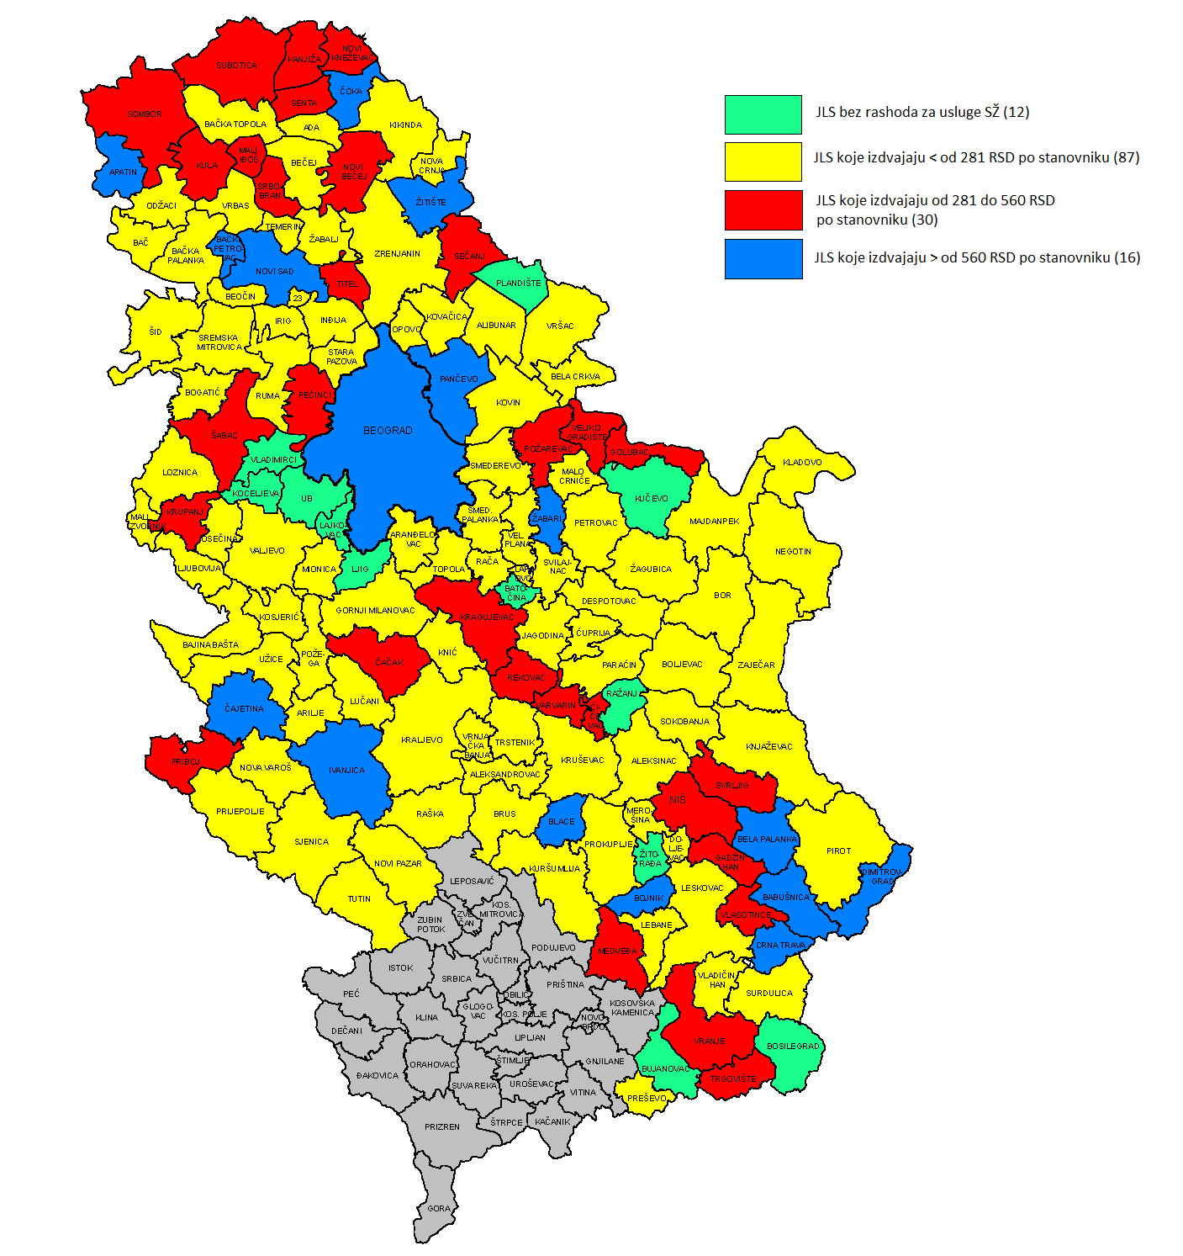
LGs with no expenditures on SC services (12)

LGs with per capita expenditures < RSD 281 (87)

LGs with per capita expenditures of RSD 281-560 (30)

LGs with per capita expenditures > RSD 560 (16)

Map 2. Distribution of local governments by share of expenditures on social care services in local budgets, 2015

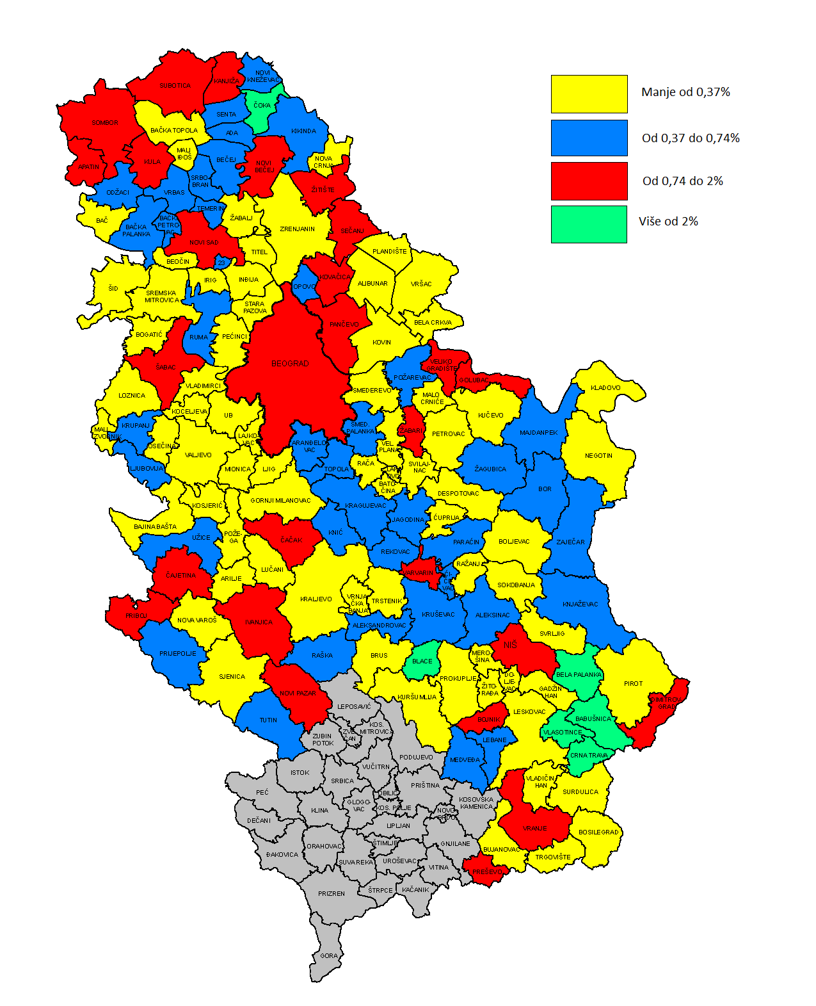
Under 0.37%

Between 0.37% and 0.74%

Between 0.74% and 2%

Over 2%

Map 3. Distribution of local governments by number of months of adult and elderly home care (HC) service provision, 2015

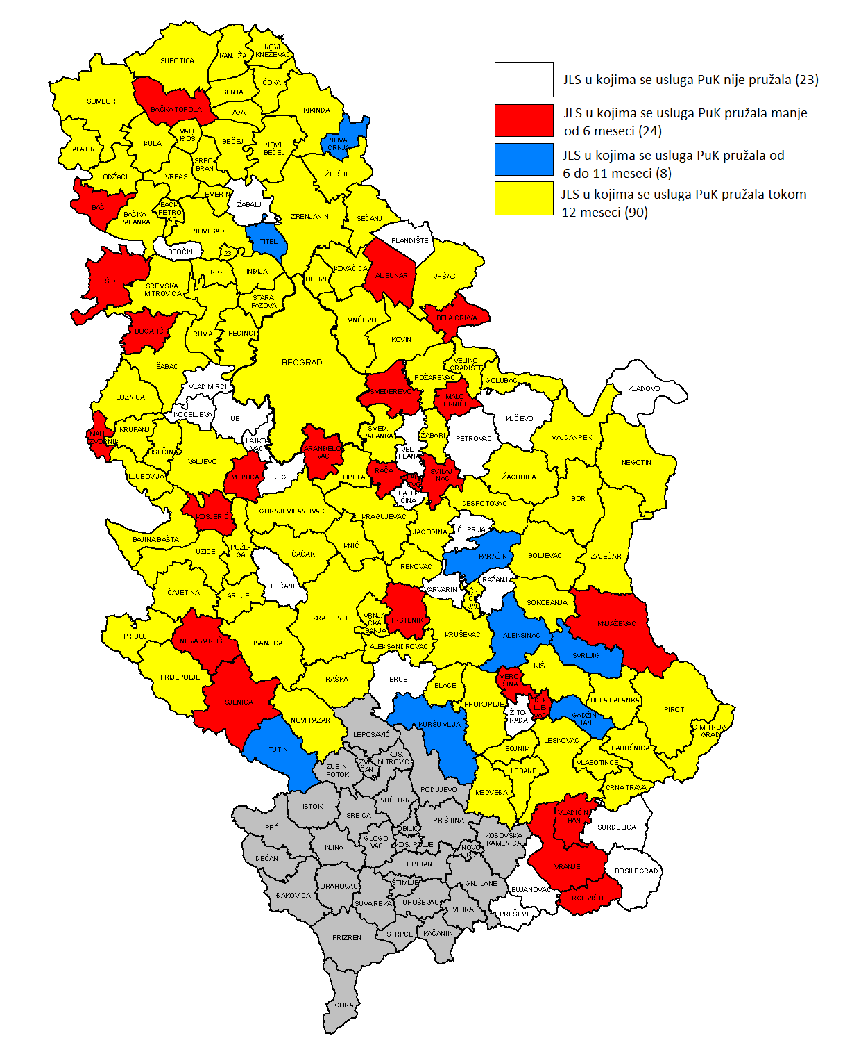
LGs with no HC service (23)

LGs with HC service provided for under 6 months (24)

LGs with HC service provided for 6-11 months (8)

LGs with HC service provided for 12 months (90)

Map 4. Distribution of local governments by adult and elderly home care (HC) service provision, 2012 and 2015

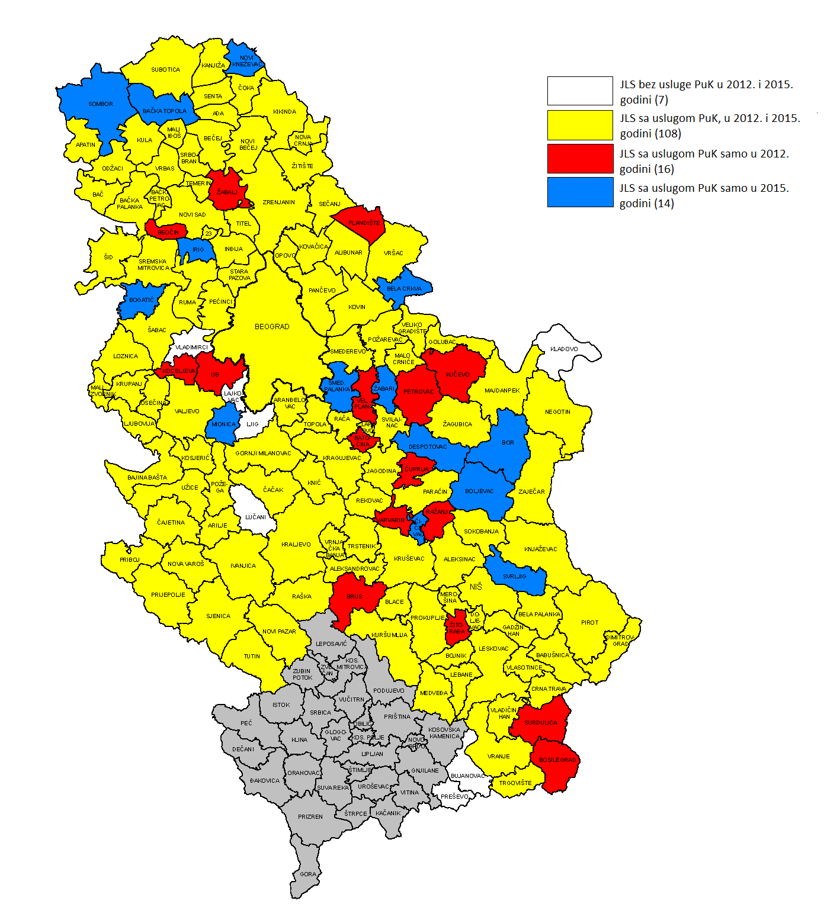
LGs with no HC service in 2012 or 2015 (7)

LGs with HC service in both 2012 and 2015 (108)

LGs with HC service in 2012 only (16)

LGs with HC service in 2015 only (14)

Map 5. Availability of home care (HC) to persons aged 65+, 2015

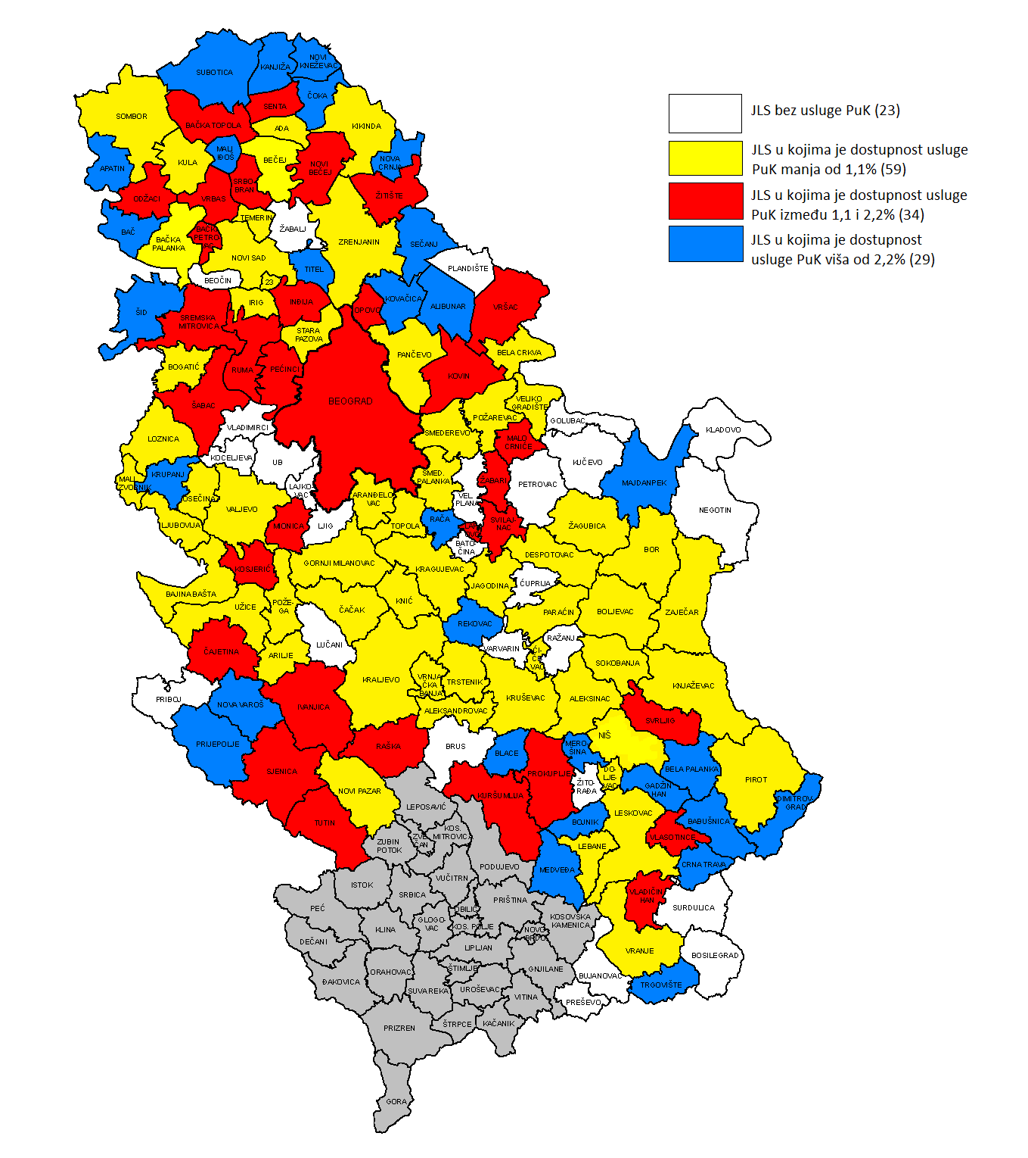
LGs with no HC service (23)

LGs with HC service availability under 1.1% (59)

LGs with HC service availability of 1.1-2.2% (34)

LGs with HC service availability over 2.2% (29)

Map 6. Availability of home care (HC) by average weekly number of hours of service provision to the client, 2015

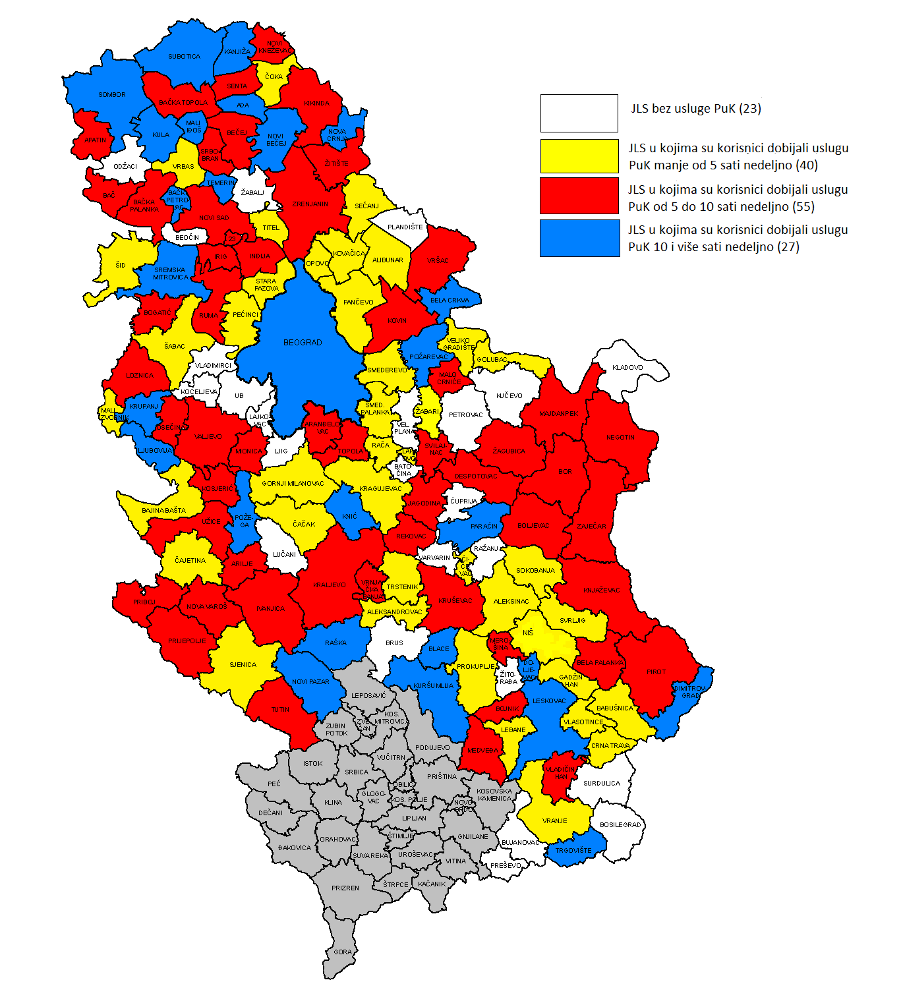
LGs with no HC service (23)

LGs with under 5 hours/week of HC service (40)

LGs with 5-10 hours/week of HC service (55)

LGs with 10 or more hours/week of HC service (27)

Map 7. Distribution of local governments by unit cost level for adult and elderly home care (HC), per hour of service provision, 2015

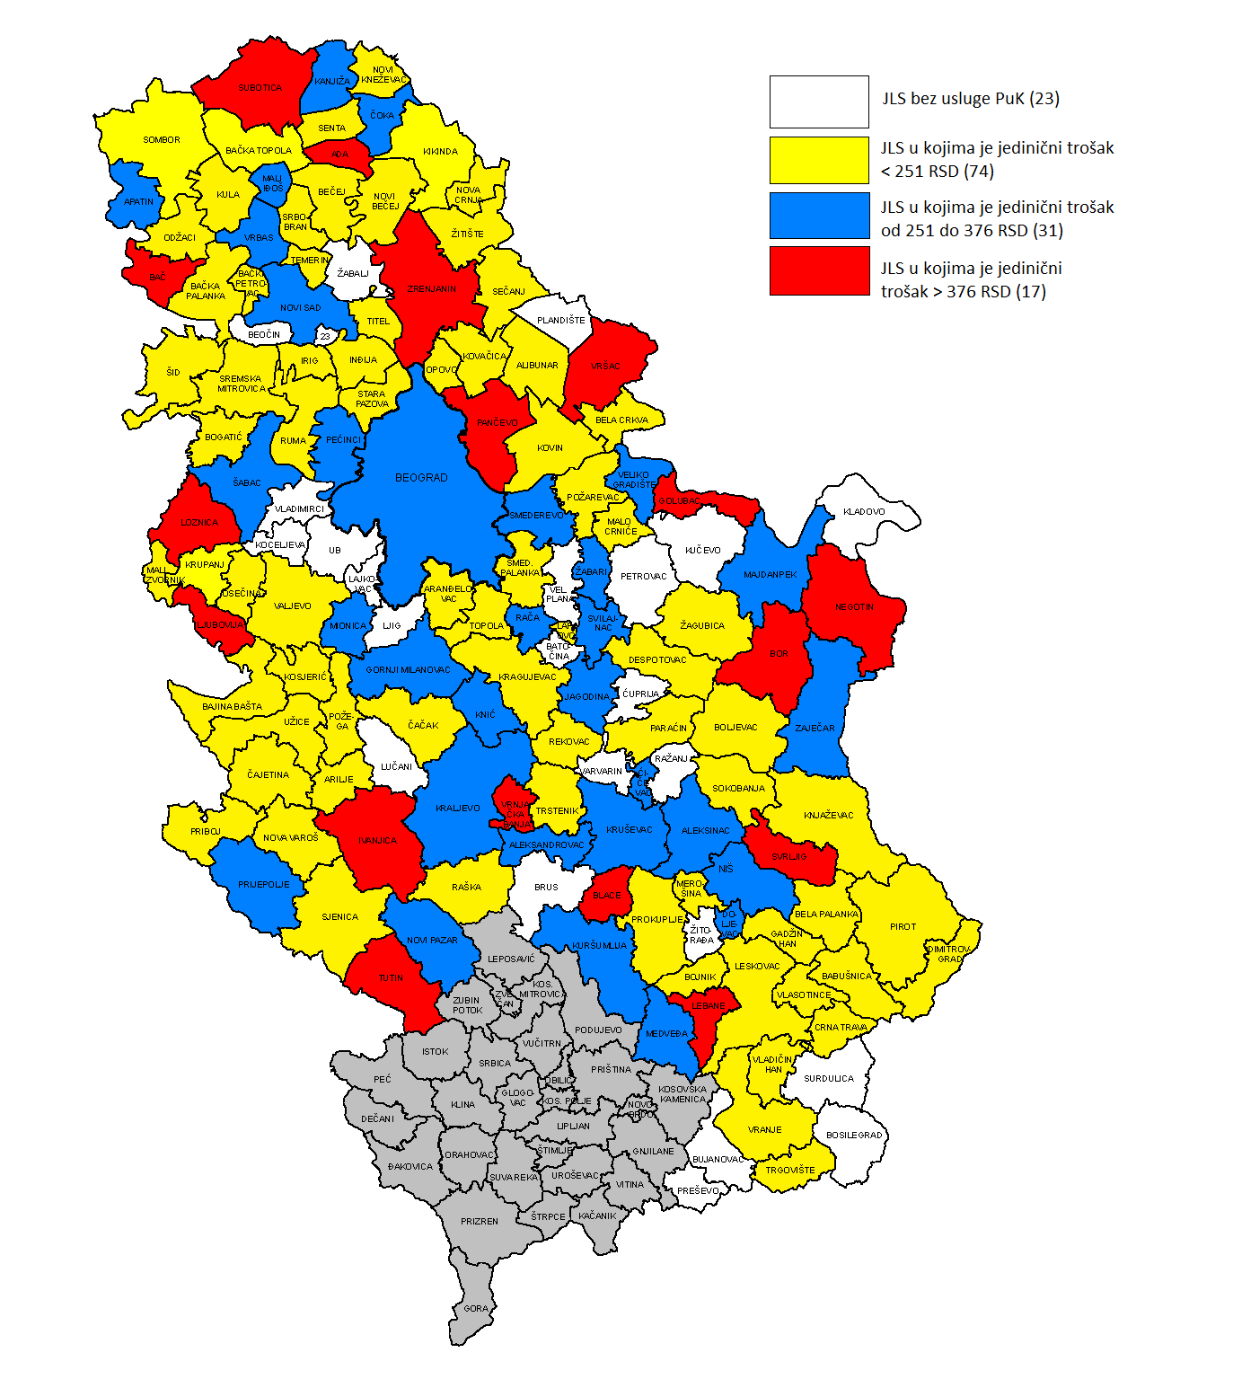
LGs with no HC service (23)

LGs with unit cost < RSD 251 (74)

LGs with unit cost of RSD 251-376 (31)

LGs with unit cost > RSD 376 (17)

Map 8. Prevalence of day care (DC) for children with developmental and other disabilities by service provision continuity, 2015

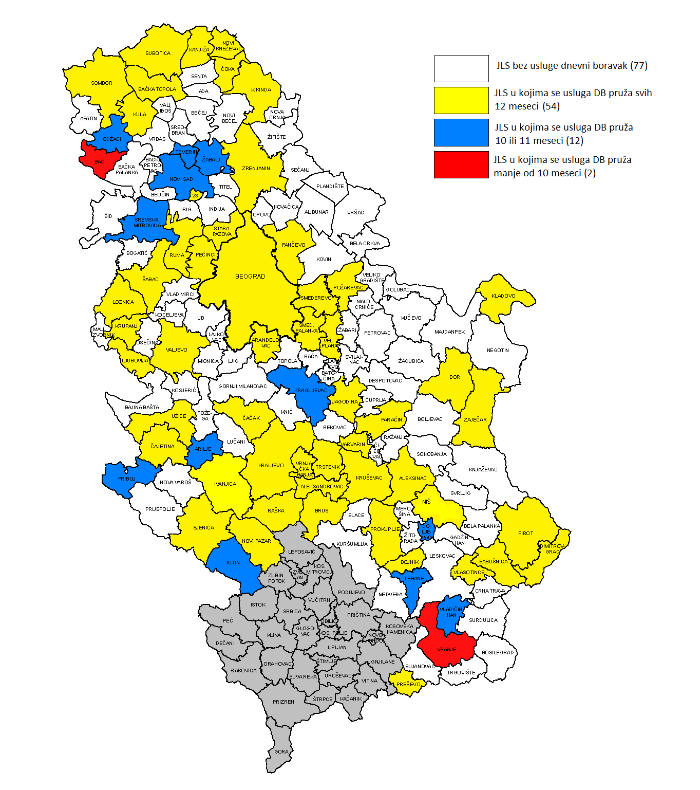
LGs with no DC service (77)

LGs with DC service during all 12 months (54)

LGs with DC service for 10 or 11 months (12)

LGs with DC service for under 10 months (2)

Map 9. Prevalence of day care (DC) for children with developmental and other disabilities, 2012 and 2015

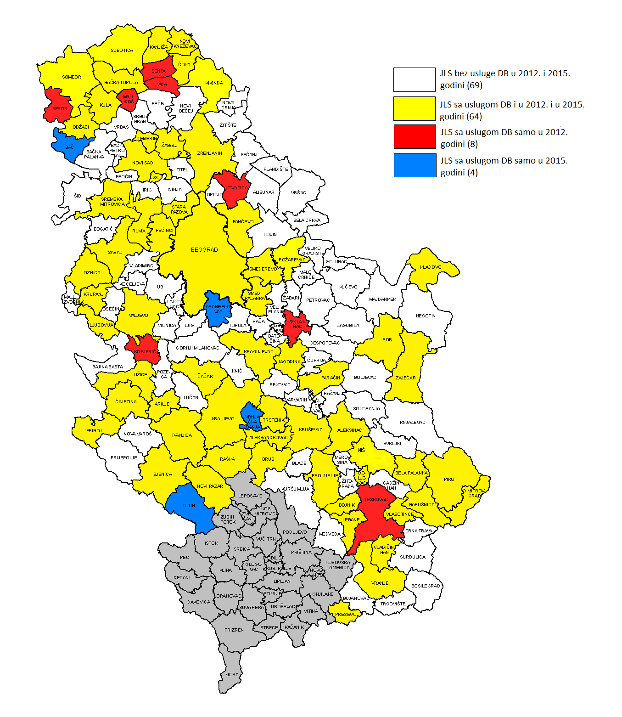
LGs with no DC service in 2012 or 2015 (69)

LGs with DC service in both 2012 and 2015 (64)

LGs with DC service in 2012 only (8)

LGs with DC service in 2015 only (4)

Map 10. Availability of day care (DC) for children with developmental and other disabilities to clients aged up to 26, 2015

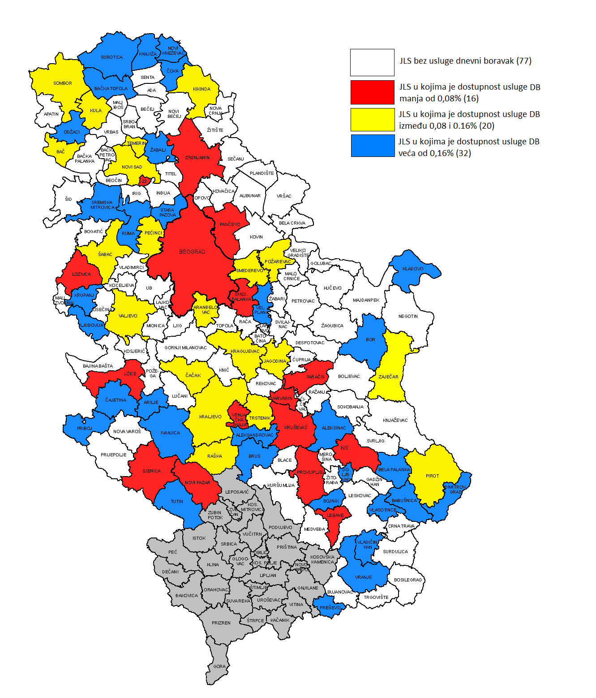
LGs with no DC service (77)

LGs with DC service availability under 0.08% (16)

LGs with DC service availability of 0.08-0.16% (20)

LGs with DC service availability over 0.16% (32)

Map 11. Availability of day care (DC) for children with developmental and other disabilities by opening hours, 2015

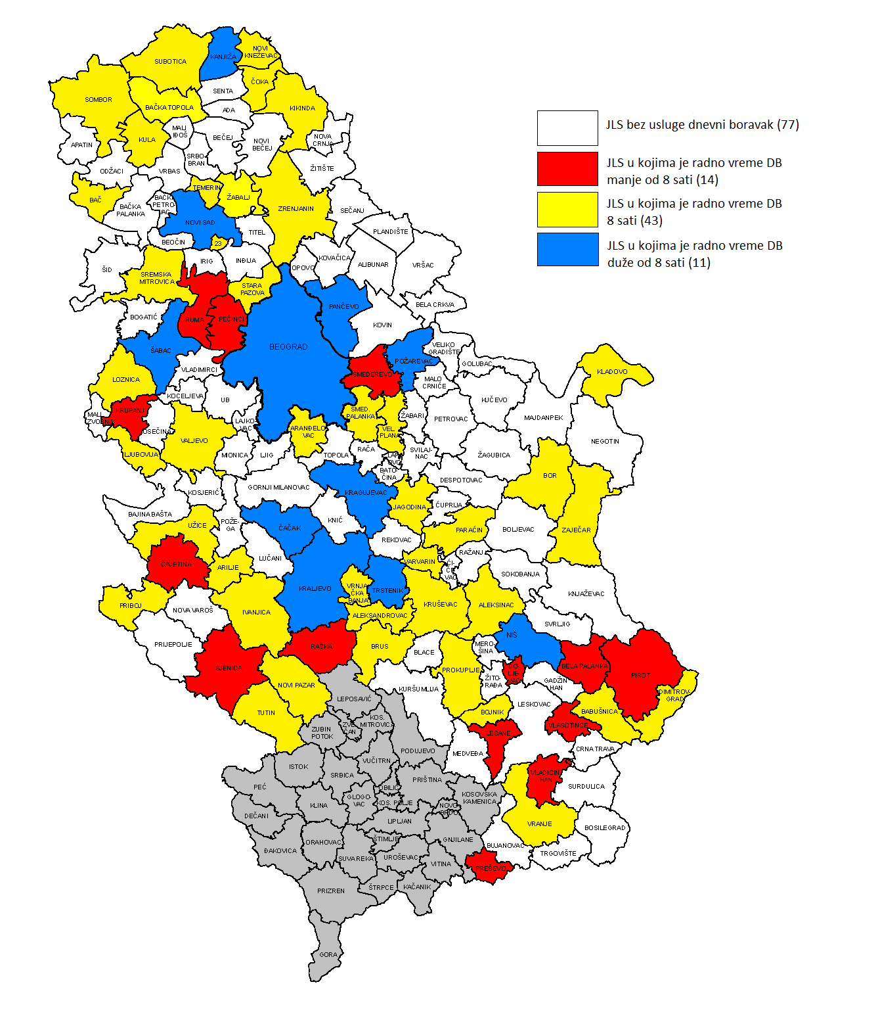
LGs with no DC service (77)

LGs with DC open for under 8 hours (14)

LGs with DC open for 8 hours (43)

LGs with DC open for over 8 hours (11)

Map 12. Distribution of local governments by unit cost level for day care (DC) for children with developmental and other disabilities, 2015

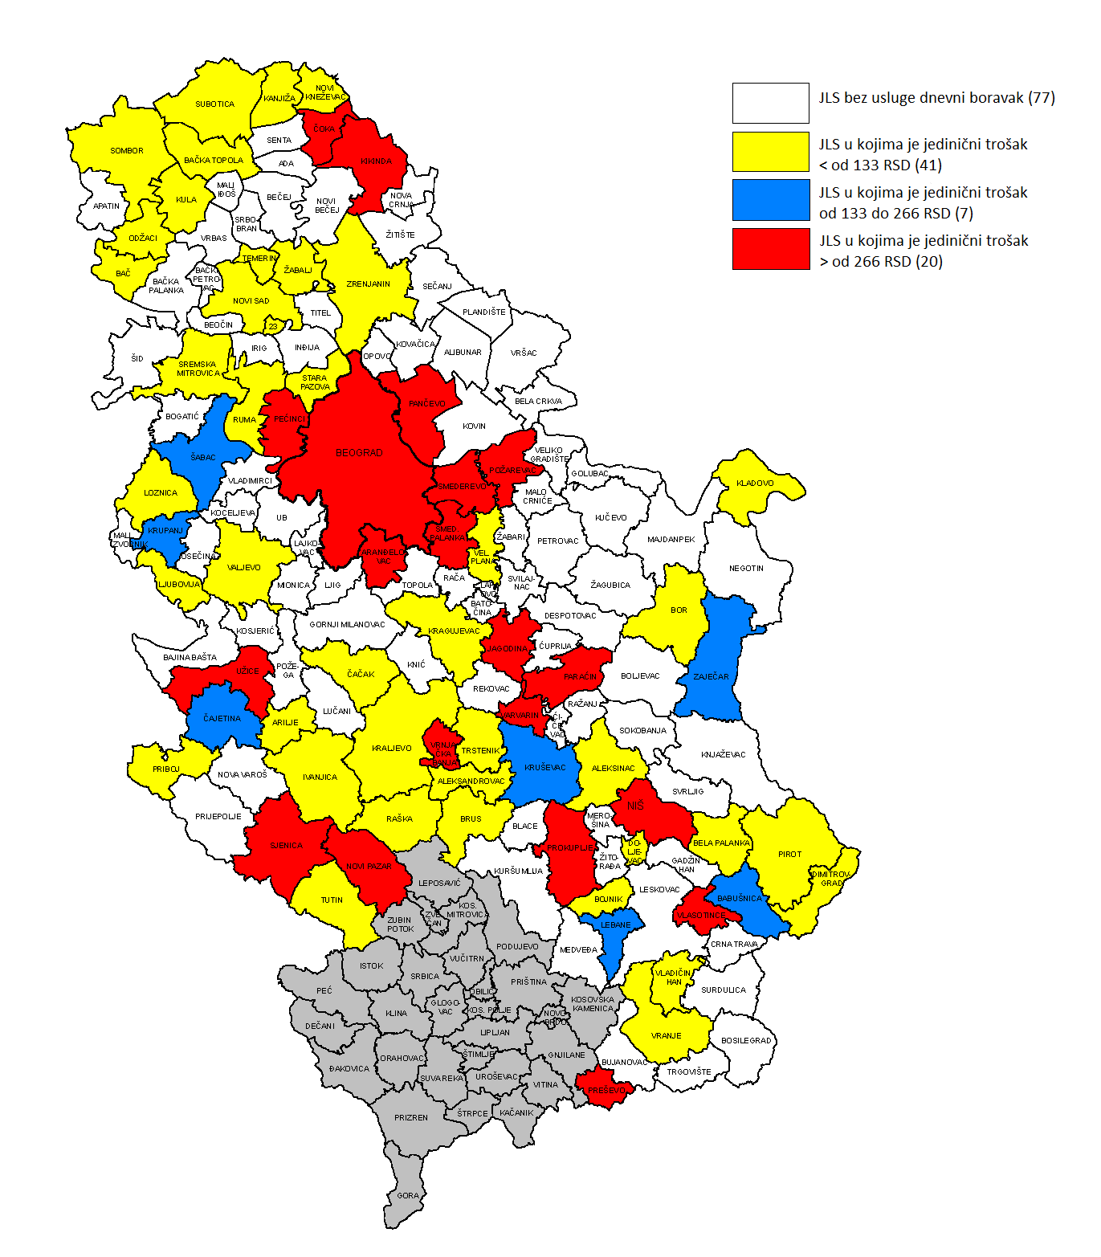
LGs with no DC service (77)

LGs with unit cost < RSD 133 (41)

LGs with unit cost of RSD 133-266 (7)

LGs with unit cost > RSD 266 (20)

The data on all social care services within the mandate of local governments for each municipality and city were entered into a questionnaire. After checking and making any corrections, the questionnaire was automatically entered into the database; integrated data on social care services are thus available for each municipality and city.
The questionnaire was piloted in the following LGs: Aranđelovac, Bač, Bački Petrovac, Bojnik, Vlasotince, Ivanjica, Pančevo, Topola and Trstenik.
Data on all services present in the community were to be entered, irrespective of whether the service(s) was/were funded pursuant to a LG decision or on a project basis.
The questionnaire items in respect of which, according to assessment, local representatives would need assistance in questionnaire completion were identified. These items are tables in Part IV, concerning service efficiency: Table (sheet) 5 – Duration and frequency of service provision and Table (sheet) 8 – Service funding sources. The intensive support plan concerned planning the number of visits to local governments and working directly with local representatives of service providers and/or local governments. In that sense, the intensive support plan was a rather logistical matter, as well as a technical one.
It was expected that most concerns would arise with regard to filling in the data on the duration and frequency of service provision.
Ibid.
This especially pertains to elderly home care services and counselling centres.
The service was piloted under a project launched by the Ministry of Labour, Employment, Veteran and Social Affairs and UNICEF with support from Novak Djokovic Foundation, and implemented by the Republic Institute for Social Protection from October 2013 to 2015.
Analysis of Initial Results of the Family Outreach Worker Service. (2015). Republic Institute for Social Protection.
The service provision model is best demonstrated in the home care service, as the intensity and schedule of support to clients are substantively affected by their needs for quality of life improvement. An example of two different models for the home care service, which provided the most characteristic illustration, is given on page 16, in the section Clients.
Provided and funded by LGs whose development level is above the national average.
More information is given in section 9.2 Elderly home care.
In 2015, there were 136 active inter-sectoral committees (ISCs) in Serbia, excluding Belgrade. In Belgrade, all 17 ISCs in the 17 metropolitan municipalities were operational (figure taken from the report on the project Enhancing Community Professional Capacities – An Important Step in Child Inclusion, implemented by CSP as a UNICEF Serbia partner between 2014 and 2016).
Rulebook on Detailed Conditions and Standards of Provision of Social Care Services (2013), Official Gazette of RS.
The programme was implemented with IPA 2008 funds for social inclusion under components 1 and 2 for technical assistance to the national and local levels, and support for capacity improvement at the local level.
In 2016, standards for the family outreach worker service, which proved to be an appropriate form of support for families with children from unstimulating environments, were under development. The family outreach worker service was piloted in four cities (Belgrade, Kragujevac, Niš and Novi Sad) for the past two years under a programme implemented by the Republic Institute for Social Protection in partnership with UNICEF.
Synthetic Report on the Operation of Centres for Social Work in Serbia 2014 (2015). Belgrade, Republic Institute for Social Protection, p. 50.
Different service provision intensity.
Number of months of service provision during the year.
Taken from the report Mapping Social Welfare Services within the Mandate of Local Governments in 2012.
Based on full-time equivalent.
Matković, G., Stanić, K. (2014). Socijalna zaštita u starosti: dugotrajna nega i socijalne penzije, Belgrade, Centre for Social Policy, Faculty of Economics, Finance and Administration and Social Inclusion and Poverty Reduction Unit of the Government of the Republic of Serbia.
The total number of clients referred to these services during the year stood at approximately 9,500.
These data were not declared by service providers from five municipalities and cities: Čačak, Kruševac, Loznica, Titel and Užice.
Synthetic Report on the Operation of Centres for Social Work in Serbia 2014 (2015). Belgrade, Republic Institute for Social Protection, p. 50.
The total expenditures pertain to running costs, do not include depreciation or expenditures such as procurement of vehicles, furnishing and renovating premises and the like.
The organisational unit Day Care Centres and Clubs within the Belgrade Gerontology Centre was established in 1982, and the Home Care Service – in 1987, http://www.beograd.rs/lat/gradska-vlast/2454-gerontoloski-centar-beograd---rj/. The Residential and Day Care Centre for Children and Youth with Developmental Disabilities was established in May 1990, http://www.centarbgd.edu.rs/istorija/
Only 1,470, according to the most recent Population Census, 2011, Statistical Office of the Republic of Serbia.
Stipanović, B. (2011). Finansiranje socijalne zaštite u Republici Srbiji, Belgrade, CLDS (internal document).
By local government development levels in 2014. The regulation for 2015 was not adopted yet, http://www.regionalnirazvoj.gov.rs/Lat/ShowNARRFolder.aspx?mi=171
The term social protection in the narrow sense means benefits pursuant to the Law on Social Protection.
For LG development levels in Serbia, see: http://www.regionalnirazvoj.gov.rs/Lat/ShowNARRFolder.aspx?mi=171
In the mapping questionnaire, these funds were classified as other and represented an attempt to ascertain whether and to what extent the home local governments reimbursed the costs of their residents using services in other municipalities or cities.
Ibid.
It is assumed that this question was mainly in service providers’ focus.
Based on the overall data recalculated using the pivot table in the Excel database.
According to local government development levels in 2014, considering that the Decree for 2015 was not adopted yet, http://www.regionalnirazvoj.gov.rs/Lat/ShowNARRFolder.aspx?mi=171
Ibid.
For 2012, in the interest of comparability, the data on elderly home care and adult home care services, which were provided in 124 local governments, are combined. Elderly home care was provided in 122 local governments.
Decree Establishing the Single List of Regions and Local Governments by Development Levels for 2012.
The availability indicator was calculated relative to the population aged 65+ by municipalities and cities in Serbia based on the Statistical Office of the Republic of Serbia’s estimated data on the population by municipalities and cities in Serbia in 2014.
Matković, G., Stanić, K. (2014). Socijalna zaštita u starosti: dugotrajna nega i socijalne penzije, Belgrade, Centre for Social Policy, Faculty of Economics, Finance and Administration and Social Inclusion and Poverty Reduction Unit of the Government of the Republic of Serbia.
According to local government development levels in 2014, as the regulation for 2015 was not adopted yet, http://www.regionalnirazvoj.gov.rs/Lat/ShowNARRFolder.aspx?mi=171
Matković, G., Stanić, K. (2014). Socijalna zaštita u starosti: dugotrajna nega i socijalne penzije, Belgrade, Centre for Social Policy, Faculty of Economics, Finance and Administration and Social Inclusion and Poverty Reduction Unit of the Government of the Republic of Serbia.
The most prevalent providers of adult and elderly home care were social work centres and gerontology institutions.
According to local government development levels in 2014, as the regulation for 2015 was not adopted yet, http://www.regionalnirazvoj.gov.rs/Lat/ShowNARRFolder.aspx?mi=171
http://socijalnoukljucivanje.gov.rs/rs/skup-dugotrajna-nega-i-zbrinjavanje-pruzanje-usluge-pomoc-u-kuci/
In recent years, in some local governments, beneficiaries of additional financial assistance from the local budget were engaged to provide home care services. Such work engagement is “paid” by financial assistance; hence, this cost does not affect the total expenditures on the service. No data are available on this phenomenon.
http://domzastarebeograd.com/kucna-nega-starih-pomoc-u-kuci
Law on Social Protection.
Official Gazette of RS No 42/2013.
Under the Law on Social Protection (Article 41), the beneficiaries (of social protection entitlements and services) relevant to the day care service are minors (children) and adults (youth) up to the age of 26 with developmental disabilities.
Rulebook on Detailed Conditions and Standards of Provision of Social Care Services (2013). Official Gazette of RS No 42/2013.
Rulebook on Detailed Conditions and Standards of Provision of Social Care Services
In 27 out of the 41 local governments, day care was provided by social work centres, and in the remaining municipalities/cities – by service provision centres, transformed residential care homes for children, as well as primary and/or secondary schools for students with developmental disabilities. In Belgrade, the service provider was a state institution – the Residential and Day Care Centre for Children and Youth with Developmental Disabilities.
The Red Cross provided the service in only one local government.
http://www.csp.org.rs/wp-content/uploads/2014/07/Rashodi-za-usluge-socijalne-zastite-u-41-opstini-u-Srbiji-final-G-Matkovic-sa-uvodnim-delom.pdf
A lower coverage of the population aged 65+ by home care services is recorded only in Romania and Lithuania. In most East European countries, the coverage is also low, but, nevertheless, stands at about 2 %, and in most Mediterranean countries, it is about 5 %. The highest coverage is recorded in Scandinavian countries and the Netherlands (European Commission (2012) Long-Term Care for the Elderly. Provisions and providers in 33 European countries, p. 73). See also Matković, G., Stanić, K. (2014). Socijalna zaštita u starosti: dugotrajna nega i socijalne penzije, Belgrade, Centre for Social Policy, Faculty of Economics, Finance and Administration and Social Inclusion and Poverty Reduction Unit of the Government of the Republic of Serbia, pp. 20-37.
A more comprehensive offer of services means a number of different service types, rather than, for instance, home care only, which was the case in many local governments.
This figure does not include club clients.
According to local government development levels in 2014, as the regulation for 2015 was not adopted yet, http://www.regionalnirazvoj.gov.rs/Lat/ShowNARRFolder.aspx?mi=171
Thus, for instance, in Germany, the share of the elderly using home care is 2.6 % (Matković, G., Stanić, K. (2014). Socijalna zaštita u starosti: dugotrajna nega i socijalne penzije, Belgrade, Centre for Social Policy, Faculty of Economics, Finance and Administration and Social Inclusion and Poverty Reduction Unit of the Government of the Republic of Serbia, pp. 34).
Kusek, J. Z., & Rist, R. C. (2004). Ten Steps to a Results-Based Monitoring and Evaluation System. Washington, DC: World Bank, p. 13.
1.5% of the funds earmarked by the 2014 budget for the social protection programme.
Since the decree provides that at least 80 % of the total funds for earmarked transfers is allocated for type 1 earmarked transfers, approximately RSD 50 million would be awarded on the basis of this criterion.
0.86 % instead of 1.5 % of the budget funds of the relevant programme pertaining to social protection (budget section 28, programme 0902, function 70).
The data are available for the following local governments: Bečej, Blace, Bogatić, Kraljevo, Kruševac, Kučevo, Priboj, Smederevo, Sjenica and Vlasotince.
According to this recommendation, one family place per 10,000 population should be provided in shelters of this type. This includes a place for a mother and the average number of children per mother in the given country. Kelly, L., & Dubois, L. (2008). Combating violence against women: minimum standards for support services. Council of Europe.

